Step 1: Website is : https://wileyplus.com/
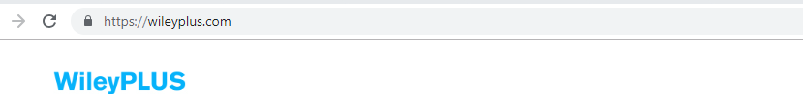
Step 2: Log in (upper right-hand corner)
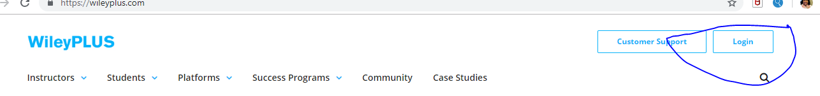
Step 3: Log into wileyplus
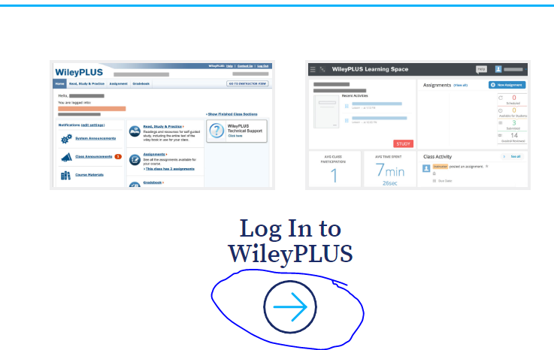
Step 4: Enter username: SHAWNEESEROSS92@GMAIL.COM and password: Mercedees26
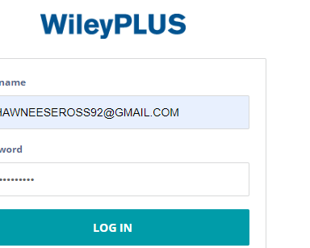
Step 5: Click on class title
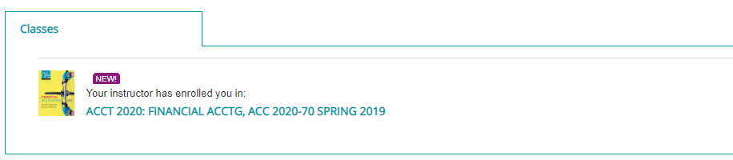
Step 6: Go to Assignments
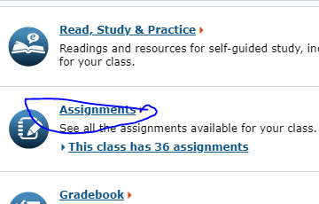
Step 7: Go to Exam 2 (timed)
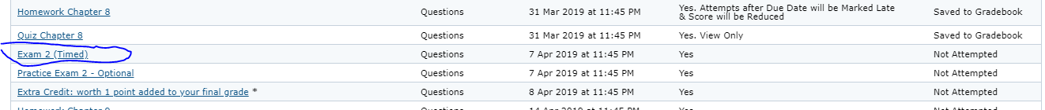
Note**
Once you access Exam, you have 100 minutes to complete it.

