Data Sheet: Activity 1 – Motion and Forces

All Content is Copyright Protected and May NOT Be Posted or Shared Outside Of The Classroom

Name | Course | Date

Activity Data Code

Table I – Common Data

Complete the table below using data found under the Activity-Form tab and information found under the Background tab (see the Summary of Needed Formulas section at the very end).

Cube | Mass  (kg) | Magnitude of Normal Force (N)
Quartz | 8.94 | 87.612
Ruby | 13.5 | 132.3
Aluminum | 9.11 | 89.28
Gold | 65.14 | 638.37

Sample Calculation: Show your normal force magnitude calculation for the Quartz cube below.

F_{n}=mg= 8.94 x 9.8
= 87.612N

Sample Calculation: Show your normal force magnitude calculation for the Gold cube below.

65.14 x 9.8 = 638.37N

Table II - Coefficient of Static Friction: Procedure 1 Data

Complete the table below using results from Table I, data from your Velocity Plots (see the Velocity Plots tab), and information found under the Background tab (see the Summary of Needed Formulas section at the very end).

Cube | Magnitude of Normal Force  (N) | Magnitude of  Applied Force  (N) | Static Coefficient  of  Friction
Quartz | 87.612 | 27.25 | 0.311
Ruby | 132.3 | 32.40 | 0.245
Aluminum | 89.28 | 34.80 | 0.39
Gold | 638.37 | 44.7 | 0.07

Sample Calculation: Show your coefficient of static friction calculation for the Ruby cube below.

Static Coefficient of Friction = 32.4/132.3
=0.245

Observations and Questions

[1] What accounts for the different values of minimum applied force for each cube?

Each cube exerts a different frictional force heed to push itnce this accounts for the force need

[2] Which type of motion occurs in this situation: accelerated or constant velocity? Why? Explain how your velocity plots support your answer. Hint: review the “Understanding and Interpreting Velocity vs Time Plots” section of the Background material (see Background tab).
The type of motion is accelerated. The graph is of velocity against time forms a straight line.
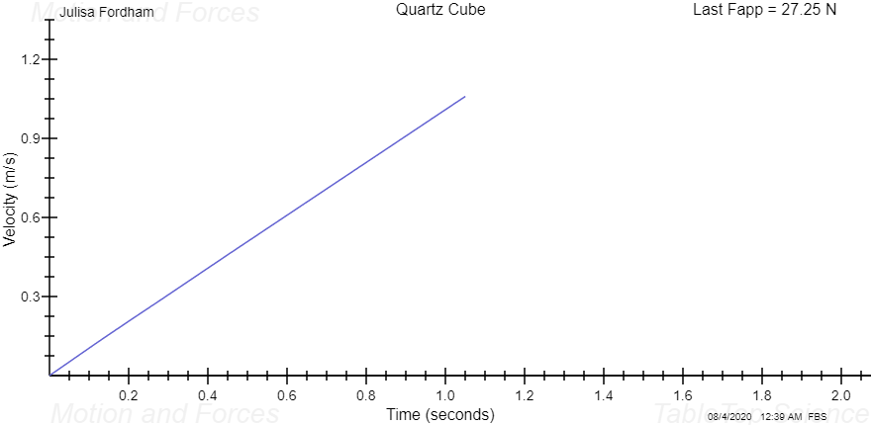

Table III - Coefficient of Kinetic Friction: Procedure 2 Data

Complete the table below using results from Table I, data from your Velocity Plots (see the Velocity Plots tab), and information found under the Background tab (see the Summary of Needed Formulas section at the very end).

Cube | Magnitude of  Normal Force  (N) | Magnitude of  Applied Force  (N) | Kinetic Coefficient  of  Friction
Quartz | 87.612 | 18.3 | 0.209
Ruby | 132.3 | 18.9 | 0.143
Aluminum | 89.28 | 22.9 | 0.256
Gold | 638.37 | 31.9 | 0.05

Sample Calculation: Show your coefficient of kinetic friction calculation for the Aluminum cube.
Uk=Fapp/Fn
=13.30/89.28
=0.209

Observations and Questions

[1] Why is there a difference between the force needed to start a cube moving and the force needed to obtain constant velocity motion?

The force needed to start a cube needs to change from potential energy to kinetic energy and once the kinetic energy is attained the cube moves at a constant acceleration

[2] Why do we need constant velocity for this particular analysis? Hint: think about how the force of kinetic friction and the applied force compare to one another in this situation.

A constant velocity is needed to reduce the force applied.

[3] Describe how your velocity plots in this case are different from the static friction analysis. Note: your instructor may require you to submit velocity plots in support of this analysis.
.
The static friction analysis displays a straight line in it plot of velocity against time while the kinetic coefficient has a bent line.
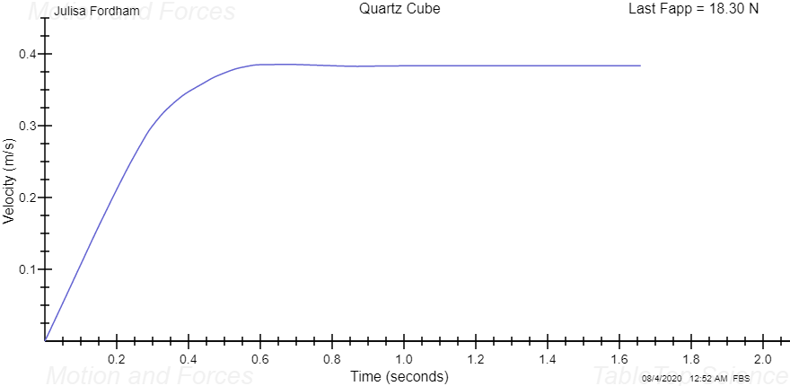
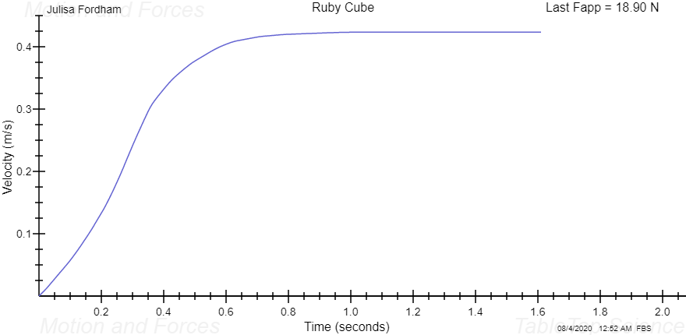
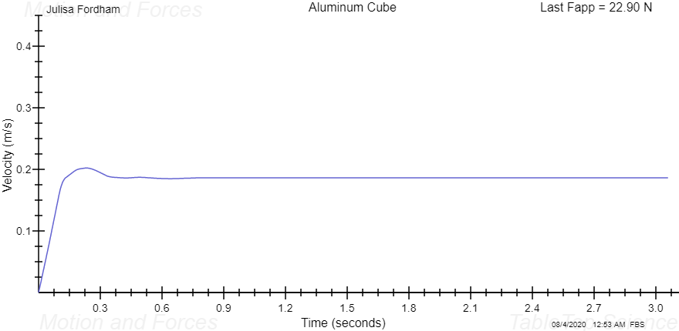
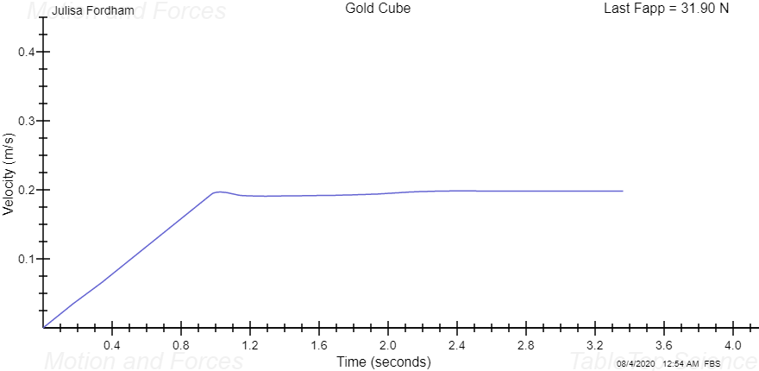

Table IV - Coefficient of Kinetic Friction: Procedure 3 Data

Complete the table below using results from Table I, data from the Activity (see the Activity tab), and information found under the Background tab (see the Summary of Needed Formulas section at the very end).

Cube | Magnitude of  Normal Force  (N) | Magnitude of  Applied Force  (N) | Acceleration  (m/s²) | Kinetic Coefficient  of  Friction
Quartz | 87.612 | 45 | 2.987 | 0.514
Ruby | 132.3 | 45 | 1.933 | 0.34
Aluminum | 89.28 | 45 | 2.426 | 0.504
Gold | 638.37 | 45 | 0.201 | 0.07

Sample Calculation: Show your coefficient of kinetic friction calculation for the Gold cube.

Uk=Fapp/Fn
=45/638.37
=0.07

Observations and Questions

[1] Review your velocity plots for this part of the activity. Which of the cubes achieved the highest speed? Why?
Quartz cube
It has the highest kinetic coefficient.

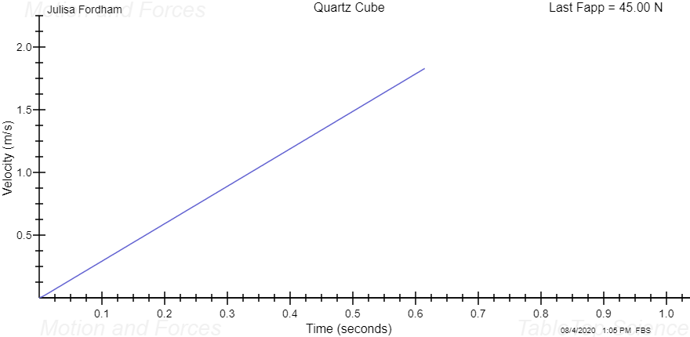

[2] Why is it necessary to record acceleration for this analysis?

Acceleration is used to calculate the speed of the cube

[3] How do your results for kinetic friction coefficients in this analysis compare to the constant velocity analysis?
Both their plots are of a straight line

