Activity 1: Dark Energy Explorers

Student's Name
Institutional Affiliation
Course Code and Name
Instructor's Name
Date

Activity 1: Dark Energy Explorers
The main goal of this activity is the identification of the distant galaxies that would help in measuring dark energy when the universe was only 2 to 3 billion years old. Although the issue of dark energy is much essential in astronomy, it is also a central challenge for physics. Dark energy is said to be causing the universe to expand faster than its actual ages. Science depicts that dark energy constitutes approximately 70 percent of all the energy within the universe.
I participated in the classification of how far galaxies are, that is, identifying if a galaxy was nearby or distant. Different images were displayed in exact identification, and I could closely examine each picture to be able to make the correct classification. Below are examples of an image as shown below.
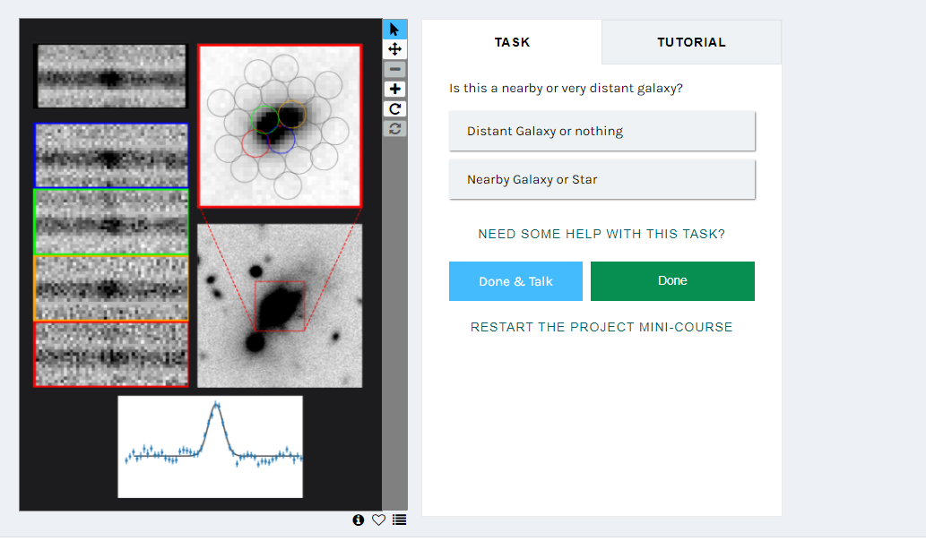
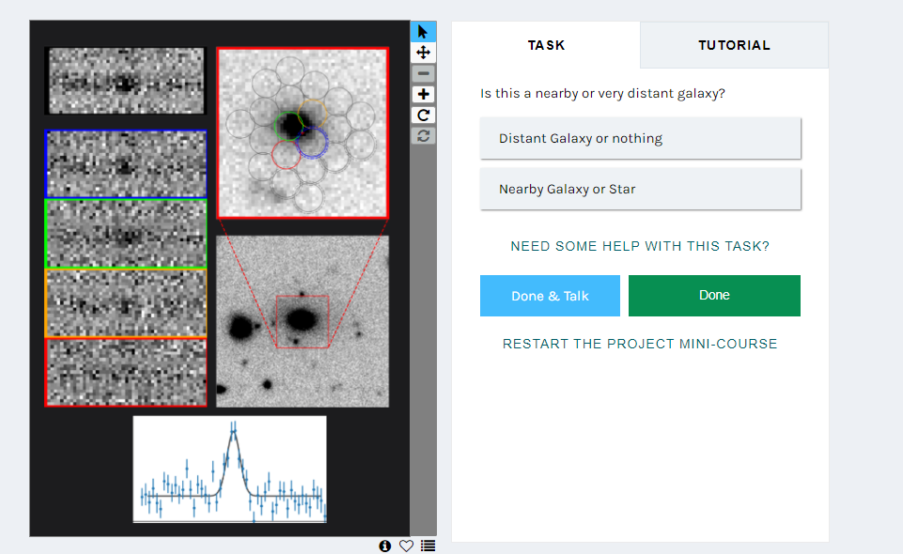
While conducting the classifications, it was fun and interesting exploring from one object to another and trying to identify how far each was. I was keen and took some time to examine each object so as to be able to make a perfect classification. At first, I expected that most of the objects were at distant locations, but to my surprise, I was able to find that there were some that were so much near. I would be happy to learn why the difference in the distance of the location of one object to the other. I liked the way that there were lines in each object which greatly helped me in making the classifications. I also noticed that great knowledge is required in making the classification. Keen and time are essential factors that are needed when one decides to make these classifications. It was somehow difficult to be able to differentiate between the spectral lines, but with time I was able to note the differences.
Summary
