Activity 2: AL4Mars

Student's Name
Institutional Affiliation
Course Code and Name
Instructor's Name
Date

Activity 2: AL4Mars
The main goal of this activity is "teaching mars rovers how to classify Martian Terrain." To be able to get around Mars, the terrain is important. According to scientists, it is important to know where it is safe for rovers to drive or even sleep or land on Mars. The long-term agenda is starting a machine learning that could help in Mars Exploration.
I participated in classifying different services that were captured by Mars rovers into either sand, consolidated soil, Bedrock, or big rocks. Different pictures were presented, and I was able to choose one classification for each of the objects presented. Below are examples of the classifications I came across;
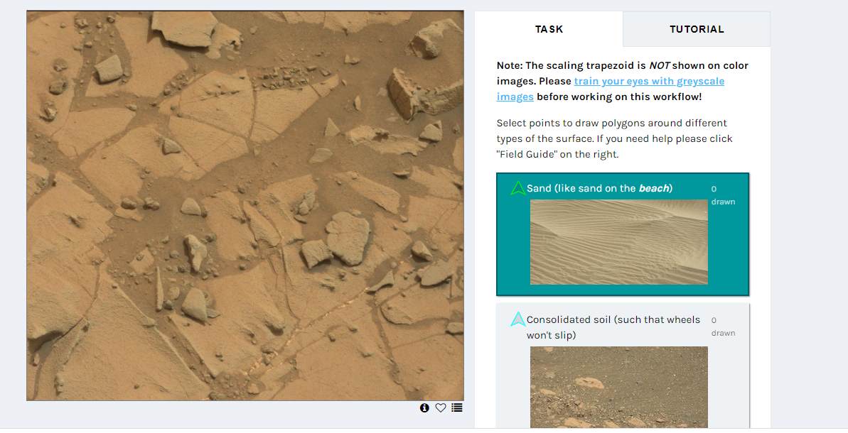
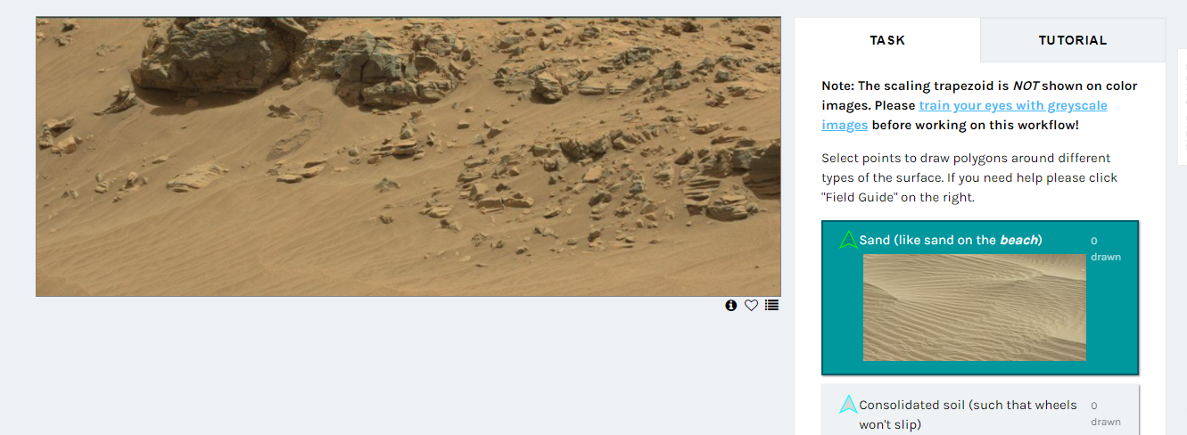
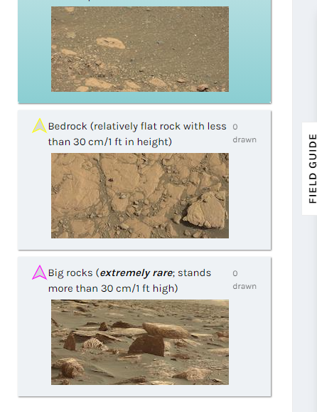
It was so interesting coming across different surfaces and be able to classify them. Some of the surfaces were so unique that I even took some photos to keep them for future consulting. While doing the classification, I noticed that most of the surfaces were different. I also think that the classifications could be expounded because I used to come across some very unique surfaces, but I have to classify them where they could closely fit. My greatest challenge was drawing the polygons around different types of the surface to help in the classification. However, as I proceeded with the classification and Identifications, I was able to note an awesome pattern that I used in drawing the polygons. My expectation was that the mars had sand or beach surface. However, it was to my surprise to come across some bedrocks and rarely some big rocks. This brought some sort of fear in me, and I thought that all rovers need to be careful, and they explore.
Summary
