Activity 3: Disk Detective

Students Name
Institutional Affiliation
Course Code and Name
Instructors Name
Date

Activity 3: Disk Detective
The goal of the activity I spotting the disks that are around the nearby stars where the planet forms and dwells. Scientifically, the activity is essential in helping in finding out where the planets are also forming where the planets remain today through the searching of stars surrounded by the disks.
I identify different objects and gave them the best description according to the pictures provided. The classification of the images was all around the inner, or the outer cycles presented. Below are examples of classifications I came across;
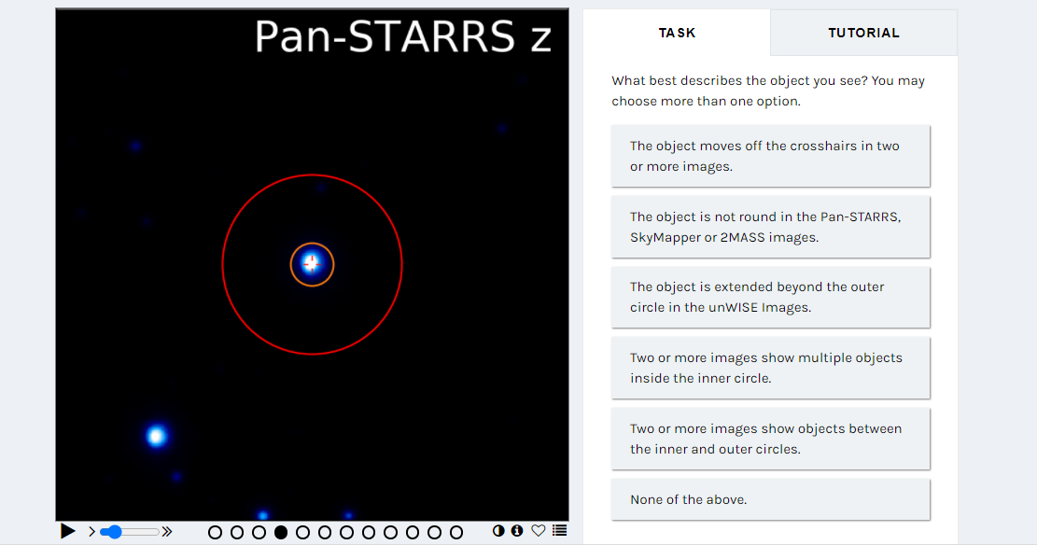
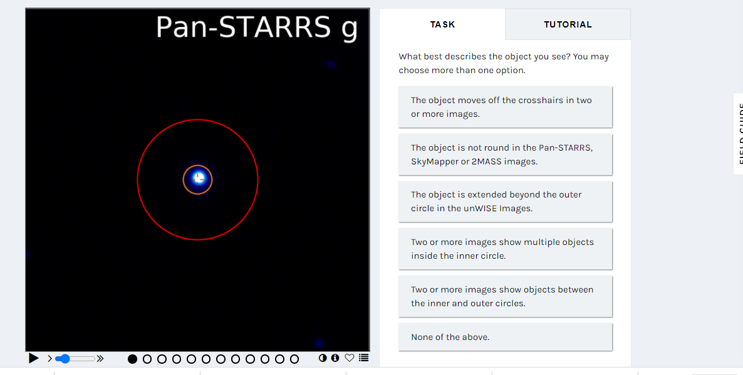
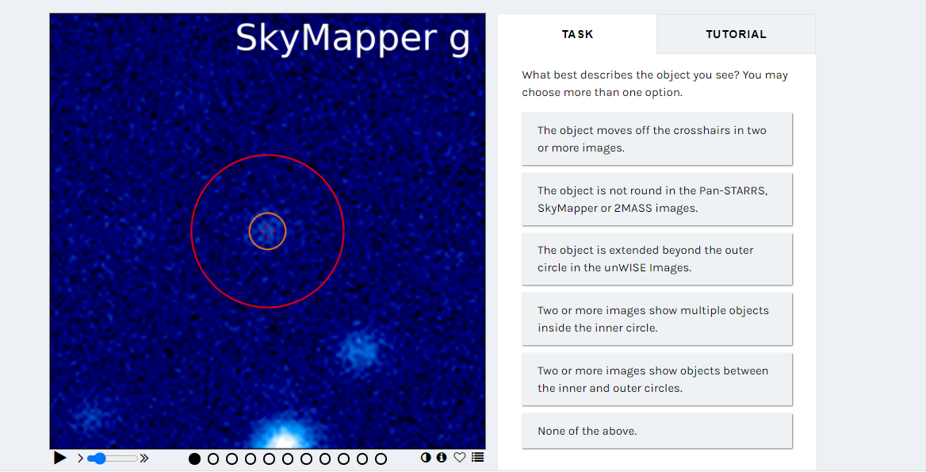
One fantastic thing with the objects within this activity is that multiple pictures were of great help during the classification. I used to look at one image after the other while closely examining the objects. This took me more time but greatly helped me to be able to classify the objects according to the best description correctly. Honestly, some of the images I came across were aye capturing; hence I was able to monitor the objects and place them in the best classifications possible. I liked the patterns that some of the objects formed. However, some objects in few images formed very complex patterns that made it difficult for me to classify them. Most of the data that I observed when doing the classification was confirming the previous knowledge about these objects. This was mostly within the objects that were well captured in the circles. I learned that most of the images had multiple objects depicting the existence of many complex images within the universe.
Summary
