POLITICAL, ECONOMIC AND SOCIAL CHARACTERISTICS AND CHALLENGES IN AFRICA
Name of student
Name of tutor
The institution affiliation
Date

Summary
One of the issues Africa is facing today is poverty. Poverty continues to be a top issue Africa is trying to challenge today. Just like many poor nations of the world, many people in Africa are poor. The gap between the rich and the poor is very high. And this can be attributed to the fact that economic growth rate is far too low in Africa. The GDP of most countries in Africa is stagnant or growing at a slower rate. Another challenge facing Africa is corruption. Corruption is experienced in institutions and in politics. Leaders are stealing money from government offices. People are corrupting their way into offices. Corruption is therefore denying the chance for economic prosperity because money is being stolen. Political change is another challenge in many African nations. In most parts of Africa, political change is marked by violence. Democracy is weak in many African nations (Lawal, 2007). This is because many leaders have held onto power for far too long denying other people who may bring change to government the right to do so.
Colonialism can be attributed to the challenges Africa is facing today. For example, geographical divide as experienced during colonial times in Africa brought about the creation of ethnic groups. Ethnic groups have continued to fight in many parts of Africa because of the issue of land. Also, some families grabbed huge acres of land post-colonialism which denied other people to own land. A case example is in Kenya where some families associated with the leadership of the country grabbed huge pieces of land after colonization and continue to do so even today. Moreover, colonization has continued to perpetrate the over-dependence of African countries on foreign aid. Experts view that foreign aid has meant that most countries in Africa cannot foster development. And many European nations are using foreign aid as a platform to grab resources such as oil and minerals from Africa.
Map
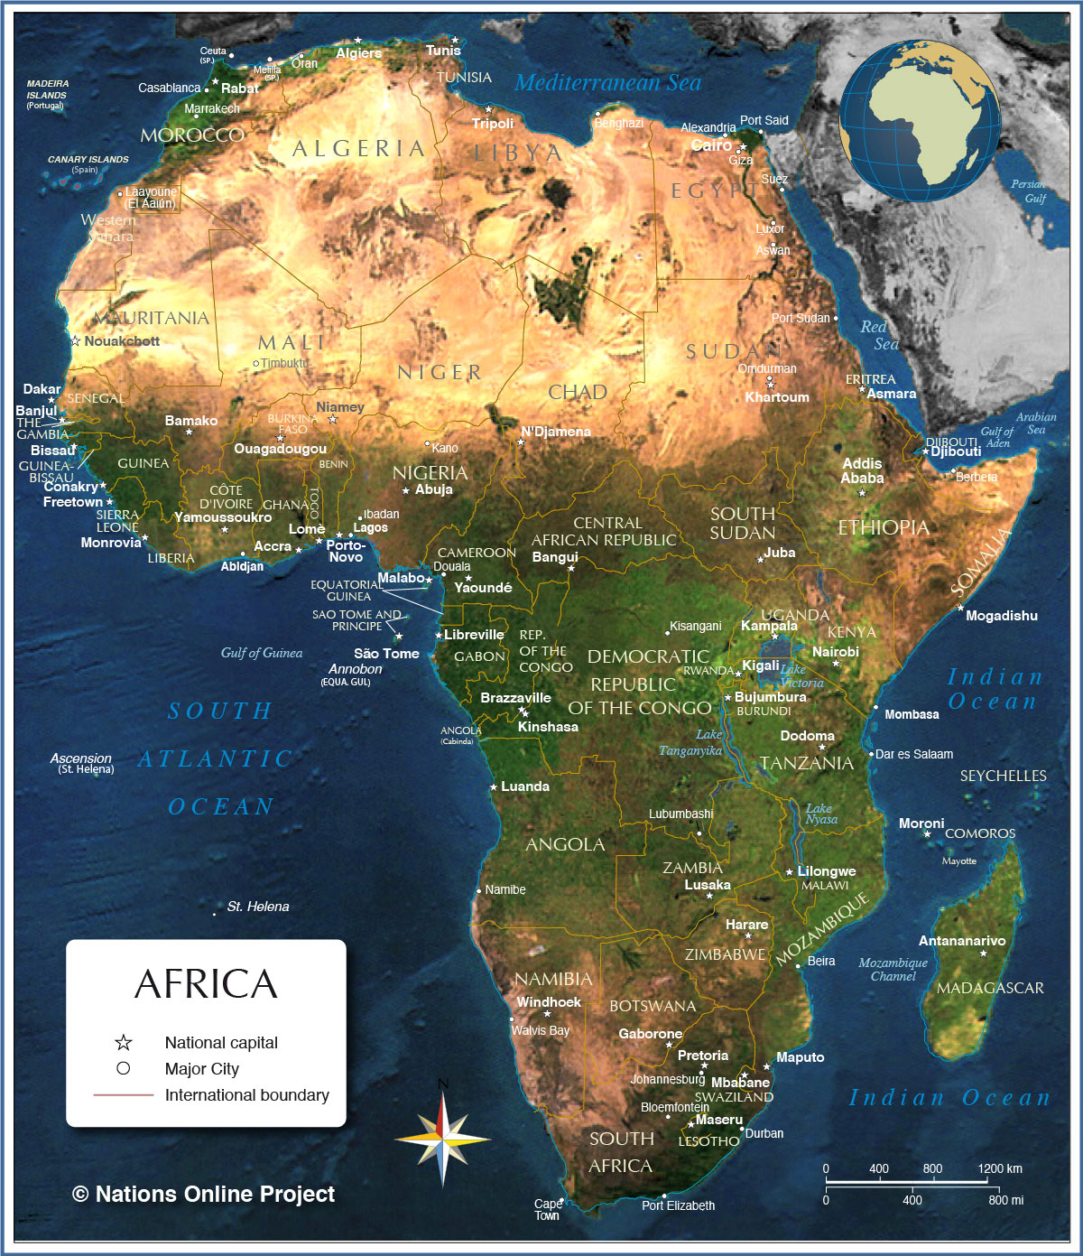

Political Characteristics of Africa
Political analysts have a common view that democratic and autocratic sytems of power are simultaneously in play in many African nations. Democratic advances have taken shape in most countries in Africa. There are some elements of democracy in many African states. Elections are held in many countries in Africa where citizens are allowed to choose their leaders despite them being influenced by key political leaders. Opposition parties compete for elective offices and a wide range of opinions can be expressed. However, many countries in Africa continue to suffer under autocratic systems of government. This proves that many countries in Africa depict a trend in which political rights and civil liberties have deteriorated.
Autocratic regimes, dictatorships, have been a dominant form of governance in Africa for many years. In most African nations, power is concentrated in the hands of a few individuals and these individuals have managed to erode any semblance of accountability, legitimacy, democracy, and justice. There is lack of full participation in governance. There is lack of accountability and transparency. Corruption is rampant in government. There is lack of protection of freedom of information and human rights. Uganda is one of the few countries which continue to suffer under autocratic regimes. President Yoweri Museveni has been in power for many years denying leaders like Robert Kyagulanyi as seen in the just recently concluded elections the opportunity to bring change.
Africa has some important regional political organizations that have played a fundamental role in addressing some of the challenges faced by the nation. The African Union is the largest political organization in Africa. Other regional political organizations like the East African Community help address challenges in specific regions in Africa. And there are a number of political challenges that Africa need to combat. These challenges include:
- Entrenched leaders and abuse of term limits
- Dismal state of press freedom
- Proliferation of restrictive laws
- Weak regional human rights mechanisms
- Lack of economic development
Economic Characteristics of Africa
Analysis of the macroeconomic circumstances in African countries indicates that there are three main characteristics of the African economy. One of the main characteristics of the African economy is that economic growth in Africa coexists with severe poverty with considerable disparities between regions and countries. The informal sector in Africa is at the cornerstone of their economy. This means that many people in Africa have been employed in the informal sector. Since many people live in impoverished conditions, they depend on farming and small businesses for their income. A small percent of people are employed in the formal sector. Therefore, the economy of Africa is driven by people in the informal sector.
Another important characteristic of the African economy is that resource exploitation and economic diversification are both being pursued. Many countries in Africa are rich in resources. In fact, a huge percent of minerals the world enjoys today are from Africa. Africa is pursuing the exploitation of their resources and selling them to western corporations. The selling of these resources to rich nations is aimed at helping Africans prosper economically. Also, Africa is shifting its economy away from a single income source toward multiple sources. Many Africans don’t just want to rely on export of commodities for their economic prosperity. The countries are encouraging broadly-based economies, active in a wide range of sectors, and firmly integrated into their regions, to better generate robust growth and sustainable growth.
Finally, to carry out development, African nations place equal stress on their own autonomous development and international coordination. Most countries in Africa are encouraging development in different sectors of their economies. They are championing for the growth of their industrial sectors in order to ensure a large number of employed people. It is a concern that many people in African nations are unemployed. And therefore, to challenge this, governments are encouraging the growth of industries to employ more people. Also, Africa recognizes the importance of international coordination. Donor countries have provided aid to help turn around African economies. Therefore, many countries still appreciate the role of foreign aid in their economic growth. For example, China has established roots in many parts of Africa thus helping in infrastructure development. This is helping their economies to grow.
Cultural Characteristics of Africa
The African culture is varied because each country has its unique way of life. The continent is home to diverse populations. Each country in Africa has its own tribes, languages, and cultural differences. There are various famous African tribes. The Zulu people are the largest ethnic group in South Africa. It is estimated that at least eleven million people live in the province of KwaZulu-Natal. The Maasai people live in the Rift Valley region of Kenya and Tanzania. They own large herds of cattle, sheep and goats and they are nomads. There are more than fifty unique tribes living in the Omo River region of South-Western Ethiopia. These tribes have unique customs and beliefs. African food is also unique to the people. Many people in Africa practice farming in their villages. Therefore, they live off the food they grow on their farms. Traditional African food is also sold at outdoor markets (Maathai, 2011).
Many people live off foods like maize, cassava, plantains, among other traditional African food. Colonisation introduced western foods in Africa. Therefore, it is common for people to be served western meals in restaurants and even at home. But generally, people in Africa eat traditional African food. African art is also fantastic. Africans are one of the biggest contributors to sculptural art. The art form of African sculpture dates back thousands of years with some of the earliest sculputures being found in Africa. Africans also embrace their traditional attires in dressing. There are thousands of indigenous languages and dialects spoken in Africa. Every African country has its own languages. In Northern Africa, Arabic is the dominant language while Swahili is spoken in East Africa. However, due to the fact that European nations once colonized Africa, many people are able to speak English and French.
Important Issues and Trends in Africa
One of the key trends in Africa is that Africa’s growth prospects look promising. According to experts, Africa’s gross domestic product (GDP) is expected to grow over the coming years. According to economists, about half of the world’s fastest growing economies are in Africa. And this is due to the fact that many African countries are encouraging the growth of their economies through Foreign Direct Investment and also loans, which they are using to expand their economies. Another important trend in Africa is the creation of African continental free trade agreement. The leadership of the African Union is working to create the world’s largest free trade zone since the formation of the World Trade Organizaton. The creation of this organization will definetly boost the African economy since it wil eliminate tarrifs on goods and also encourage the collaboration between the private sector and the government (Atiase, 2018).
Also, of great importance is Africa’s use of technology to grow. Technology is revolutionizing the way of doing things today. African growth will be accelerated by technological innovation across all sectors which are a global trend toward digital and shared economies. Technology will continue to bring innovative opportunities while addressing challenges in key sectors like healthcare, transportation, trade, among others. Also, climate change continues to be an issue of debate in Africa. It is expected that there will be a focus on types of fuel for projects being developed in Africa. Renewable energy will be impacted by improved technology as well as regulatory and economic issues. However, the region continues to face many challenges. Politics is at the center stage of all the problems Africa is facing today. Democracy seems to be eroding in many African countries. There is corruption in the way election is conducted. Leaders who are elected into office do so through corrupt means. Also, in most African countries like Uganda, individual freedom is denied. For example, the just concluded elections in Uganda proved how people can be denied a right to vote their preferred leader. Press freedom is denied in such countries with weak democracies.

References
Abrahamsen, R. (2017). Africa and international relations: Assembling Africa, studying the world. African Affairs, 116(462), 125-139.
Atiase, V. Y., Mahmood, S., Wang, Y., & Botchie, D. (2018). Developing entrepreneurship in Africa: investigating critical resource challenges. Journal of Small Business and Enterprise Development.
Lawal, G. (2007). Corruption and development in Africa: challenges for political and economic change. Humanity and social sciences Journal, 2(1), 1-7.
Maathai, W. (2011). Challenge for Africa. Sustainability Science, 6(1), 1-2.

