Chemical weathering
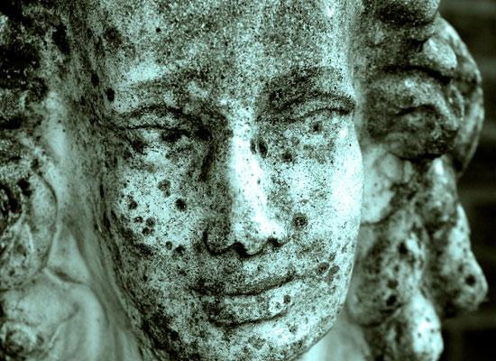 Dissolution on a statue: Chemical weathering takes place when the internal part of the mineral consisting or rock changes in addition to other elements. Dissolution, for example, takes place in places where limestone is commonly found. The chemical equation for dissolution is H₂O + CO₂ + CaCO₃ Ca⁺² + 2HCO₃⁻ Dissolution takes place in places where limestone is found. Acidic water dissolves limestone to allow the water to have entrance into the limestone. Dissolutions are evident in sinkholes and gravestone as well as statues such as the example below.
Physical weathering
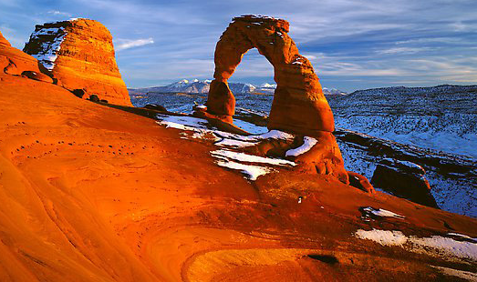 Physical weathering abrasion: Abrasion is an example of physical weathering where the rubbing together or rock particles result in a reaction. Similar to the way sandpaper breaks down wood, sediments in either wind or water have the ability to weather rocks. Often physical weathering takes place in mountain regions and deserts. In the example below, the unique shape of the rock formation is as a result of the physical weathering process of abrasion by the wind.
Biological weathering
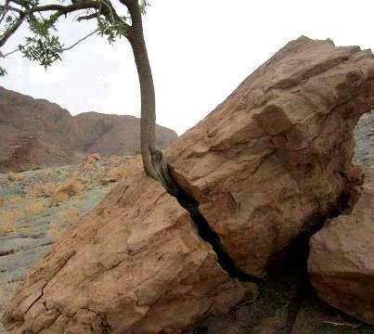 Plant creating weathering biologically: Rocks and mineral are disintegrated due to chemical and physical agents of an organism. The roots break apart the rocks by growing into joints and cracks. The plant gives off organic acid that can help in breaking down rocks chemically. Biological activities cause the movement and also minerals to mix. This movement can bring materials to different processes of weathering at different locations in the soil profile.

