1. 6+6-1
- A)
2. As x increases, y increases, and as x decreases, y increases.
3. {(2,-3), (2,0), (2,5)} (B)

4. Y= $\frac{1}{5}$x +2 (A)
5. 2a+6b+12a+3b
14a+9b (B)
6. Sum of a number and 8
X+8 (C)
7. Debt to income ration
Expenses: Income
975:1200
0.8125
8. The price increased more in the afternoon than in the morning. (C)
9. 3-100÷ (2+3) +20
3-100÷5+20
3-20+20
3 (A)

10. 9($\frac{17}{3}$) (C)

11. $\frac{32-6*2}{27-5*3-2}$
$\frac{20}{10}$
2 (A)

12. Less than the product of 3 and n (B)
13. 9.56cm³ (C)
14. in 2007 the whale population is about 240 (A)
15. Additive identity property (C)
16. 0 to 270 miles (B)
17. 0 to 270 miles (B)
18. (A) n² + 34
(B) 5 ÷ 2x
19. A. 4w² + 7w² + 7z²
= 11w² + 7z²
B. 15w – 6w + 14w²
9w + 14w² = w (9 + 14w)
20. 13 + 23 + 12 + 7
Commutative: 23 + 7 + 13 + 12
Associative: (23 + 7) + (13 + 12)
30 + 25 = 55

21. a. 9t² (2+t²)
18t² +9t⁴
Expansion method

b. 3(d² + r)-2(d² + r)
3d² + 3r – 2d² + 2r
d² + 5r
Factorization method
x | y
3 | -2
1 | 0
-2 | 4
3 | 1
22.

Domain | Range
3 | -2
1 | 0
-2 | 4
3 | 1

23. debts: income ratio
2850: 4000
285:400
57:

24. $\frac{2b+ c^{2}}{a}$ = $\frac{2\left(4\right)+ 6^{2}}{2}$
$\frac{8+36 }{2}$ = 22
25. 4m² + 2 in verbal expression is Sum of a product of four and square of m, and two
26. A product of r raised to power four, and t raised to power three (cubed)
27. f(x) = 3x + 2 and g(x) = x² – x
A. if g(3b) then g(x) = x² – x is (3b)² - 3b = 9b² – 3b
= 3b (3b – 1)
B. if f(2) + 1 then f(x) = 3x + 2 is {3(2) + 2)} + 1
6 + 2 + 1 = 9
28. Function graphed is nonlinear
Intercepts: (0,0) and (120,0)
Symmetry: Symmetric about the y-axis
Positive: (20,80), (40,130)
Negative: (100,80), (110,40)
29. 2(5+1)÷4+1

30. a.
Weight (oz) | 5.0 | 6.0 | 7.0 | 8.0
Rate$ | 4.20 | 5.05 | 5.90 | 6.75

b.

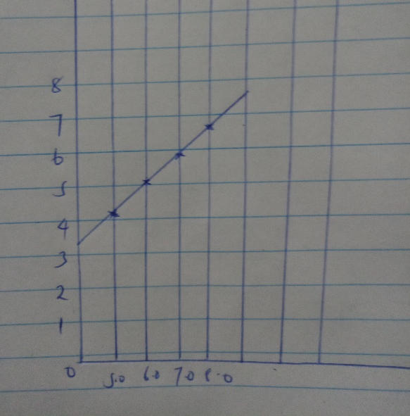

c. There is increase in cost as weight increases.

