Alternate Population Ecology Procedures without Google Earth
Only use this if you cannot pull up the Google Earth map with the pictures and other materials.

INTRODUCTION
Population Ecology
Northern Spotted Owl populations were shown to be declining rapidly in the 1980's. In 1990, the Northern Spotted Owl was designated as a threatened species and recovery efforts have been enacted to preserve critical habitat. Your work today will be gathering information to conduct an analysis to determine if the Northern Spotted Owl population has been decreasing, increasing, or staying constant.

For accurate population monitoring you need to factor in births, deaths, immigrations, and emigrations. We will focus on birth and death rates, which may depend on age: often very young individuals have higher death rates than older individuals do.

The study of a population is called DEMOGRAPHY. In this lab, you will complete a demographic analysis of Northern Spotted Owls. Steps for this analysis include: conducting a monitoring survey along a transect; recording the information of each individual you see; and conducting a population analysis to estimate population growth rate.

Watch this video for more information on Northern Spotted Owls
https://youtu.be/Bi68NsHlWYY

Tracking Wildlife
The Population Ecology Lab is designed to allow you to practice real-life field techniques. As we are unable to conduct this lab at our field site, we have adjusted the procedures to allow you to complete a similar study at home.

Mark-recapture methods are common in wildlife biology. By capturing and tagging a number of individuals in a population, you can perform multiple recapture studies to determine how many times you re-sight a captured-and-marked individual or capture a new, unmarked individual. If you do this across multiple years you can also understand the population demographics across different age classes. The recapture data can be utilized to estimate birth and death rates of a population.

This lab will use a modified mark-recapture method called sight-resight, where "captures" are actually sightings of individual owls that are either banded or non-banded.

Please refer to the Introduction in your lab manual (p. 161-164) for more information on the techniques and equations you will use in this lab.

PROCEDURE 1

Procedure 1: Radio Telemetry
Procedure 1 of this lab is designed to use radio telemetry to track a population of spotted owls around Boulder, CO. For an introduction on telemetry, watch the following video created by a friendly New Zealander, Chris.

www.youtube.com/watch?v=WtB9WgtFqxg

Procedure 1 update: GPS Tracking
GPS, or Global Positioning System, is being used more frequently with wildlife monitoring. Though GPS receivers are more expensive to use then radio receivers, we have obtained funds to tag a number of spotted owls with these GPS tags.

Please watch this video for an introduction to using GPS and Google Earth in Wildlife Monitoring.
https://www.youtube.com/watch?time_continue=1&v=pSAkG27WM4E&feature=emb_logo

The GPS tags will send us real time GPS information of owl movements. The tracks for two individuals were shown in the Google Earth document. Pictures of these tracks are included below.

GPS-tagged owl 2020A
The first track, 2020A, in RED, was placed on an adult female last fall. Each point (A-E) is where the Owl perched for long periods of time.

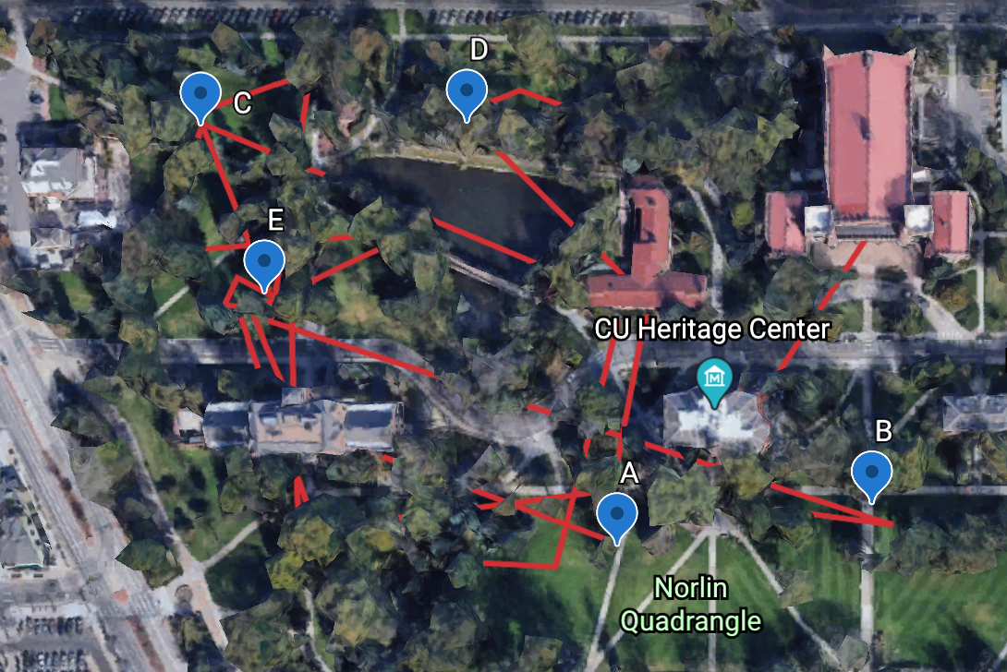
Here is Owl 2020A – she was a nesting female and has one offspring. Pull out your binoculars and get a closer look to identify the age and sex of each owl.

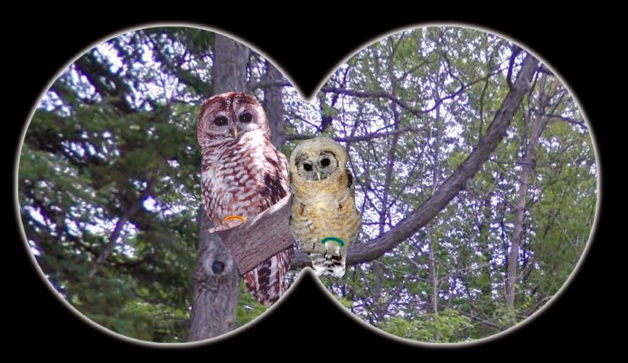

Record each of these spotted owls in your datasheet, on p. 171, including their gender, age class, number of offspring (if any), and whether or not they are banded. Use the guide on pp. 169-170 to help you with this identification. You will do this for every Spotted Owl you see today.

Hint: the older owl will be recorded as a mother with one offspring; the younger owl will be recorded by gender and age class; it has no offspring. See the regular “Procedure 2” instructions for more information and examples.

GPS-tagged Owl 2020B
Our next owl track is to the north and colored blue.

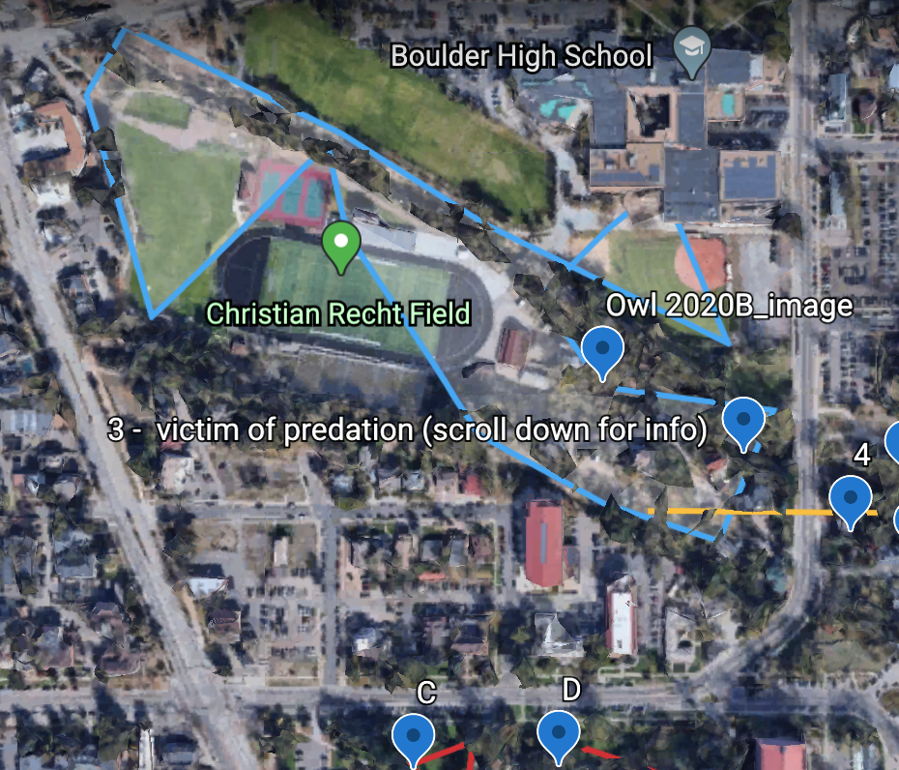
What appears to be the range of our 2nd owl? Does it overlap with that of owl 2020A?

Here is an image of Owl 2020B. Make sure you record this owl on your datasheet (p. 171). Use the identification guides to correctly identify the age and gender of this owl.
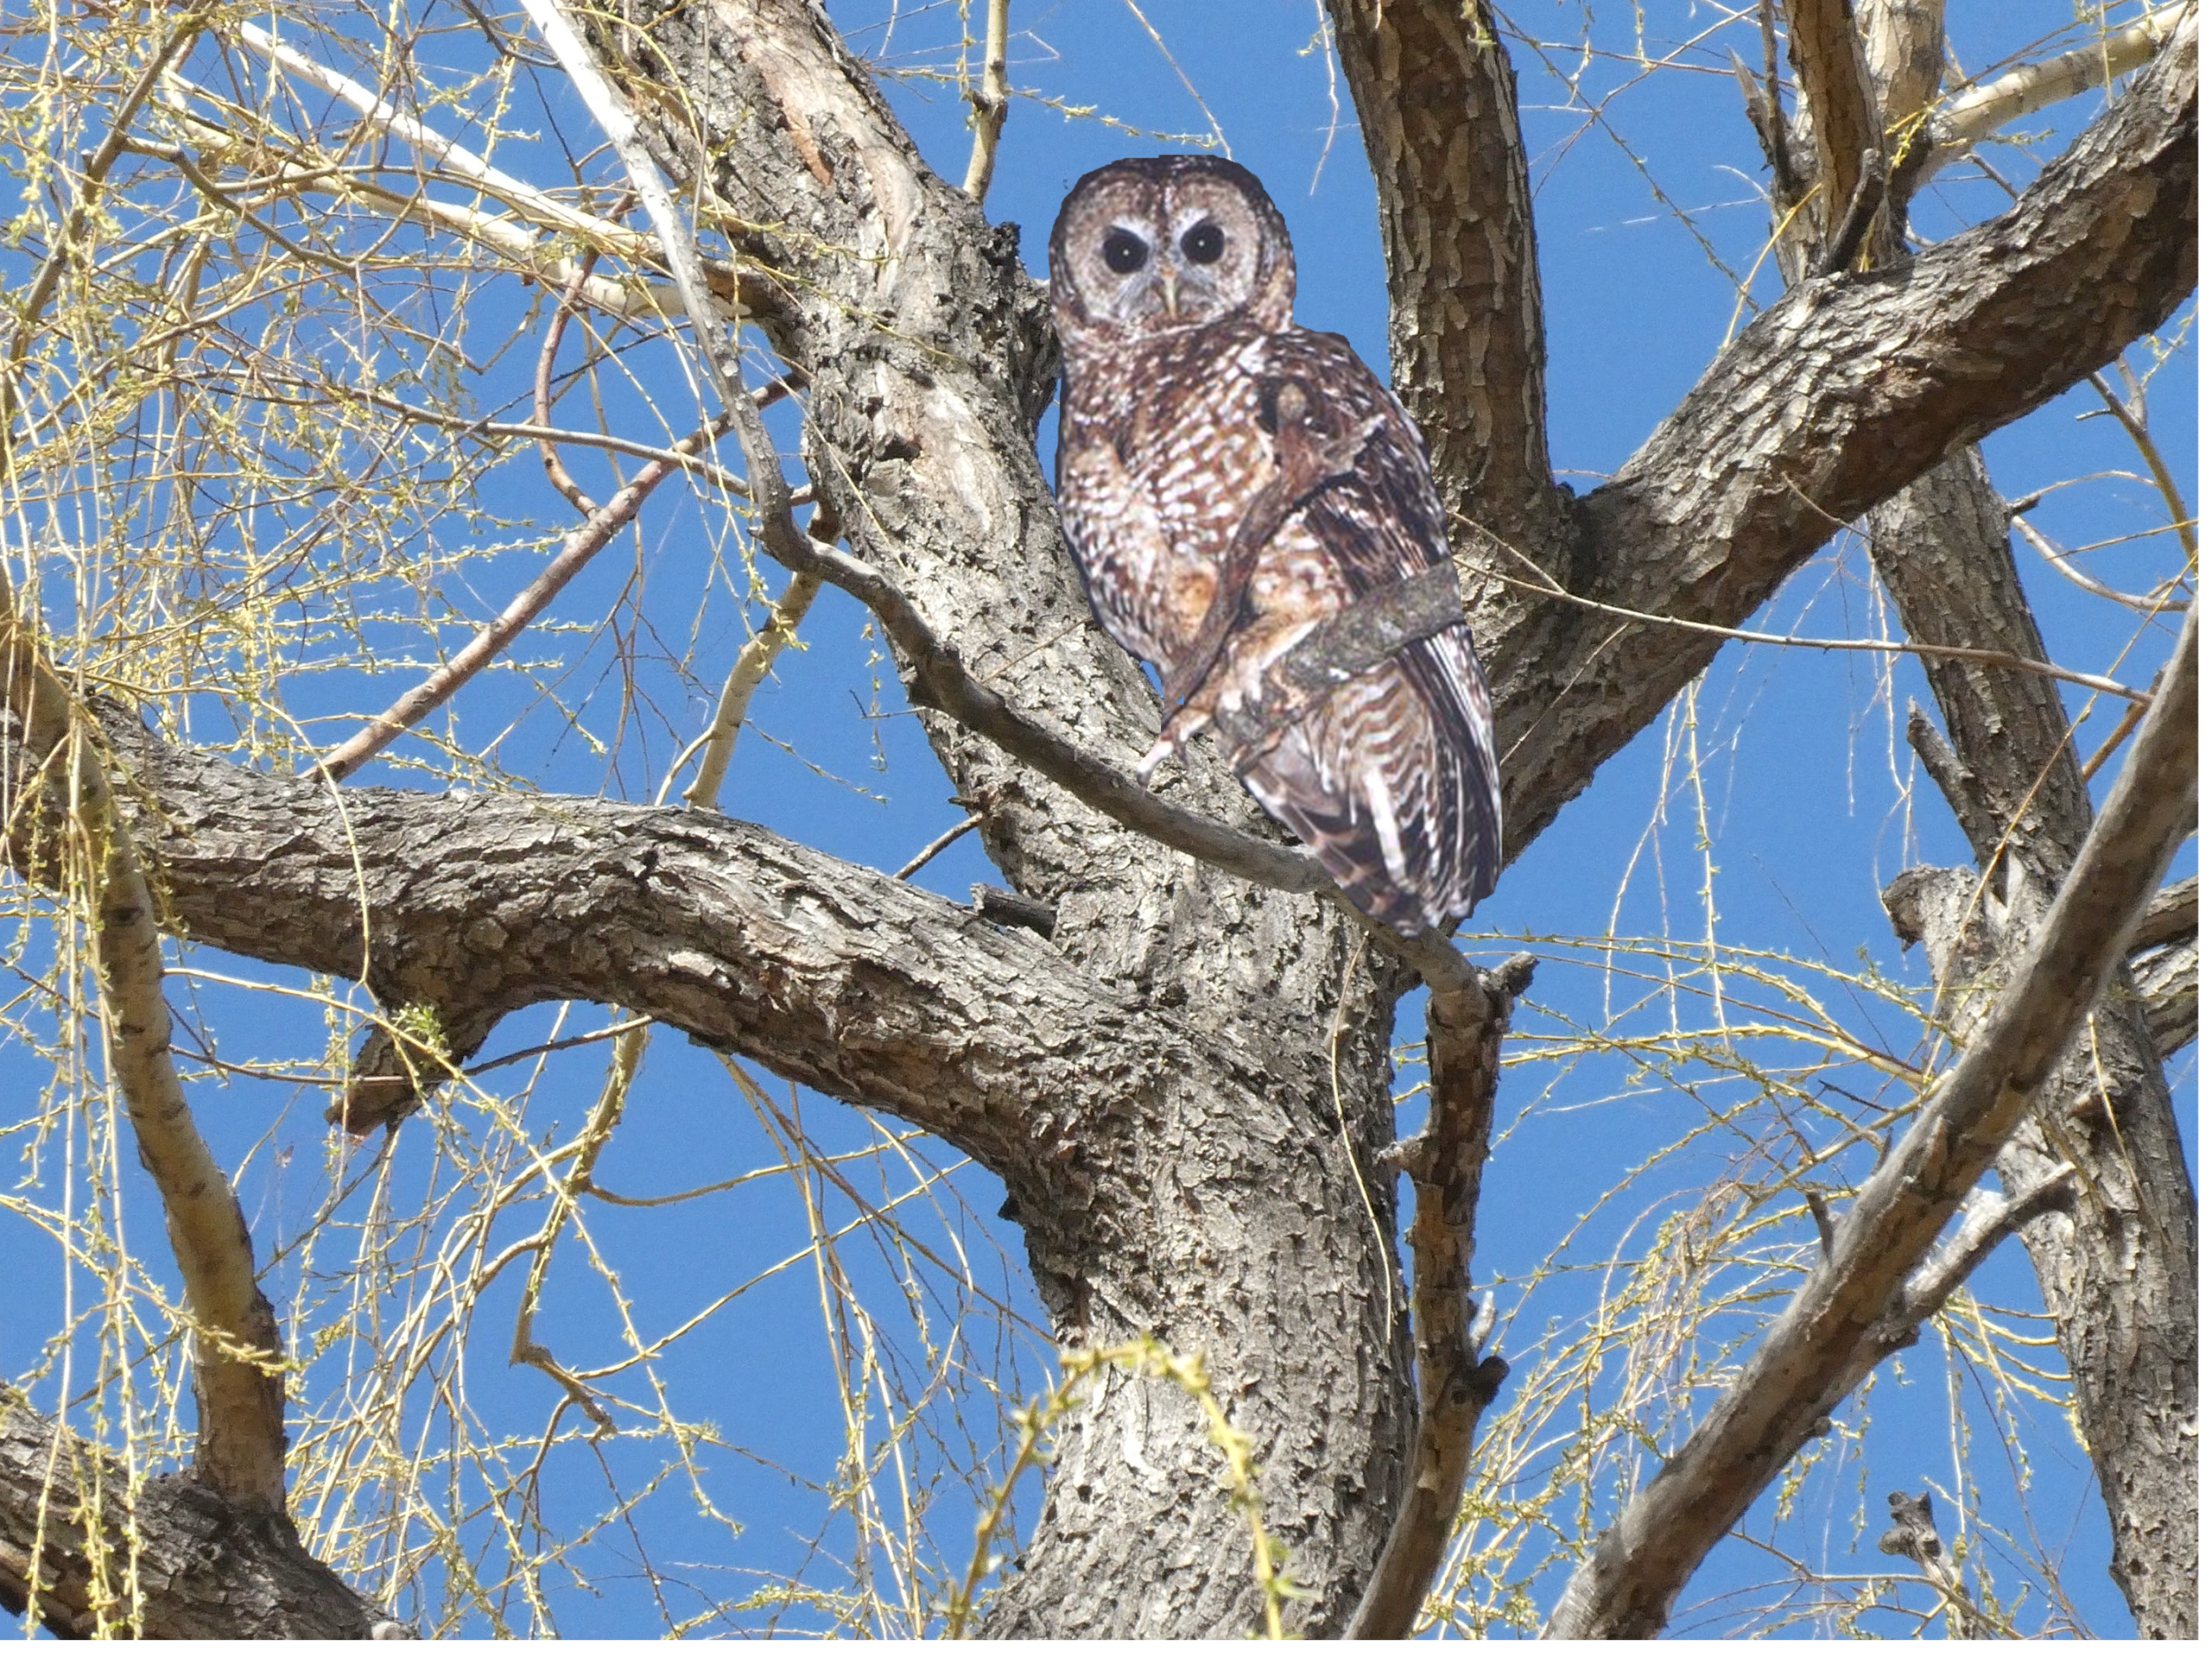

PROCEDURE 2
Procedure 2: Spotted Owl survey transect
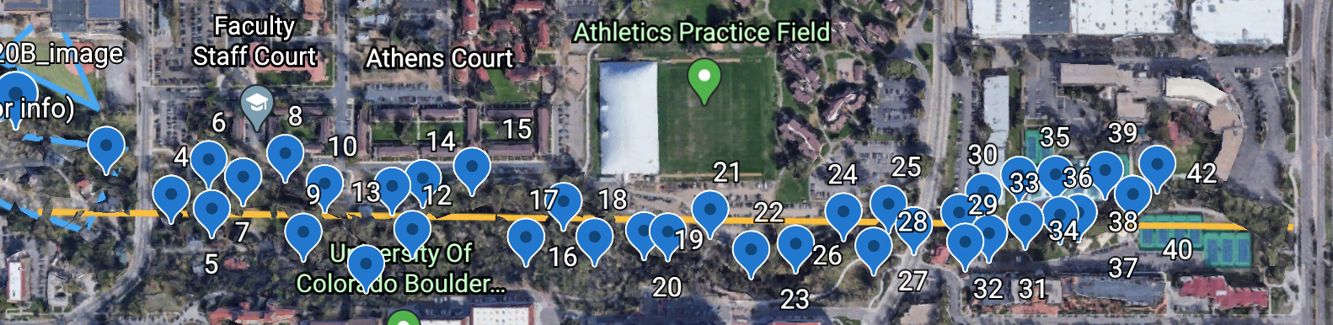
This yellow line is the survey transect for our study. We took photos of all the owls that were spotted along here. You will find photographs of these owls in the Population Ecology/ Alternate Procedures section of Canvas, using the link labeled “Alternate Procedure 2 images”. You will be identifying all of the spotted owls you see as you “walk” along this transect.

FIRST, read through the Procedure 2 instructions and examples found in “Population Ecology/ Procedure 1 and 2 Instructions” to correctly identify and record all of the Spotted Owls you see.

THEN go through the Owl Images folder and identify all of the Spotted Owls from each of the 42 locations. You have already visited locations 1 and 2: they were Owls 2020A and 2020B. You only need to record them once. Use either the ID Guide in your manual (p. 169-170) or the color photos in the Canvas “Identification Guide” to help you with your identification. Add the complete information for each owl to your table on page 171.

Do ask your TA if you have any questions. Have fun!

