Anatomy
Student’s Name
Institution of Affiliation

Answer to question 1
Mechanical energy which helps in movement
Electrical energy in nervous impulse transmission
Heat or thermal energy essential for maintaining body temperature
Chemical energy, mostly the storage form of energy
Answer to question 2
Oxygen, Nitrogen, Carbon, Hydrogen
Oxygen is very important for cellular respiration and therefore energy production. Nitrogen is utilized by the body to make amino acids which make up proteins, important structural components of the body. Carbon is the basic building block for many body cells and hydrogen bonds with carbon nitrogen and other elements to form structural compounds in the body (Ashley Koff, 2018).
Answer to question 3
An isotope refer to each of two or more forms of an element that contain equal numbers of protons but different numbers of neutrons in their nuclei while radioisotopes refer to isotopes of elements which have an unstable nucleus and emits radiation during its decay to a more stable form. Radioactive decay releases gamma rays which upon meeting an electron they destroy each other. The detection of these rays and this radiation activity is the basis of the functioning of the PET scans (Helmenstine, 2018). This creates 3D images of the part of the body in question. An example of application of radioisotopes and radioactively labeled molecules is in medicine where they are used as tracers for diagnosis of abnormal bodily processes and dysfunctional organs.
Answer to question 4
X-Ray test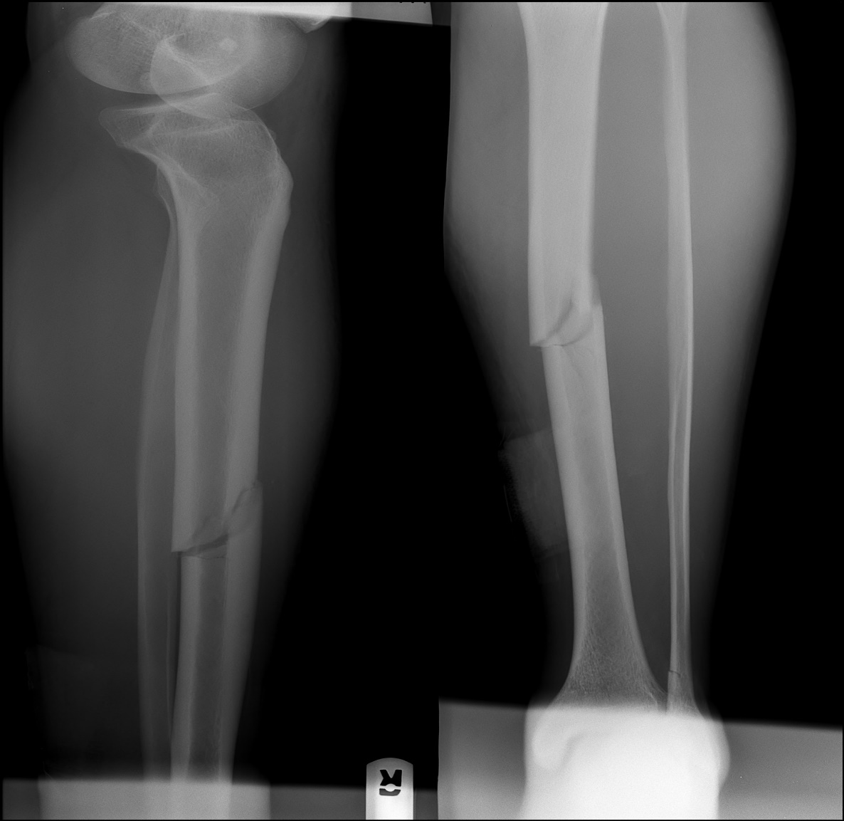
Can be used to diagnose a broken fibula. The radiation exposure is as follows; xrays pass through the body and are absorbed in different amounts depending on the type of tissue material. Dense materials such as bone and metal will show up as white air as black and fat and muscle appear as grey on the xray image.
https://goo.gl/images/ywKDVW
CAT scan
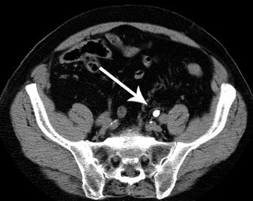
https://goo.gl/images/8sbUHC
DSR test
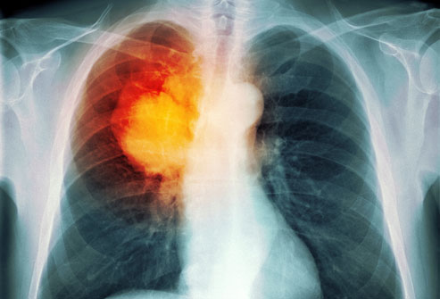
https://goo.gl/images/hpMqzy
PET scan
The radiation exposure dose is usually low and safe. It can be as low as 7mSv for the whole body.
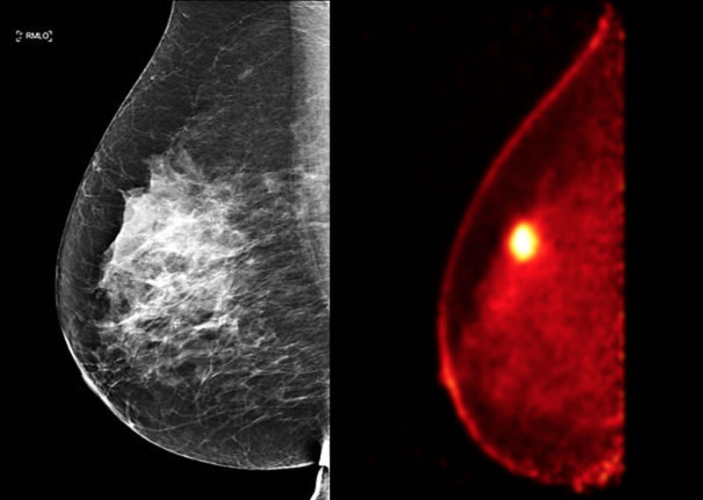
https://goo.gl/images/gdafPD
Sonography
Can be used to diagnose a baby in utero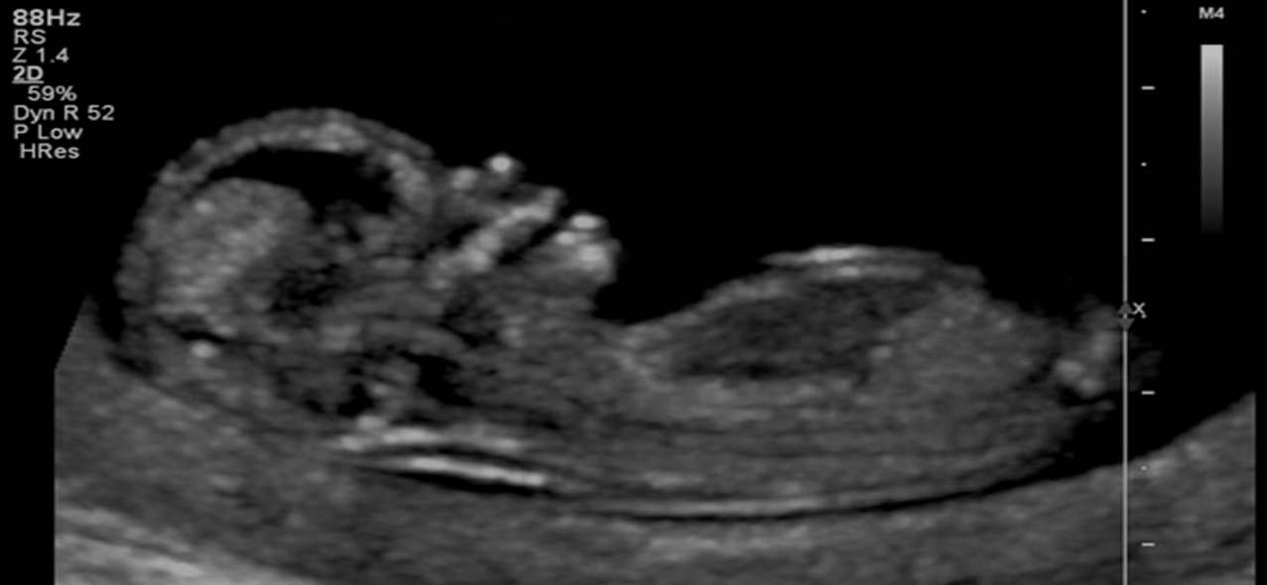
https://goo.gl/images/99oHN9
MRI Scan
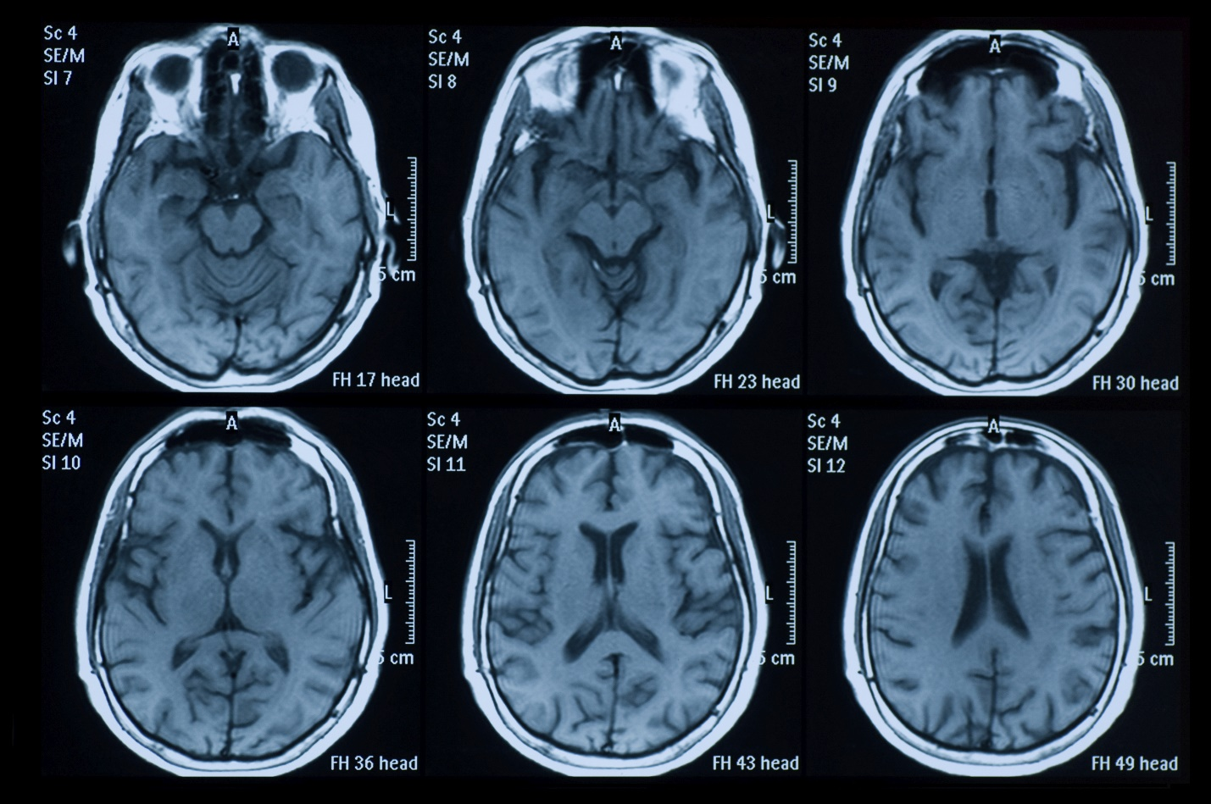
It is suitable for diagnosing brain tumors. https://goo.gl/images/Vt9DnE
It can also be used to detect Alzheimer’s disease and torn knee cartilage.

Answer to question 5
A covalent bond is a chemical interaction or bond formed by sharing of electrons.
An example of a covalent bond is the bond between 2 hydrogen and 1 oxygen to form a water molecule.
Answer to question 6
The blood needs an environment which is stable in terms of pH to function properly and avoid cell death, respiratory acidosis and alkalosis. The pH of blood is usually between 7.35-7.45. It can only vary with 0.05 because of the presence of buffers in the body like hydrogen carbonate ions. Carbonic acid and bicarbonate ions make up the most efficient buffer system in the body. The bicarbonate usually neutralizes excess acids in the body and the carbonic acid excess bases hence maintaining the pH at a relatively constant level (James, 2018).
Answer to question 7
The pH is 1.5-3.5 in lumen of a human stomach. When the stomach releases excess acids, heartburn, sour stomach, acid indigestion and stomach upset manifest; an antacid can be taken to neutralize these effects and reverse the conditions (James, 2018).
Answer to question 8
The electrolytes are sodium potassium and chloride. These electrolytes are important because they help replenish the electrolytes lost during sweating in a vigorous activity. The also help the body in water retention hence helping it make the most of water. Therefore drinking Gatorade instead of water might be necessary to replenish both water and electrolyte balance in the body as water contains very little electrolytes (Jason, 2017).
Answer to question 9
Examples of inorganic compound are sulphates, phosphates, iron (iii) oxide and hydrochloric acid.
The main distinguishing factors between organic and inorganic compounds are the presence of carbon atoms or carbon hydrogen bonds. Most organic compounds contain carbon within and also carbon hydrogen bonds while inorganic compounds do not.
Answer to question 10
Carbohydrates and sugar refer to the same thing, however carbohydrate can come in two forms; simple sugar or conjugated sugar that is starch. They are however broken down to the same molecular constituents whilst in the body. Examples of monosaccharides include glucose, fructose and galactose. Examples of polysaccharides include glycogen, starch, cellulose and chitin.
Carbohydrates are broken down in the body into glucose which is metabolized to produce energy in the body. I approve that it doesn’t matter the form in which carbohydrates are taken because they are all broken down to glucose in the body through metabolism.
Answer to question 11
The different forms of lipids are Fatty acyl, Glycerolipids, Glycerophospholipids, Sterol lipids, Sphingolipids. Unsaturated fatty acids are liquid at room temperature and unlike saturated. They differ from saturated fatty acids in that they contain one or more double bonds while saturated fatty acids have only single bonds. Unsaturated fatty acids are healthier than saturated fatty acids as they have been shown to lower blood cholesterol which is implicated in the development of coronary heart disease when in excess.
Answer to question 12
Amino acids are the basic building blocks of proteins. They combine in different proportions to form different proteins. Enzymes are organic catalysts which are needed in the body for metabolic pathways, respiration, digestion and other important life processes. Enzymes speed up metabolic processes and digestion in a rate that supports life. Enzymes react with substrates to produce products in cells. A defective or missing enzyme leads to many diseases, e.g. phenylketonuria results are a disease which comes as a result of defective gene for the enzyme phenylalanine hydroxylase. Some enzymes help the body in detoxification e.g. catalase in the liver cells helps break down toxic hydrogen peroxide into harmless water and oxygen.
Answer to question 13
Nucleic acid is complex organic substances found in living cells especially in the nucleus which consist of many nucleotides linked in a long chain.
The two examples are Deoxyribonucleic acid (DNA) and Ribonucleic acid (RNA).
DNA differs from RNA in function in that it is solely responsible for storing genetic information in a coded sequence. The DNA combine in the nucleus to form chromosomes while RNA is responsible for taking the information stored in DNA to mitochondria or endoplasmic reticulum and coding for different proteins through transcription (Claridge, 2016).
Answer to question 14
ATP is short form for Adenosine Triphosphate. It is the energy currency of life, a high energy molecule that stores energy which can be released when it’s broken down.
ATP uses in cells include; Movement-ATP breakdown helps in muscular contraction, spindle action in living cells and ciliary action. ATP is used to provide energy in building of macromolecules such as DNA, proteins and polysaccharides. Thirdly ATP is used to power up enzymes to function properly and efficiently (Claridge, 2016).
Answer to question 15
In forensic medicine DNA finger printing is used in criminal identification whereby the molecular characteristic of a scene of crime sample be it blood or semen is determined and compared with the samples of the suspects. Where the patterns match then a possibility that the samples are from the same source is strengthened and thus the suspect is probably the criminal. But is if they do not match then the suspect is probably not the criminal (Claridge, 2016).
Answer to question 16
DNA structure is important to me in disease treatment of diseases because of its application in Recombinant DNA technology. Through this technology, important proteins required for health problems and dietary purposes can safely be produced at an affordable cost in sufficient amounts. This technology is applied in treatment of diseases e.g. in diabetes human insulin is nowadays produced by genetically modified bacteria. Erythropoietin is also produced in a similar way (Claridge, 2016).
I think that the future of disease treatment in medicine will be through altering DNA. I think it is a very good idea because it provides a lifelong solution which can be passed down to offspring as DNA is inheritable.
References
Ms. Ashley Koff (2018). What are the different forms of energy in the body? Share care. Retrieved from https://www.sharecare.com/health/energy-boosters/what-different-forms-energy-body
Anne M. Helmenstine, Ph.D. (2018). Isotopes definition and examples in chemistry. ThoughtCo. New York. Retrieved from https://www.thoughtco.com/definition-of-isotopes-and-examples-604541
James L. Lewis, MD (2018). Overview of acid base balance. MSD Manual Consumer version. Kenilworth. Retrieved from https://www.msdmanuals.com/home/hormonal-and-metabolic-disorders/acid-base-balance/overview-of-acid-base-balance
Jason Dority (2017). Electrolytes in Gatorade. Livestrong.com. Mumbai. Retrieved from https://www.livestrong.com/article/502971-can-gatorade-elevate-potassium-levels-in-the-blood/
Jack Claridge (2016). DNA Fingerprinting. Explore Forensics. Retrieved from www.exploreforensics.co.uk/dna-fingerprinting.html

