Student’s Name
Professor’s Name
Course
Date
Sickle Cell Anemia
INTRODUCTION
Sickle cell disease is a congenital disorder of the red blood cell (RBC) whereby the RBCs are insufficient to transport oxygen all through the body. Typically, the RBCs are characterized by the shape of a disc that makes them flexible to travel via small and large blood vessels. Nonetheless, in sickle cell disease, the RBCs are characterized with an uncharacteristic crescent shape that bears a resemblance to a sickle. This makes them sticky, rigid, and susceptible to being stuck in narrow vessels, thereby obstructing the flow of bloods to different body parts. In this regard, an individual feels pain and can suffer damage to tissues. The paper’s thesis seeks to examine sickle cell anemia by demystifying its causes, symptoms, complications, risk factors, diagnosis, and treatment.
CAUSES
Sickle cell anemia is a hereditary disorder initiated by transformations within the beta-globin gene, resulting in hemoglobin S (Pecker and Lanzkron p.91). Typically, the hemoglobin within the RBC carries oxygen blood from the lungs transporting it to other body parts. Most importantly, the RBC with normal hemoglobin is disc-shaped and flexible to aid them in moving with ease through small and large blood vessels to convey oxygen to body tissues. However, sickle hemoglobin has an abnormal shape compared to normal hemoglobin. Thus, mutations within the gene can be problematic when the oxygen levels within the blood are insufficient after the hemoglobin has transported oxygen to different tissues of the body. Hence, fewer oxygen levels ensure that the uncharacteristic hemoglobin S gene can prompt inflexible, non-liquid protein constituents create within the RBC, thereby changing the cell’s shape and bringing about the red blood cell with sickle cell.
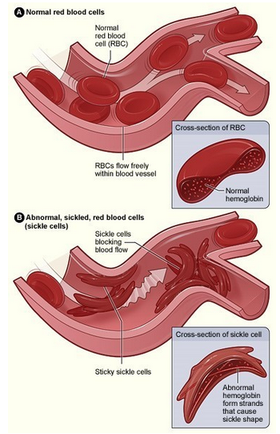
The hemoglobin S gene is passed on to offspring from a parent having the single-cell trait. When a parent with a single cell trait has inherited the hemoglobin S gene, a typical hemoglobin gene is usually passed on from another parent. An individual begotten has higher chances of contracting the sickle cell trait. Nevertheless, individuals who possess the sickle cell trait led to healthy lives. They infrequently have complications recognized in characters with sickle cell anemia. Persons with sickle cell traits carry a faulty hemoglobin S gene that their newborns can inherit. Also, when the other child's parent has atypical hemoglobin genes like hemoglobin C or thalassemia, the probability of the child having sickle cell anemia is high.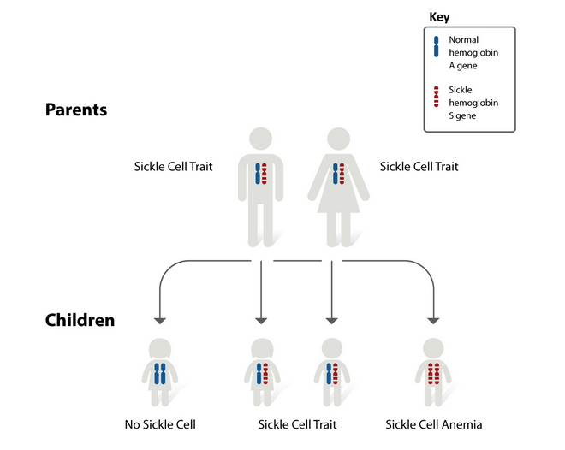
Risk Factors
A baby or a newborn born with parents having a sickle cell trait is likely to contract a sickle cell anemia. In America, sickle cell disease is prevalent in African Americans. This showcases that many black people have the sickle cell trait making them their babies or children susceptible to the disease.
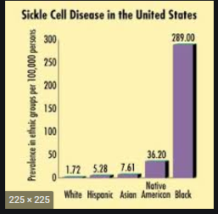
Signs, Symptoms and Complications
When an individual has sickle cell anemia, he or she inherited it from the parents. However, most newborns have no problems with the disease till they have grown to 5 or 6 months. The indications of the ailment differ from individuals and may change after some time. Typically, a person can exhibit symptoms based on how the disease distresses their health. Some of the primary signs and indicators of sickle cell disease encompass:
- Painful swelling on hands as well as feet a condition referred to as dactylitis.
- A person experiences fussiness or fatigue
- The skim of a person turns yellow (jaundice) or white (icterus) that happens when multiple red blood cells go through haemolysis.
- Delayed puberty
- Difficulty in breathing
- A fast heart rate
Also, people with sickle cell anemia undergo certain complications in their health:
- They experience acute chest syndrome. The disease deprives the lungs of sufficient oxygen (Ochocinski et al., p.39). Hence, it can damage the lung tissues and lead to chest pain, fever, and difficulty in breathing.
- Sickle cell disease is characterized by acute pain crises. Normally, sickle cells impede the flow of blood, causing painful sensations that attack almost everywhere within the body. The pain is sharp, intense, piercing, or excruciating.
- Sickle cell disease is accompanied by heart complications like coronary heart disease as well as pulmonary hypertension.
- The disease can result in delayed growth and puberty in children.
A child that has sickle cell anemia can experience slow growth and development than their peers. Even though children with the disease will attain their full sexual maturity, it will be delayed.
Severe sickle cell anemia complications are life-threatening. For instance, newborns or children with severe anemia are likely to have undergone aplastic crisis along with splenic sequestration crisis. A parvovirus B19 infection characteristically triggers aplastic turmoil, a common health problem in sickle cell anemia. It prevents the manufacture of the RBC by the bone marrow for some time resulting in sickle cell disease. A splenic sequestration crisis occurs when the spleen sifts the blood and recompenses old RBCs. Individuals with sickle cell anemia may have blood locked in in the spleen that can develop abnormally large. This makes red blood cells get stuck in the spleen, leading to scarce red blood cells circulating in the bloodstream. An enlarged spleen can result in pain within the abdomen’s left side.
DIAGNOSIS
When an individual undergoes various screening tests showing that he or she might have the condition, a doctor may utilize different tests to diagnose sickle cell anemia. One way is through screening tests (Delgado-Font et al. p.121). Individuals who seek to know if they have sickle cell disease can do so by undergoing screening tests. In this regard, they will see whether they have a genetic factor for abnormal hemoglobin that their offspring will inherit. After acquiring such facts, parents will remain knowledgeable concerning the chances of giving birth to a newborn having sickle cell anemia. Also, newborn screening is a blood test that a child can undertake. When a baby has been found to have sickle cell anemia, health practitioners inform and counsel the parents on the appropriate medical services that the child has to be provided with.
TREATMENT
Sickle cell anemia is a deadly disease that can result in the death of an individual if left untreated or when the sickling person is not provided with essential medication. The disease can be treated through blood transfusions (Tisdale, Thein, and Eaton p.111). This technique is vital for people with severe sickle cell anemia since it helps alleviate a rapid deteriorating of anemia caused by infection or enlargement of the spleen. However, numerous blood transfusions can result in health glitches due to iron overwork, recognized as hemosiderosis that can destroy the liver, heart, pancreas, and other vital organs in the body. Besides, a transplant of the blood and bone marrow is a natural antidote for people with anemia. Typically, doctors endorse medications that help cope with the complications associated with sickle cell diseases such as chronic pain or heart problems. Moreover, newborns with sickle cell anemia must be taken to a hematologist to be provided with better ways of managing the disease.
Various medicines have been recommended by the US Food and Drug Administration (FDA) to be used for offering treatment of sick cell anemia in adults and children. Voxelotor is a medicine ratified by the US Food and Drug Administration in 2019 to treat the disease. It can be used by grownups as well as children aged 12 years and above. However, its potential side effects encompass diarrhea, headache, nausea, fatigue, fever, and many more. Penicillin is another medicine that can be used by children who have sickle cell anemia. Other medications used to treat sickle cell disease include hydroxyurea and crizanlizumab-tmca (Power-Hays, and Ware p.172).
Conclusion
Sickle cell anemia is a genetic disease that can be passed on from the parent to their offspring. It is associated with various health complications that can be life-threatening to a person with sickle cell anemia. Some of the difficulties include chronic pain, damage to the vital body organs – heart, liver, and kidney – tissues and bones. Even though no cure has been found for most patients having the disease, different treatments can boot out pain and aid in forestall problems related to the disease. Some of the treatments include blood transfusion as well as blood and bone marrow transplants. Parents with sickle cell anemia should consider seeking the medical help of hematologists to provide appropriate medical intervention regarding their newborns or babies.

Works Cited
Delgado-Font, Wilkie, et al. "Diagnosis support of sickle cell anemia by classifying red blood cell shape in peripheral blood images." Medical & biological engineering & computing 58.6 (2020): 1265-1284.
Ochocinski, Dominik, et al. "Life-threatening infectious complications in sickle cell disease: a concise narrative review." Frontiers in pediatrics 8 (2020): 38.
Pecker, Lydia H., and Sophie Lanzkron. "Sickle Cell Disease." Annals of Internal Medicine 174.1 (2021): ITC1-ITC16.
Power-Hays, Alexandra, and Russell E. Ware. "Effective use of hydroxyurea for sickle cell anemia in low-resource countries." Current opinion in hematology 27.3 (2020): 172-180.
Tisdale, John F., Swee Lay Thein, and William A. Eaton. "Treating sickle cell anemia." Science 367.6483 (2020): 1198-1199.

