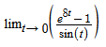
Test L’Hopital condition: 0/0
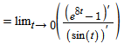
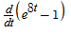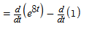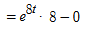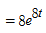
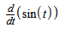
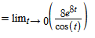
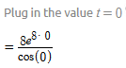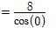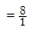
Question #1:
f(x)=x^3-12x^2-27x+3
f'(x)=3x^2-24x-27
3x^2-24x-27=0
critical points are x=-1,9
Therefore, f(x) increasing on (-inf,-1),(9,inf) and decreasing on (-1,9)
f"(x)=6x-24
inflection point at f"(x)=0
6x-24=0
x=4
the function is concave up on (4,inf) and concave down on (-inf,4)

Question #2
Test L'Hopital condition 0/0
Lim t-->0 ((e^8t-1)'/sint')
d/dx(e^8t-1)=e^8t*8=8e^8t
d/dx(sint)=cost
Lim t-->0 ((e^8t-1)'/sint')=Limt-->0(8e^8t/cost)=8/cos(0)=8/1=8

Question #3
f(t)=t^3-12t^2+36t
velocity = f'(t)
f'(t)=v(t)=3t^2-24t+36
v(5)= 3*25-24*5+36=-9
v(t)=0
3t^2-24t+36=0
t = 2,6
particle is rest at t=2,6
f(8)=96ft

Question #4

h(-3)=(-3)^3+3*(-3)^2+8=8
Therefore, absolute minimum is 8
h(2) = 2^23+3*2^2+8=28
Absolute maximum is 28

