Andrea Palladio’s La Rotonda (Villa Capra) Vicenza
Name
Institution
Date

Introduction
The Villa Rotonda Vicenza is a villa of the Renaissance era which is located in the Northern Italy area, just outside the Vicenza. The villa is popularly designed by the Architect Andrea Palladio. The villa when designed initially as named as the Almerico Villa Capra Val Marana. However, the name was then changed to a more popular Villa Capra La Rotonda (Borys, 2017). The villa also goes by the names Villa Rotonda, La Rotonda, Villa Allmerica and Villa Capra. As it is, the name Cara was conjured by the architect deriving it from the brother who had taken up the responsibility to complete the building after it was officially ceded to them before completion in the year 1592, the Capra Brothers (Wassell, 2015). Along with other works of the famous Palladio Andrea, the Villa Rotonda is conservation among the City of Palladian and Vicenza Villas of the Veneto World Heritage. It is famously quoted to be childbirth of the inspiration acquired from the retirement of the priests Paolo Almerico who was to be allocated one of Palladio's bets legacies to the architectural world (Hind, & Murray, 2010). The priest Almerico was retiring to his home village at Vicenza in Italy in 1565 for the Vatican having served as Pius V, and before as referendario apostolico Pope Pius V. It has been an inspiration to a thousand more villas alike built by Andrea Palladio and many other great architects in the nearer future in subsequent buildings. The Villa was, however, an inspiration from the Roman Pantheon whose design takes a major depiction in the Villa Rotonda.

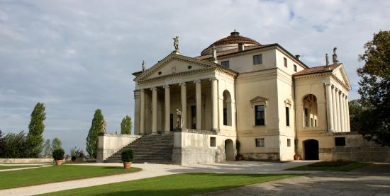

Structure and Design
The site picked to build the villa was fundamental in affecting its design. It was built on a hilltop located outside the Vicenza. It took time to come up with the complicated plan of the building at the Renaissance era as it was not initially designed to host a working am inside it in comparison to the other villas of Andrea Palladian. In modern terms, the site was designed for a suburban structure and a sophisticated building (Berenson, 2013). It was classified by the architect as a palazzo instead of a villa as it is commonly referred to by renaissance building enthusiasts. The design was set to come up with an entirely symmetrical structure of a building which had a plan that took on a symmetrical square shape. The plan had four facades each having a projecting portico. The building was primarily designed with a whole that was contained within an imaginary circle touching all the corners of the structure (Scamozzi, 2014). It is then centered at the central position of all the porticos of the architecture. The structure as described is what developed the name Rotunda Villa. The Whole at the center of the porticos is what is referred to as the rotunda. As Andrea Palladia did mention, it is therefore incorrect to refer the villa solely as rotunda as it only refers to one part of the whole building, the dome. The building is this case is not circular rather a symmetrical. The Villa Rotunda is more of a reflection of humanists essence of the Renaissance era architecture. It was designed in a 45 degrees rotation from each of the cardinal points to allow penetration of the sun, not the structure (Wassell, 2015). The pediments are graced by classical structures of deities, and a semicircular dome covers the villa as was designed by Vicenza Scammozi after the death of Palladio (Borys, 2017). The dome has a cupula cetin it at the top. The interior is painted and contains salons. The Holy room which is the West salon having paintings and frescoes carrying a religious theme (Berenson, 2013). The east salon hosts the story of the owner, Paolo Almerico and his qualities. The atmosphere in the interior of the villa is more Catholic reminiscent attributed to the abundance of frescoes and trompe l'oeil on the cupola walls.
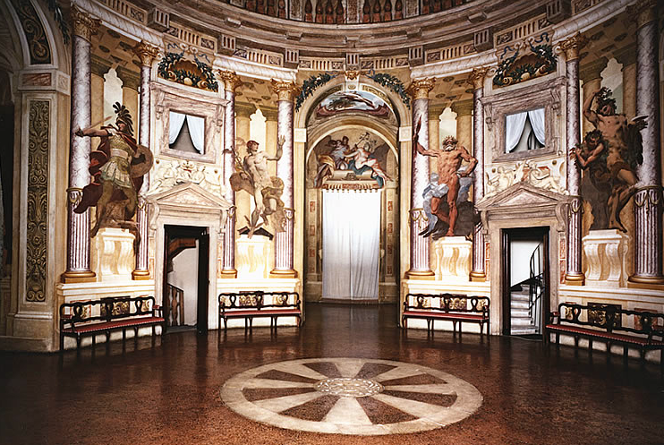

The two structure maintain the renaissance aspect of the spiritual dimensioning. The church, for example, is a basilica. It maintains the classical style of a renaissance in buildings. Similar to the rotunda, it has a design depicting religion and affiliating it to the stench religious beliefs of the renaissance era (Berenson, 2013). The Villa Rotonda n the other hand, other than having a dome representational of the spiritual dimensioning, the interior of the villa is more Catholic reminiscent attributed to the abundance of frescoes and trompe l'oeil on the cupola walls.
They also affiliate to the renaissance aspect of the architecture of cultural, geographical, political and religious influence on their design and structuring. The Church of San Giorgio Maggiore, Venice carry heavy political and religious influence on is its very existence in the first place. The first church was built between the years 720 and 982 as a tribute to the Benedictine order. It was gifted by the Doge Tribune Memmo. It is a 16th-century Benedictine church famous for its renaissance style of design having a heavy religious influence (Scamozzi, 2014). It was also influenced by its geographical aspects as it was on an island and was challenging to develop as the Benedictory design of renaissance churches. The Villa rotunda was also religiously influenced as a gift retirement of the priests Paolo Almerico having served as Pius V and before as referendario apostolic Pope Pius V. It design also relied heavily on its strategic positioning outside the Vincenza (Hind & Murray, 2010). It was placed on a site at the top of a hill and therefore needed to fit the site setting depicting heavy geographical influence.
The Villa Rotunda is also famously known for the entrance points of the building. The stretches at the gate are rectangular divided through its diagonals and then superimposed on the entrance arches. The grid to the front of the gates form a rectangular loggia (Scamozzi, 2014). One of the most challenging of its aspect is how it was surgically developed in the renaissance time. The arches in the loggia would later revel the geometrical construction of all the elements of the arch’s. One can develop two rectangle figures that depict how Andrea Palladio achieve this fit. The two figure can emanate from the top of the ground floor and the other one form the top of the top of the ground level (Wassell, 2015). Dividing the first rectangle into three vertical thirds, it is becomes visible that the upper third would align to the sprig of the imposts.
The loggias project as the element of the main body of the villa rotunda and they are very fundamental to the volumetric composition of the La Rotunda. The villa rotunda (Villa Capra La rotunda) would only appear as a simple hollowed building without the loggias (Borys, 2017). Additionally the stairs create an enhanced perception of the visitor of the La Rotunda as they lead to the transitional space between the indoors and the outdoors. In totality the villa was a successful combination of the main body, the loggias and the stairs in a unique manner.

The Windows of the La rotunda main rooms appear to be centered in the walls of the elevated drawing of Andre Palladio between the interior face of the lateral arches of the loggias and the corners of the building (Wassell, 2015). The actual building was however different seeing as the view from the west point of the Villa depicts that the Villa’s main room windows are not at the center of the wall as they are positioned next to the fireplace. There are also two more windows on the main room of the Villa with one of the windows made facing the interior of the loggia. The other window is positioned around the corner of the building. It gets interesting to understand how the windows were proportioned in the first place. The windows intersect accurately at the upper corner of the windows and the left frame. The surgical intersection these points actually coincide with half the height of the Villa La Rotunda (Wassell, 2015). The same aspect can also be derived from extending the diagonals from the top to the bottom.
Conclusion
Villa Rotund is easily among the most beautiful buildings of the legacy of Andrea Palladio (Hind, & Murray, 2010). The surgical precision of the building developed in the renaissance age is astonishing as each part of the building is in its place with mathematical precession. Catching a glimpse of what could be done by the reminiscent technology, is key to the endowment of the innovative architects of Palladio Andrea. It is for this purpose that the building is under the Unesco World Heritage cites.

References
Scamozzi, O. B. (2014). The Buildings and Designs of Andrea Palladio. Princeton Architectural Press.
Berenson, B. (2013). The venetian painters of the Renaissance. Read Books Ltd.
Borys, A. (2017). Vincenzo Scamozzi and the Chorography of Early Modern Architecture. Routledge.
Hind, C., & Murray, I. Z. (Eds.). (2010). Palladio and his legacy: a transatlantic journey. Marsilio.
Wassell, S. R. (2015). The Mathematics of Palladio’s Villas. In Architecture and Mathematics from Antiquity to the Future (pp. 107-120). Birkhäuser, Cham.

