ENGL 1020
Kyle Crawford
Zaid Al-Harbi

SUMMARY
The author illustrated that students miss a lot of things by not being taught in their family’s - private- language. The Spanish rooted author found it difficult to shift to the public language - English - in discourse of his educational path which, ultimately, led him to lose his confidence. In an effort to overcome the timid behavior of the author, the teachers encouraged the family to use English as a mode of communication at home. Soon the Spanish origin family started losing traces of Spanish accent and became the victim of Americanization. As a result, the cultural cohesion started fading away and, eventually, the closeness in the family diminished. Once, the socially disadvantageous child now became a comprehend American. Now the bilingual author also agrees upon that children lost their individuality in processes of integration in public society.

CRITICAL ANALYSIS
The ‘Public and Private Language’ is an article written by Richard Rodriguez in 1982 in an effort to distinguish between cultural identity and Public norms. Rodriguez highlighted the effects of bilingual education in his contributions to culture and identity. He coins the terms Public language and private language to further his arguments on the subject matter.
According to Rodriguez, it is more beneficial to be familiar with the public language than the private language. The author by telling his own story tried to make a strong case to explain the importance of bilingual education and private and public language. He unambiguously explains the drawbacks and of public language in families of immigrants. He also noted the importance of public language in self-respect and dignity therefore he stresses the need of bilingual education for the people who hesitate in sharing public and private language. He argues that fluency in language and expression of words in public promotes personal and social confidence making one more adept to the challenging circumstances.
By using the personal experience and his father after they, the children, had mastered the public language the he successfully achieved his claims on the subject. Referring to this childhood, Rodriguez had neither confidence in class lectures, nor he could harmonize with the neighbor kids because he was not comfortable in communicating with others freely. According to Rodriguez, he and his siblings come home early and preferred to stay indoors to avoid any interactions before getting confidence in communicating in public language. Rodriguez noted that once they (he and his siblings) get more acquainted with the public language as compared to their parents a barrier of communication started arising between the two generations. Their parents started having difficulties in conversations and they opted to stay silent whenever they were encountered with the public language gathering.
Rodriguez used his father’s behavior - confidence level and way of communication while talking to Spanish fellows as compared to public - as an example to demonstrate how language affects an individual’s public confidence or individuality, He states his father opted to stay quiet in the house, a reflection of his childhood life. He notes that his mother explained that he (his father) lost both of his parents at an early age and was raised by an uncle who neither treated him well nor he was encouraged to speak. However, Rodriguez emphases that this silence cannot be attributed to his father’s childhood experiences, rather it is the power of language that brings the confidence of communication and interaction. Rodriguez noted it was not the shyness or the limited vocabulary his father possessed that made him quiet. Rodriguez supported this claim by narrating an instance of his father talking to his Spanish fellow men in fluency that when his father was using Spanish and interacting with fellow Spanish men that he was very demonstrative, sparky and lively. In Spanish, the private language, he floated ideas and feelings he rarely expresses in English. He seemed more confident and authoritative in Spanish conversation which found absent in him while speaking English. It is worth observing how Rodriguez has perfectly established the stance of his theme in the light of the above example. His articles seek the attention of both young and old group of audiences that how the young generation is being drifted away from the cultural identity they inherent from the parents. The older generation on the other hand stay stiff and oppose any alien intervention to their private life. This tug and war dilute the private family bonding and gives rise to a communication and cultural gap. However, he focused more on communicating the power of public language, along with keeping some of the private languages, which composes the person and builds a strong character.
Richard Rodriguez’s essay “Private Language, Public Language” explicitly relays the main idea of the essay. Public and Private language are an antipode to each other which this essay continues to prove to his audience. The essay begins with highlighting a cultural eccentric person who is bilingual as well. Rodriguez’s essay is an autobiography of how he, an immigrant, migrates to America and recognize the cultural differences between his innate identity and American society. Following along, Rodriguez proclaim the purpose of his writing to the audience, in a simplistic and structured approach, by pointing out the difference between Private and Public language.
In order to grasp the main theme of the essay one has to identify the repetitive difference between the public - English, which is outside language normally associated with gringos - and the private language - Spanish, which they speak fluently at home. Rodriguez’s main idea establishes the fact that there is always a difference in the way we speak at home and in public. The reason for this distinction can be due to the inherently different language spoken at home and then relating it with the external public language. Rodriguez’s point is stated through his own retrospective insight of his early life.
Furthermore, Rodriguez is not able to support his thesis with the use of statistics or any research tool. he did not take interviews of other immigrants to support his point of view. He did not explain the term bilingual education explicitly and did not quote any authority to prove his thesis.

VISUAL ESSAY

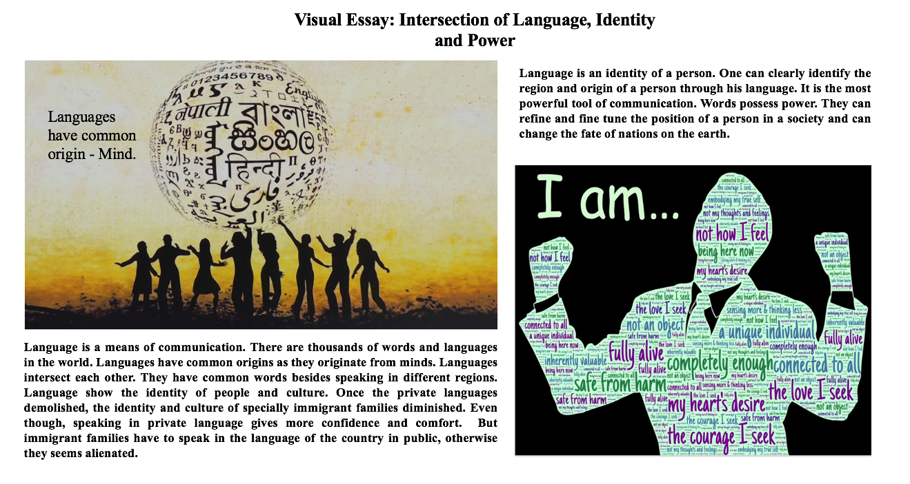

References
Rodriguez, Richard. "Public and Private Language." Seeking
Common Cause: Reading and Writing in Action Ed. Diane
Durkin and Lisa Gerrard. New York: McGraw-Hill, 2008. 51-55.

