Rosalind Ragans ArtTalk . He discussed the different relationships humanity has with nature, how nature is affected, and how we perceive it. He asked the question, what do we consider beautiful and why? Is it motivated by its use to us (i.e. cleared fields, crops, and livestock for our consumption) or is it simply for its actual natural beauty? Human survival has always depended on close contact with nature. There are instincts left from our not so distant hunter gatherer days and appreciate the prospective of an elevated viewpoint because at one time we could observe game or possible enemies from a distance. Love trees because we depended on them for cover or refuge and fuel. Our landscape aesthetics is most likely a product of our culture. He also discussed the “Insider vs. Outsider” to the landscape.
The insider actually lives on the land and within the landscape. The outsider lives in the city and visits the landscape. He views it from the outside (i.e. wealthy visiting nature for hunting or sport). The Insider (ranchers and farmers who work the land) went to the city in hopes of selling what they grew on the land. The Gardens of Versailles (17th century) in France were designed for the visitor or the outsider’s view and meant to impress and be viewed in its entirety. Japanese Gardens (17th century) were built for the insider. They were individualized and have a noted lack of straight lines. The nature was meant to be enjoyed with all senses, slowly and walked through.

Since humans have been on earth they have been inter-connected and dependent upon nature for survival. Societies have formed and disappeared because of the availability or the lack of natural resources. History tells us that our first civilized societies formed around 10,000 years ago in ancient Egypt, Mesopotamia, ancient India and ancient China (Wiki). The earliest known piece of art depicting man’s relationship with nature is considered to be a cave painting that dates to almost 37,000 years ago. It’s a landscape image of an erupting volcano (a megaloceros was added later) on a wall located in Chauvet-Pont d’Arc Cave in France (paper published in the Open Access scientific journal PLOS ONE. smithsonianmag.com/smart-news/chauvet-cave-paintings-could-depict-year-old-volcanic-eruption-180957861/). This cave is a World Heritage site.
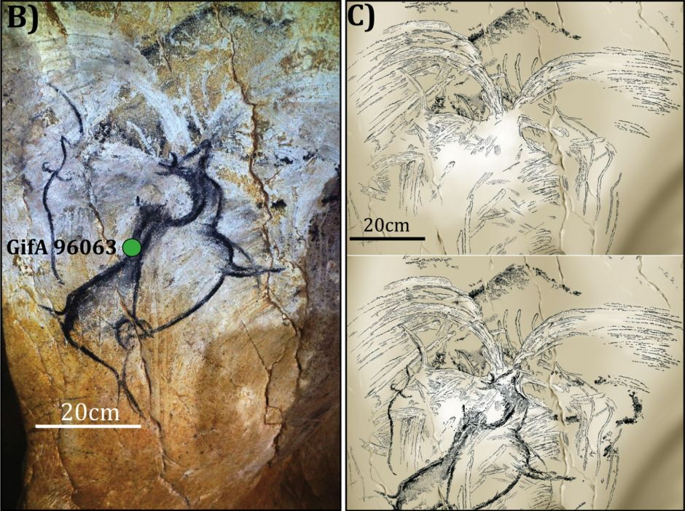
Discovered in 1994. ”Anonymous, Volcano in Eruption (c 36,000 BP), pigment on limestone mural, 60 x 60 cm, Chauvet-Pont d’Arc Cave, Ardèche, France. B is the original panel (date sampling site shown in green), and C the constructed time sequence of layers. The photo in B was taken by D Genty, and the images in C by V Feruglio and D Baffier. These images are © 2016 Nomade et al.”
The Chinese have a long cultural history connecting art with nature. Since their earliest dynasties, artists have depicted nature with real and imaginary animals - dragons, serpents, bovines and cicadas and endowed them with special powers. The mountains were imagined to have sacred powers and depict scenes of nature’s energy (qi) and given credit for watering crops, protecting herbs, providing magical fruits and minerals.
Caves were considered entries into other realms where aging is stopped and you could live in harmony (metmuseum.org/toah/hd/cnat/hd_cnat.htm). Dragon images are prevalent throughout Chinese history and as far back as 6,800 years ago was used for designs on pottery as evidenced by a shard found from a Pan-p’o Yang-shao site in the Shensi province (npm.gov.tw/exhbition/dro0001/english/introduction.htm).
Dragon images are found on Neolithic pottery and jade carvings. In the Bronze Age they were associated with powerful and sudden natural elements like wind, thunder, and lightning and associated with superior beings, rulers and sages.
During the Han dynasty, the dragon was used for the imperial symbol. It’s interesting to note that dragon sightings were officially recorded and considered a sign of good fortune. Chan (Zen) Buddhists considered the dragon a symbol of sudden enlightenment. Two Flasks of the Ming dynasty,1403–1424, Porcelain jars with underglaze cobalt blue decorations, are beautiful examples of the dragon and nature depicted in Chinese art. One flask has a “background of plant designs and the other has a white dragon silhouette floating in the ocean waves (pg. 813, sixth edition, vol. II Art History and class discussion/Dr. Joshua Fisher).
Chinese literati painting is expressed in writings by Dong Qichang (1555–1636), a high official in the Ming dynasty who exemplified the literati achievement of poetry, calligrapher, and painting. He viewed Chinese artists as either one of two opposing schools labeled as northern and southern (not the geographic homes of the painters). The southern school of Chan was considered the progressive school and preferred monochromatic ink and free brushstrokes instead of details. They strived to create poetry and encouraged individualism. The northern school was traditional and conservative and made up of professional painters whose emphasized technical skills. Dong’s viewpoints had long lasting influence on the way the Chinese viewed their own traditions. He summarized his views on the training for literati painters, “Read ten thousand books and walk ten thousand miles” meaning study the works of the great masters and follow “heaven and earth the world of nature.” He believed a painting of “the scenery and the actual scenery are two different things.” How well a painting is done isn’t about how well it resembles the reality (he didn’t think that could be done), but instead “its expressive power’ created with brushstrokes (pg. 818-19, sixth edition, vol. II Art History). An exquisite example of Dong Qichang’s literati artwork is a landscape, The Qingbian Mountains, 1617, scroll with ink on paper (pg. 820, sixth edition, vol. II Art History).
During the Renaissance and the late fourteenth century wealthy middle class patrons supported the arts in northern Europe. This was a time of new interest in the natural world and artists were beginning to include nature in their art including life like images of birds and flowers (pg. 576, sixth edition, vol. II Art History). The papal court in Avignon, France had artists from Italy, France, and Flanders working together in the International Gothic style. Although the art is primarily known for slender, grace-fully posed figures wearing rich clothing and jewelry, it does include nature. The landscape settings are secondary, but have delicately detailed trees, flowers, insects, and birds. They also include beautiful soft skies, meadows and mountains with high horizon lines that show “progressive diminution in the size of receding objects and atmospheric perspective” (pg. 577, sixth edition, vol. II Art History).
A German landscape painter, Albrecht Altdorfer (c. 1480–1538) who was most likely trained in Bavaria became well known for painting nature in the Danube River Valley. His colorful velum on wood panel, Danube Landscape, circa 1525, is an early example of a pure landscape painting. It’s one of the first European paintings without a narrative, human figures or an obvious religious context (pg. 701, sixth edition, vol. II Art History and Landscape ArtTalk by Dr. Joshua Fisher).
Later, classicists Nicolas Poussin (1594–1665) and Claude Gellée (1600–1682) created the French ideal of the “Classical” landscape and had a great influence on painters over the next two centuries. They are known for organizing natural elements (and figures) into “illuminated and idealized compositions” (pg. 776-77, sixth edition, vol. II Art History).

