MDSC 341: Principles of Human Genetics, Fall 2020: Assignment #4
This assignment must be uploaded to the D2L dropbox “Problem Set 4” on December 3. Late assignments will not be accepted. Please use .pdf format. Please name your file LastnameFirstinitial_A4 (i.e. FranklinR_A4). For multiple files label them FranklinR_A4a, FranklinR_A4b, etc. Type/write your name, ID# at the beginning of the documents. Please type, write on a tablet, or write in pen if you are scanning from paper. Illegible or poorly scanned documents will not be graded. This assignment is worth 5% of your grade. (30 marks total). Question 2 e) Corrected.

1). (20 Marks) Sex determination in tribbles, a legendary creature, is not determined by sex chromosomes. Both sexes have two pairs of autosomes and no sex chromosomes.
- Sex is in tribbles is determined by nutrient density and crowding. When nutrients are poor, tribbles develop as males, when nutrients are rich, tribbles develop as females, and when nutrients are rich AND the animals become crowded, tribbles develop as males.
- you have identified a male specific gene (msg) that controls sex determination and is transcribed in all cells in male tribbles. The protein is also expressed in all cells. The gene is found in both sexes but neither the mRNA nor the protein are ever expressed in females. All animals that are homozygous mutant for msg null alleles develop as females.
- msg is regulated by DNA binding transcription factors encoded by the genes TF1 and TF2. Both transcription factors bind an enhancer located upstream of msg.
- The transcription of msg mRNA in crowded high nutrient conditions and also requires RPB1, and RNA binding protein known to bind to the 3’UTRs of some mRNAs.

Table 1: Transcription and translation patterns of the genes msg, TF1, TF2, and RBP1 in normal tribbles.

 | tribbles in low nutrients |  | tribbles in high nutrients |  | tribbles in high nutrients and crowding
Gene | Transcribed? | Translated? | Transcribed? | Translated? | Transcribed? | Translated?
msg | yes | yes | No | no | yes | Yes
TF1 | yes | yes | Yes | yes | yes | Yes
TF2 | no | no | Yes | yes | yes | No
RBP1 | yes | no | Yes | no | yes | Yes

Figure 1: The enhancer, promoter, and transcribed region of msg. The 200 bp enhancer is 1500 bp upstream of the promoter. The binding sites for TF1 and TF2 have been determined by foot-printing and are shown as black lines in the magnified diagram of the enhancer.

Enhancer Promoter











TF1 TF2

male-specific-gene

Questions:
- (2 marks)What experiment could demonstrate that the enhancer indicated on the diagram is responsible for the patterns of msg transcription described in the table above? What would you do and what results would you predict?
Expose the female tribbles from low nutrients who are already male to high nutrients and see if they will become male.
- (2 marks) Based on the expression patterns of msg, TF1 and TF2, predict which transcription factor is a repressor and which is an activator. Explain your conclusion.
Msg is an activator while Tf1 and TF2 are repressors. This is due to the fact that msg is specific t sex determination.
- (2 marks) Based on your answer in b), use a table to indicate whether the transcription of msg
would be on or off under low nutrient, high nutrient, or crowded, high nutrient conditions in:
  - tribbles that are homozygous for a null mutation in the gene for TF1.
  - tribbles that are homozygous for a null mutation in the gene for TF2.
  - tribbles that are homozygous for a mutation of the TF1 binding site in msg.
  - tribbles that are homozygous for a mutation of the TF2 binding site in msg.
 | Low nutrient | High nutrient | Crowded nutrient
Tf1 | Yes | No | Yes
Tf2 | Yes | Yes | Yes
Tf1 binding | No | Yes | Yes
Tf2 binding | Yes | Yes | Yes

- (2 marks) For each mutant in part c), predict the sex of the mutant and explain your logic.
Tf1- female
Tf2- female
Tf1 binding msg- male
Tf2 binding msg-male
This is because for both the Tf1 binding and the Tf2 binding it is due to specificity of the male gene where the same case applies to the Tf1 and Tf2 where it is also due to specificity of the female gene.
- (2 marks) If we assume that an activating transcription factor binds to the enhancer and the mediator complex (see Fig. 17.6a in Hartwell), draw a diagram of the msg enhancer, promoter, transcribed region, transcription factors, mediator complex and RNA polymerase II in the nuclei of tribble cells under low nutrient conditions
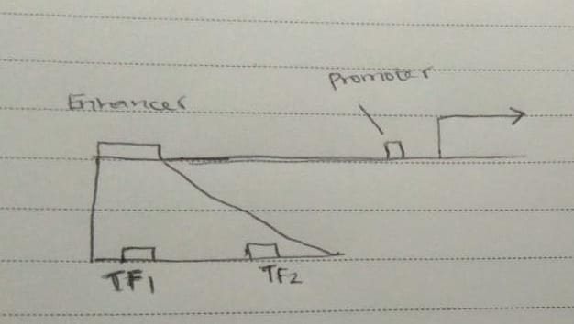
- (1 marks) Make a suggestion for how the transcription factor encoded by TF2 could regulate msg
transcription.
By dictating if the tribble formed will be a female.

- (2 marks) In tribbles homozygous for a null mutation in RBP1, the msg mRNA is not expressed under conditions of high nutrients and crowding. Based on the evidence in Table 1, propose a model for how RBP1 influences msg mRNA transcription. Transcription occurs as the first step of DNA based gene expression. This is known as the obligate release model. The cell free transcription translation (TXTL) creates a polyvalent experimental platform to engineer in biological system.

- (2 mark) What sex do you predict for RBP1 null mutants? Explain your logic.
Male, this is because the null mutants leads to the transfer of the y chromosome in addition to the x chromosome and leads to a generation that is characterized of a male offspring.
- (1 mark) Suggest an explanation for the transcription and translation patterns of RBP1 in Table 1.
Transcription and translation provide for two pillars which are used for expression. The two serves a common role as a multiple human promoter.
- (4 marks) You have null mutants for msg, TF1, TF2, and Rbp1. Based on your answers in d) and h):
  - what sex would you predict for tribbles be homozygous double mutant for combinations of the four genes? Explain your logic for each genotype in terms of the effects on the expression of the other genes. Female. The genotype results from chromosomal manipulation that is carried through the DNA and RNA and contributes to the gender of an offspring.
  - Does msg show epistatic or complementary genetic interactions with any of the other three genes? Explain.
Epistasis is the a situation where the gene mutation depends on the presence or absence of mutations in the other genes. The phenotypes of both parents and genotypes determined by performing the modification of the genes.
2. (10 marks) Sequencing the DNA from the tumors of several skin cancer patients, you find that a common inversion is found in all of the patient samples. The inversion results in the enhancer of a gene expressed at very high levels in skin cells becoming located adjacent to the promoter for the gene encoding the human CDC25 phosphatase. CDC25 is normally expressed at low to moderate levels in skin cells. Your sequence data show that in each gene, there is an identical 2 kb segmental duplication (a.k.a low copy number repeat) between the enhancer and the promoter.

- (2 marks) How might the presence of the segmental duplication in the genes explain the recurring inversion in your patients? Segmental duplications are the large segments of DNA that are interspersed. The gene copy are taken within the individuals that reduce the risk for the inverted orientation of genome.

- (2 marks) Draw a diagram of the genes on the original chromosome before the inversion. Indicate the location and orientation of the enhancer, promoter, coding, region and the segmental duplication. Draw a diagram of the new arrangement of the genes and regulatory sequences resulting from the inversion.

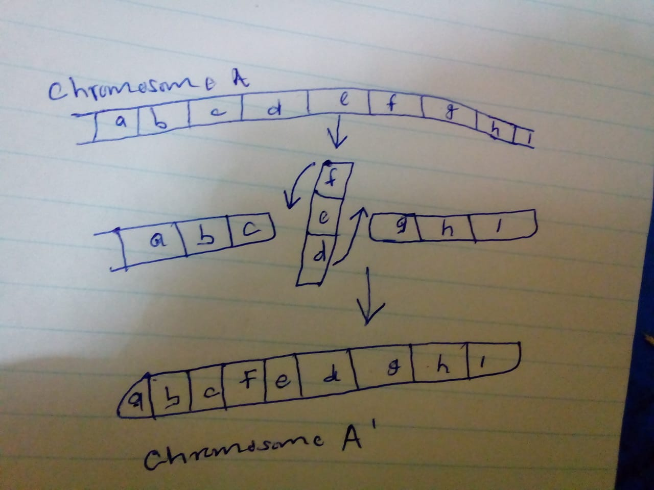

- (2 marks) You suspect that the inversion contributes to the progression of skin cancer in your patient cohort. Propose a model for how this mutation would affect cell cycle regulation. Genes mutate that the cell can progress to get infected with cancer and there expose the patient to more danger posed by such infection to the patient.

- (2 marks) Would this mutation be an oncogene or a tumor suppressor? Explain your answer. Oncogenes results to the activation which turns on proto-oncogenes while tumor suppressor genomes when the cancer cells are acquired through mutation of genes.

- (2 marks) How could the cell cycle defects described in ‘c)’ promote cancer progression? Cancer cell cycle is linked to the overactive cell cycle regulators. Cell division regulators damaged the process. cancer leads to overgrown of cells in the body of the patient.

