Q1.
Considering triangle Δ𝑂𝐴𝐵 below
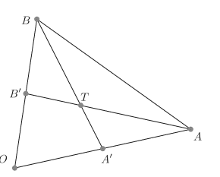
The triangle has proportions when no explicit coordinates are given. Let’s determine in which proportions the intersection of two midpoint bisectors of a triangle divide the bisectors.
𝐴′ and 𝐵′ be the midpoints of 𝑂𝐴 and 𝑂𝐵, respectively.
To determine the intersection 𝑇 of 𝐴𝐵′ and 𝐵𝐴′ , we interpret 𝐴, 𝐴′ and 𝐵, 𝐵′ as vectors with 𝑂 as origin of our coordinate system.
Then 𝑇 = (1 − 𝑠)𝐴 + 𝑠𝐵′ = (1 − 𝑡)𝐵 + 𝑡𝐴′ .
As 𝐴′ = 1/ 2𝐴 and 𝐵′ = 1/ 2𝐵,
this implies (1 − 𝑠)𝐴 + 𝑠(1/2) 𝐵 = (1 − 𝑡)𝐵 + 𝑡(1/ 2) 𝐴 .
Regrouping gives (1 − 𝑠 − 1 /2 𝑡)𝐴 = (1 − 𝑡 − 1 2 𝑠)𝐵 .
As the vectors 𝐴 and 𝐵 are linearly independent, this implies that 1 − 𝑠 − 1 2 𝑡 = 0 = 1 − 𝑡 − 1 2 𝑠,
which has 𝑠 = 𝑡 = 2/3. Hence 𝑇 divides 𝐵𝐴′ and 𝐴𝐵′ in the proportion 2:1.
t and s are equal therefore there is incident homomorphism.

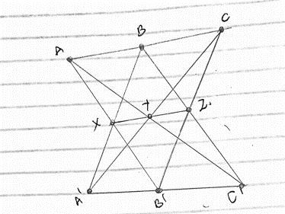

Considering the set of 9 points if we use the set 𝔽3 = {0, 1, 2} of integers modulo 3. the affine plane 𝔽²₃ consists of 9 points that we can represent in a 3 × 3 array. There are three lines through each point, with a total of 9 lines, each with three points on it. Thus the sets of points and lines in 𝔽²₃ is a configuration called the Hesse configuration.
A midpoint of a segment is always the third point on the line extending the segment. for a triangle Δ𝐴𝐵𝐶 in 𝔽²₃, the vector from the midpoint 1/2(𝐵 + 𝐶) = −𝐵 − 𝐶 to 𝐴 is equal to 𝐴 + 𝐵 + 𝐶, and this remains true if the midpoint bisectors ending at 𝐵 or 𝐶 are used. In other words, all three midpoint bisectors of a triangle are parallel in geometry.

Q2.
(𝑎, 𝑏) + (𝑎′ 𝑏′) = (𝑎 + 𝑎′ , 𝑏 + 𝑏′)
(𝑎, 𝑏) ⋅ (𝑎′ 𝑏′) = (𝑎𝑎′ − 𝑏𝑏′ , 𝑎𝑏′ + 𝑎′ 𝑏)
1 = (1, 0) and 𝑖 = (0, 1)
𝑎 + 𝑏𝑖 = (𝑎, 𝑏)
𝑖 ²= −1
(𝑎, 𝑏) ⋅ (𝑎′ 𝑏′) = 𝑎𝑎′ − 𝑏𝑏′ +i(𝑎𝑏′ + 𝑎′ 𝑏)
The additive identity is 0 = 0 + 0i, the multiplicative identity is 1 = 1 + 0i, and the multiplicative inverse of a nonzero complex number a + ib is (a + ib) ⁻¹ = a/(a² + b² ) + i(−b/(a²+ b²)).
If a’ is a positive real number, the symbol √ a’ will be used to denote the positive (real) square root of a’. Also √ 0 = 0. Notice that if z = a + ib is a nonzero complex number, then a 2 + b 2 is a positive real number. Definition. The absolute value of the complex number z = a+ib is |z| = Note that z = a + ib ≠0 is equivalent to |z| 6≠ 0. Viewing z = a + ib as a point (a, b) ∈ R² , the length of the line segment joining (0, 0) and (a, b) is √ a²+ b²= |z|. If θ is the angle that this segment makes with the positive first coordinate axis, then a = |z| cos θ and b = |z|sin θ. (Here we have the usual convention that positive angles are measured counterclockwise from the positive first coordinate axis).
Therefore z = |z|(cos θ + Isin θ) but z=(a,b)
z/|z|= cos θ + isin θ 1/z= /|z|² and if |z|=1 , 1/z= and thus the imaginary units have additive inverse as well as multiplicative inverse and the two inverse are equal. Since the modular product of these two elements is non zero the set F3 is a field. We do not divide by zero as this will give us an infinite answer

