Task: Identify a news article that discusses a current event or social issue that relates to your field of study. Follow the instructions below to explain the issue, provide an additional example of the issue, connect the issue to your field of study, and pose questions about the issue.
Source: One news article, available through the UMUC library, published within the past 12 months.
Length: Responses to individual questions should follow the guidelines below, and the entire completed assignment should be at least 700 words.
Due date and grading: This assignment is due by the end of Week 2. It will be graded with a rubric and will count for 10% of your course grade. To view the grading rubric, please access the assignment through the Assignments area of the classroom.
Outcomes you should achieve by completing this assignment
As you complete the tasks required for this assignment, you will be working toward several of the course outcomes:
- Begin the writing process by exploring a topic (Relates to course outcome 1)
- Compose paragraphs that explain an event or issue (Relates to course outcome 2)
- Demonstrate accurate grammar and mechanics in writing (Relates to course outcome 3)
- Identify a recent and reliable news source and provide APA documentation (Relates to course outcome 4)
Formatting your assignment
Incorporate these elements of APA style:
- Use one-inch margins.
- Double space.
- Use an easy-to-read font between 10-point and 12-point.
Note: Title page is not required, but make sure you include your name and a title that reflects your topic at the top of the first page.
Number your answers and/or include the assignment questions so your instructor can see that you addressed each part of the assignment.
Respond to each of the following.
1. Provide an APA-style reference for the news article you selected. The format for the reference is as follows:
Author, A. A. (Year, Month Day). Title of article in sentence case. Title of Newspaper in Title Case and Italics. Retrieved from http://www.newspaperhomepage.com
Although the newspaper article should be available through the UMUC library, provide the URL directly to the newspaper that published the article. An APA reference entry does not link to a library database record. It does include the URL of the newspaper homepage, such as https://www.washingtonpost.com
2. For your instructor's reference, provide the URL to the article in the UMUC library. This will be listed as "Document URL" in the library record:
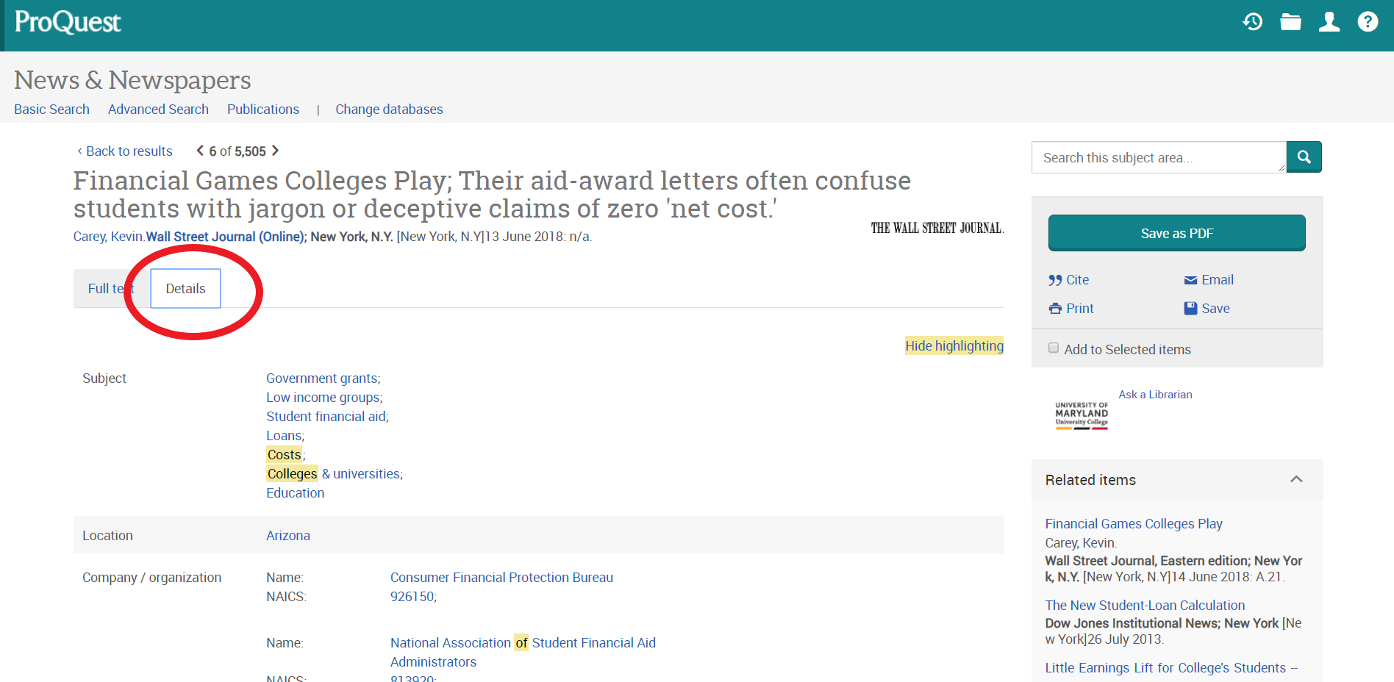
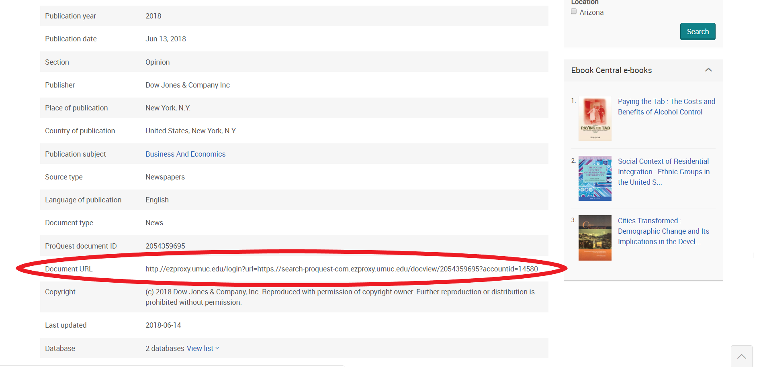
3. Summarize the article. Explain the event or issue covered in the article, assuming your reader has little or no prior knowledge of it. Answer in 1-2 paragraphs.
4. Describe a specific real-life situation (other than one discussed in your news article) where the issue at hand has been observed. This could be something that happened to you or someone you know, or it could be a related event in the news. Explain the connection to the event or issue in your news article. Answer in 1-2 paragraphs.
5. What is your field of study and how do you see it relating to the event or issue in your news article? Answer in one paragraph.
6. What do you want to know about the issue or event in your news article? List two or more questions that you could pursue as part of your research. Though you are listing two or more questions here, your research should ultimately be focused on a single guiding question.

