

PES111 – Lifetime Fitness
Assignment 2 – Weight: 15%

The deadline to submit it on Moodle is on Tuesday the 6th of April 2021 at 11:59pm. Please refer to course syllabus for late submission and plagiarism cases.

“Human Anatomy & Physiology”

Answer the below questions:

Part 1 - Name the below anatomical planes. 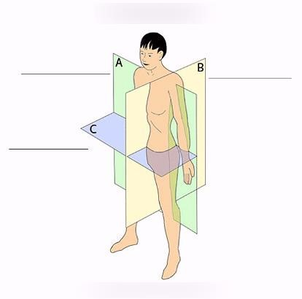

A. Sagittal plane
B. Coronal Plane
C. Transverse Plane
- Continue the following sentence. “The coronal plane divides the body into front (anterior) section and back (posterior) section.”
ii.Which actions/functions take part in the horizontal plane?
Rotation where the internal or external turning about the vertical axis of the bone; pronation which involves the rotation of the hand as well as wrist medically from the bone; supination which involve rotation of the hand and wrist laterally from the bone; flexion and abduction
- Define flexion and abduction.
Flexion refers to the contraction which results in a degree decrease in an angle at a joint while in abduction limbs tend to move away from the body’s midline in the frontal plane.

iv. The areas of the hand which are closer to the body are referred to as proximal and those further away are referred to as distal respectively. (True or False)True

Part 2 - Write the names of the bones numbered: 1, 5, 6, 7, 10, 14, 15.

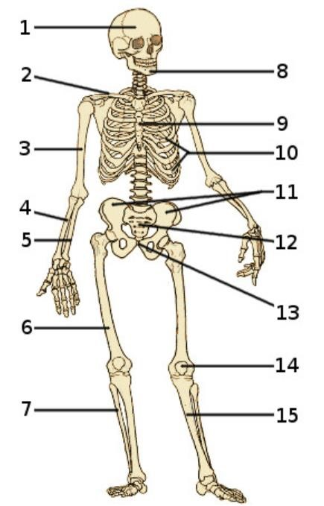
1. Skull
5. Ulna
6. Clavicle
7. Fibula
10. Ribs
14. Patella
15. tibia
a) Name 3 synovial joints and give one example of each.

- Pivot joints example top of the neck
- Ball & socket example shoulder/hip
- Saddle example CMC joint

Part 3 - In the below pictures identify:
- the action performed and at which joint?
- the plane of motion
- the primary muscle(s) mover

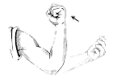
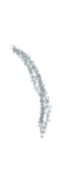
Example:
  - Elbow flexion
  - Sagittal plane
  - Biceps

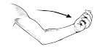
Pic 1 -

- Shoulder extension
- Sagittal plane
- Pectoralis major, and anterior fibers of the deltoid

Pic 2 -
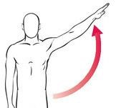
- shoulder abduction
- Frontal plane
c. deltoid, trapezius, serratus anterior

Pic 3 –
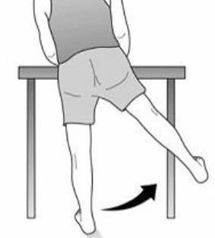
a. hip abduction
b. Frontal plane
C. gluteus medius, gluteus minimus, tensor fasciae latae (TFl)
Part 4 - Name the following muscles and give one exercise to strengthen each: 2, 3, 4, 6, 8, 9, 12, 13, 14

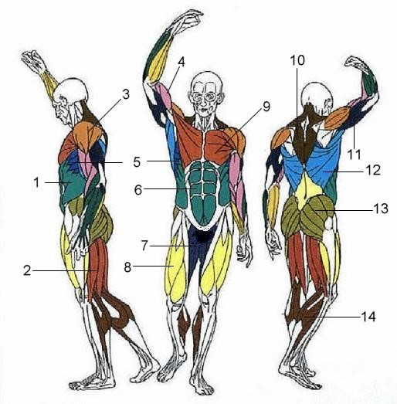

2: Semimembranasious muscle. It can be strengthened by training on a lying leg curl machine
3: Deltoid muscle. It can be strengthened by dumbbell shoulder press, tops in training for the anterior deltoids
4: biceps. It can be strengthened by the one-arm dumbbell preacher curl
6: Rectus abdominis. It can be strengthened by bent knee hip raise
8: Rects femoris. It can be strengthened by lieing on the back and use of ypga block
9: Pectoralis femoris. It can be strengthened by pushups and dumbbell press
12: Latissimus dorsi. It can be strengthened by lat pull-down and medicine ball slam
13: Gluteus Maximus. It can be strengthened by back squats and deadlifts
14: Gastrocnemius. It can be strengthened through heel raise training
- What is the major difference between ligaments and tendons?
Tendons tend to bind muscles to bone and it connects to the end of the muscles to any part of the bone. In contrast ligaments tend to bind bone to bone and it connects the ends of the bones at joints.

Short answers:

- Which system are the lungs in? Respiratory system
- Which system is the heart in? Circulatory system
- Which organ pumps the blood to the rest of the body? heart
- How many vertebras are there in a human spinal cord? 33 vertebral
- Where does digestion start? Mouth
- During muscle contraction, the origin moves towards the insertion. (true or false)
- One of the main functions of the nervous system is to receive stimuli from inside and outside the body. (True or False)
- Which muscles are attached to bones and aid with movement? Skeletal muscles
- Smooth and cardiac muscles are both voluntary. (True or False)
- What connects skeletal muscles to bone? Tendons
- Which system provides movement to the body? musculoskeletal system
- Where do two or more bones meet? joint

