

SFT 110 – 10%
Spring 2021

Assignment 2
Group-based

Name | Student ID | Comments

Assignment 2 (10%) – Submission
Deadline:

Finding another perspective
Part 1 – 50 points
- Write a definition of perspective.
Perspective refers to a way of thinking on something, majorly one which is impacted by the type of person you are or by your experiences. Basically it is an approach in which one considers something to be.
- How might the following people react to this photograph?
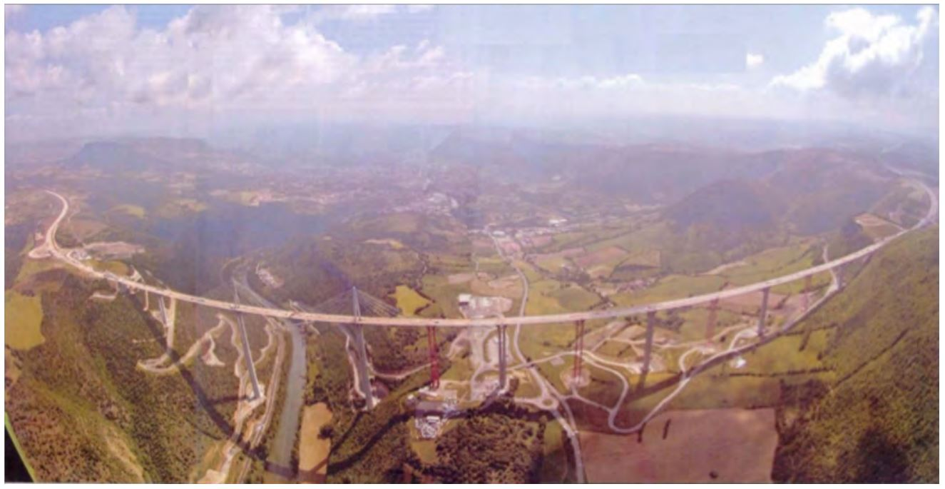
A. a helicopter pilot
B. an engineer
C. a seismologist (scientist who studies earthquakes)
D. a truck driver
Answer here (100-150 words):

Helicopter Pilot
A helicopter may perceive the weather of this place to be foggy and term it to have poor visibility. This climate may minimize the visibility to the point that they cannot operate effectively. In such conditions, it tends to be hard for the helicopters to land on the ground which tends to the biggest problem. Therefore, this shows that it will be hard for the pilots to fly at this time.
An engineer
An engineer may consider the road and its construction. The road has been brought up in a professional as well as proficient way. It is strong enough to accommodate any weight. The poles have been established in an effective way, in a way that it may be efficient for more than 100 years.
Seismologist
The occurrence of an earthquake in this area may be so fatal. It may lead to the collapsing of the road which may have a major impact the earthquake may weaken the poles which may have fatal consequences on the roads. The abrupt release of accumulated strains acting on the tectonic plates may cause sudden ground motions of trembling earth may lead to the collapsing of the road.
Truck driver
Though the weather is not so favorable, truck drivers believe that they can still drive through the weather. However, if not careful one may cause an accident due to the fog as well as the taillights in front of them. Fogs tends to reduce visibility and may lead to reduced speed of trucks.

Part 2 – 50 points
Your group should examine an issue provided below.

Issue: Restrictions on young drivers: The King of Wakanda proposed a new law that will place restrictions on young drivers in the kingdom. Any driver under the age of 21 will face a 30-day license suspension if caught speeding or using mobile phone, Young drivers will be allowed only one passenger in the car while driving. The new law has caused a controversy and tonight a town hall meeting will be held to hear all perspectives before a vote is taken on the issue.

Instructions:
- Identify as many different perspectives as possible discussed in the text above.
- Brainstorm all the other stakeholders (people or groups who might be affected by or have an interest in the event or issue).
- Speculate how each stakeholders’ perspective might be different and why each perspective is important.
- Select those groups or individuals whose perspective is likely to be most useful in expanding your understanding of the issue or event.
- Use the Answer Sheet below and fill in with needed information.

Issue: | Restrictions on young drivers
Current Perspective | Reduce road accident

Answer Sheet
Stakeholders – Identify people or groups who might be affected by or have an interest in the event or issue | Rationale – why is the perspective important? Do we need to consider it? | Rate usefulness - Is the perspective likely to be significantly different? Will the perspective increase your understanding of the issue?  Rate from 1 to 5 where 5 is very important 1 is not important.
Traffic police | There will be reduced young drivers arrest due to reckless driving. Therefore the law should be considered | 5
Parents | There will be reduced deaths on roads due to reckless driving by young children. Therefore the law should be considered | 5
Hospitals | Young drivers driving the emergency ambulances may at times be required to use the phone by the health care facilities. Thus the law should have some exceptions. | 1
Retailers | At times a young driver transporting some perishable goods may be required to drive at a high speed which requires going against the law. Thus the law should have some exceptions. | 1
Pedestrians | They can comfortably walk through the road since they feel protected by the law. Therefore the law should be considered | 5
Government | The young drivers will learn to be more responsible and efficient on roads | 5
Conclusion
On daily basis people tend to judge similar aspects in different ways. Therefore, different individuals tend to have different perspectives on a given aspect. Each person’s perspective is based on personal beliefs or environment. For instance, in this scenario on the issue of restricting young drivers, different individuals tend to have different perspectives on this issue. Personally, I feel that this restriction should involve some exceptions. For instance, in the case of hospital drivers they may be allowed to use their and speed up in order to save the patient’s life. However, this law is as well effective since it would aid in enabling the young drivers in becoming responsible as well as reliable drivers in future. This may as well aid in reducing accidents on roads.

