Assignment 1: Observational and Motor Learning
Name
Instructor
Course
Date

According to the theory of motor skills, children develop a rule which shows the correlation between outcomes of movement and things like the performance setting conditions as well as the motor program details developed in controlling the movement they learn through motor skills (D’Hondt, Deforche, De Bourdeaudhuij, and Lenoir, 2009). Fine motor skills are essential in engaging more precise and smaller movements, usually through the use of fingers and hands. Gross motor skills are different from fine motor skills that need more precision to perform or carry out.
Children can make things by their hands by the ages of two to three years (Williams et al, 2008). Out of blocks, they can build towers, scribble with pen or crayon as well as mold clay into different and rough shapes. Children at the ages of two to three years are in a position of inserting things into fitting or matching spaces. Around age three to four years, the child begins manipulating the clothing fasteners such as snaps and zippers as she or he gains independence in undressing and dressing his or herself. At ages of 3 to 4 years, the child can also start using a pair of scissors to cut things like paper. At this age, the child continues to refine his or her skills of eating can use utensils such as spoons and forks. At ages between four to five years, the child continues refining his or her motor skills as he or she builds upon the earlier skills. For the example, the children can unbutton and button their clothes by themselves (D’Hondt, Deforche, De Bourdeaudhuij, and Lenoir, 2009). At these ages, their artistic improve and they can copy shapes like large letter, circles, squares, and draw simple stick diagrams and figures.
The best way to promote the development of fine motor skills is to offer the children with a broad range of objects to manipulate as their imaginations dictate (Williams et al, 2008). The materials can include simple sewing cards, coloring books, stained a smock to protect against stained clothing, safety scissors, construction paper, an easel, modeling clay, glue, paints, paste, non-toxic washable markers, crayons and interlocking blocks. The best way the children develop their fine motor skills is through practicing as practice makes perfect. Fine motor skills are accomplished when a child learns to use his or her muscles such as in the wrists, hands, and fingers that this can be achieved through regular practice. A child would use fine motor skills when using computer keyboards, cutting with scissors, eating, turning pages, buttoning clothing, holding small items, and when writing. Therefore, fine motor skills mastery needs coordination and precision. The activities and actions of fine motor skills for the children are the best way of ensuring that proper practice as well as the development of the fine to foster the major functional use of the children fingers and hands. The normal development of fine motor skills requires that the child is able to efficiently and accurately utilize the intrinsic muscles (the small muscles) in his or her fingers and hands (D’Hondt, Deforche, De Bourdeaudhuij, and Lenoir, 2009). Toy and games are some of the best ways that the children can use to develop their fine motor skills.
Acquisition of fine motor skills or tasks essentially involves the information transfer between the learner and the instructor (Williams et al, 2008). The common method of transferring information between the instructor and the learner is through demonstrations. Observational learning can be used to achieve motor tasks or skills as the child can watch the model behavior and adapt his or her movements as a result of what he or she has seen. Observational learning interleaves both physical and demonstration practices that involve observing, practicing and refining (D’Hondt, Deforche, De Bourdeaudhuij, and Lenoir, 2009). Observational learning is considered as a powerful tool for transmitting behavior patterns to the learners. Observational learning provides both long-term learning benefits and immediate performance benefits in behavioral measures range that enable the children to accomplish the motor tasks and skills.
Parents of children that show fine motor skills delay signs need not fear for their children because the many things they can execute to assist the child in developing to their peers' level (Provost, Lopez, and Heimerl, 2007). One good strategy is to integrate and incorporate the fine motor exercises and skills to the young child to make it a fun and a daily routine or activity. In their busy schedule, parents should create some time to assist the child with signs of fine motor skills delay to use his or her motor skills whether it is right before bed, the first thing in the morning or after school. Parents should do something active with the child with signs of fine motor skills delay such as mixing cookie dough with a spoon, spray painting boards of posters with a spray bottle, as well as kneading rather than just having the child to seat at the table and draw with crayons. The activities and actions of fine motor skills for the children are the best way of ensuring that proper practice as well as the development of the fine to foster the major functional use of the children fingers and hands. The normal development of fine motor skills requires that the child is able to efficiently and accurately utilize the intrinsic muscles (the small muscles) in his or her fingers and hands. Toy and games are some of the best ways that the children can use to develop their fine motor skills (Provost, Lopez, and Heimerl, 2007). The parents should ensure that they purchase for the child a toy and allow the child to play games on their phones, laptops or computers. The parent can help the child to scribble and write things on a piece of paper to improve the writing skills of the young child.
A child who has problems with fine motor skills has a hard time to develop strong muscles in his her wrists, hands, and fingers. Below are the online activities that purport to help in developing fine motor skills:
Stock up on play-dough
For decades, play-dough has been a favorite game for children. Play-dough develops certain key skills apart from being downright fun. Touching the Play-dough is an important sensory experience while Stretching and squeezing the play-dough helps the children to strengthen the muscles of their hands and fingers.
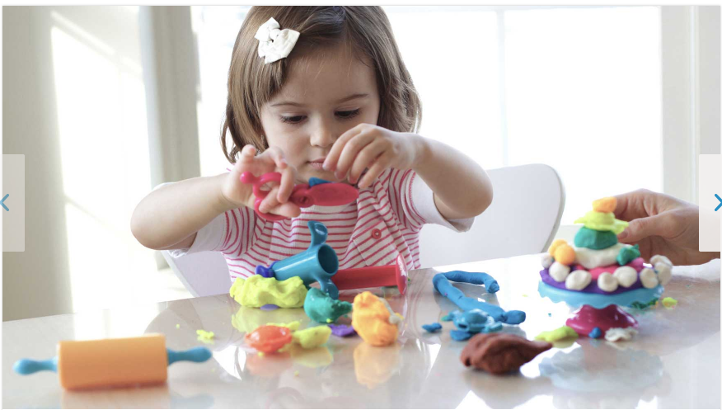
Do some finger painting.
Using finger paints can help the children to strengthen their manual dexterity and hand-eye coordination.
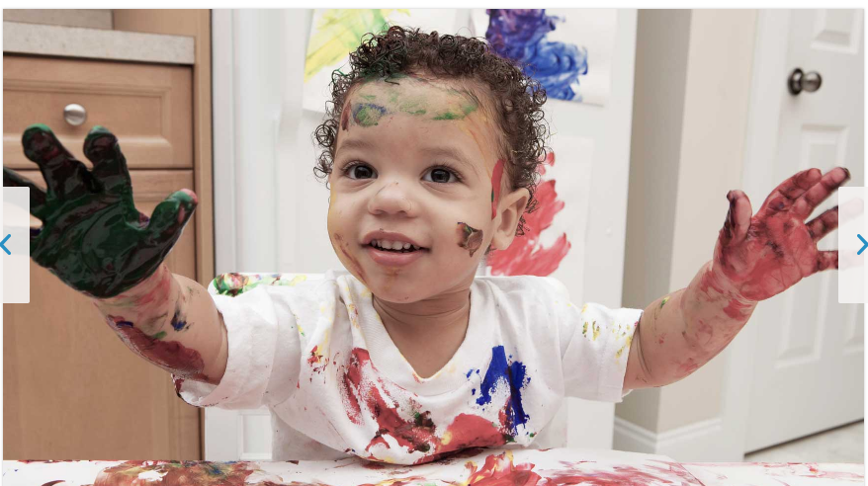
Squeeze out a sponge
When child squeezes water out of a sponge, by having a simple game of transferring water from a bowl full of water to an empty bowl by use of a sponge, the simple game can help the child to strengthen the muscles of his or her forearms and hands.
Color with broken crayons
Coloring with a broken and small crayon encourages the children to grip the crayon correctly between their forefingers and thumb. The activity is to is used to challenge the child to hold pencil or writing pen correctly.

Make paper dolls.
The children can strengthen their hand muscles by cutting and folding tabs.
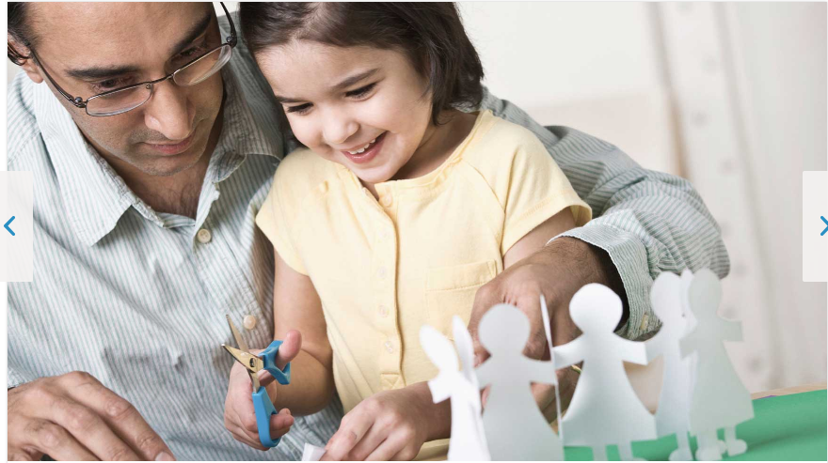

Play string games.

String games help the children to strengthen the finger muscles and to improve their hand-eye coordination.
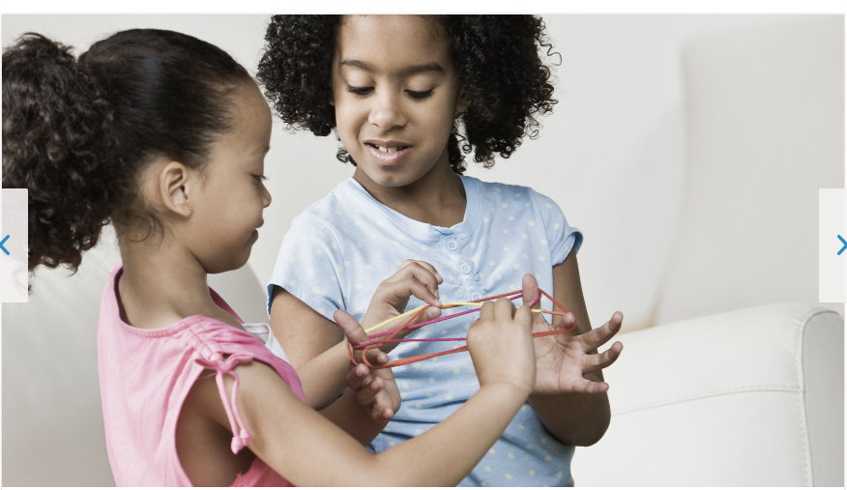

References
D’Hondt, E., Deforche, B., De Bourdeaudhuij, I., & Lenoir, M. (2009). The relationship between motor skill and body mass index in 5-to 10-year-old children. Adapted Physical Activity Quarterly, 26(1), 21-37.
Provost, B., Lopez, B. R., & Heimerl, S. (2007). A comparison of motor delays in young children: autism spectrum disorder, developmental delay, and developmental concerns. Journal of autism and developmental disorders, 37(2), 321-328.
Williams, H. G., Pfeiffer, K. A., O'neill, J. R., Dowda, M., McIver, K. L., Brown, W. H., & Pate, R. R. (2008). Motor skill performance and physical activity in preschool children. Obesity, 16(6), 1421-1426

