Student’s Full Name:  Or Group No.: | Grade:

Select a text and find illustrations for the following items that we have discussed in our course (see table of requirements below).
★Your text should be either a section from a novel OR a newspaper article (I do not mind digital) OR a blog OR any other book on any topic of your choice.
★You must provide a short summary of the text which you have read entirely while searching for each item. The summary should NOT exceed 50 words (maximum). You do NOT need to attach the original text.
★You must also provide proper citation for your source text; including title + author + year of publication. Add your citation right after your summary; you do not need to add citation after each example (illustrating each item).
★You must type and format your assignment neatly (use 12-sized font – use any font you like - with 1.5 spacing) and make sure your paragraphs are well-aligned.
★You must add page numbers + header OR footer of your group name for every page.
★For each item specified in the requirement table below, you must highlight the specific item under investigation (in any color you choose), and include the text that occurs immediately before and after it. This helps the reader (myself) identify the surrounding textual/linguistic context.
★ There is no need for both members of the group to submit separately. Only one member must submit on behalf of the group. Remember to specify your group number.
★You can submit before the deadline if you feel ready enough. You need to attach your work as WORD document OR Pdf file and submit it via the same location where you have accessed this file (the original assignment requirements). Your status will change on my screen from VIEWED to TURNED IN.

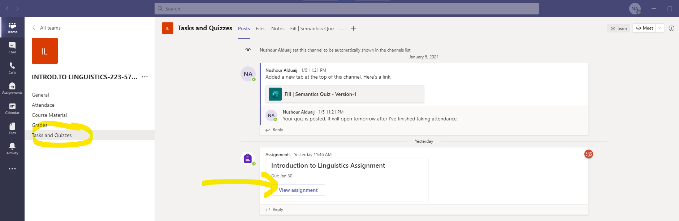

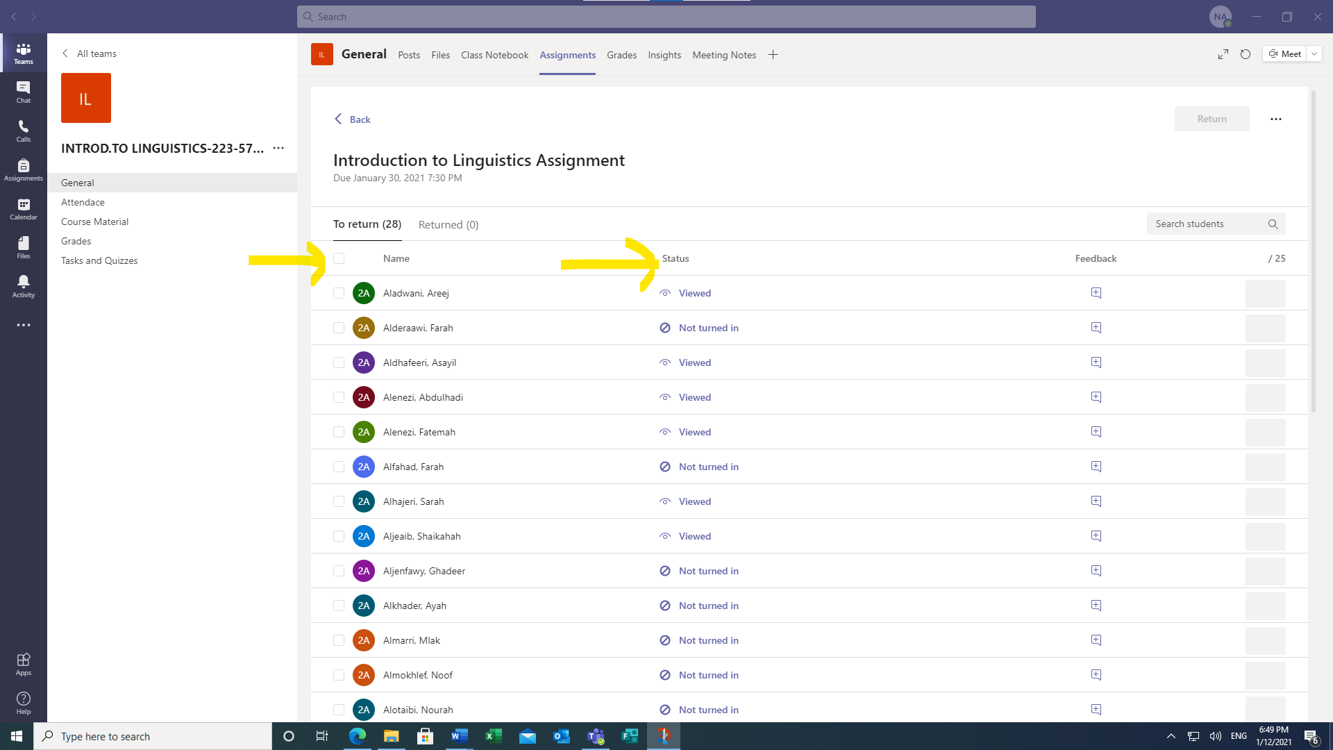

An example of how one of the items should be addressed:
Assuming I am a student responding to the item in the table below whereby I must provide a compound word. I do not provide the compound word alone but the text that immediately surrounds it as follows:
Morphology Part:
Item-4: Compound word:
A common fear, test-taking frequently causes anxiety for college students.
Test(N.) – taking (either V. in progressive tense/ or N.) in this sentence ‘taking’ functions as N.
My sample sentence is taken from an article published in 2019, by Purdue University Global.
How to Reduce Test Anxiety for College Students (purdueglobal.edu)

Table of requirements
Item |  | Requirement |  | Total 25%
 |  |  |  | Points per item
Part-A  General layout  (worth 7 points) |  | Your selection of text and whether you have complied to the requirements above. |  | =5
 |  | - Summary provided properly. | 2 | =5
 |  | - Neat overall typing and formatting. | 1 | =5
 |  | - Textual context sufficiently provided for each example. | 1 | =5
 |  | - Citation provided properly. | 1
Morphology Part  (worth 8 points) | 1- | A word exemplifying derivational morphology.  You must ALSO do the proper morphological analysis for your selected morpheme. This includes breaking up the word into its underlying morphemes + identifying the syntactic class of each morpheme (in the same manner as our class sessions’ practices). |  | =2
Morphology Part  (worth 8 points) | 2- | A word exemplifying inflectional morphology + do the morphological analysis. |  | =2
Morphology Part  (worth 8 points) | 3- | An example of negation via the use of affixation.  + Does the affixation in your selected word illustrates a SUFFIX or PREFIX? |  | =2
Morphology Part  (worth 8 points) | 4- | An example of a compound word + identify its syntactic class. |  | =2
Semantics Part  (worth 8 points) | 1- | An example of one of the semantic relations (synonymy OR antonomy OR hyponomy).  If you cannot find an example within your text, you can choose a word then look up another word that functions as synonym OR antonym to the word you have selected. |  | =2
Semantics Part  (worth 8 points) | 2- | Select a sentence that illustrates THREE different thematic roles (out of the total seven thematic roles that we have covered).  If you cannot find a single sentence that contains the three target thematic roles you have in mind, you can use two sentences. |  | =3
Semantics Part  (worth 8 points) | 2- |  |  | Role-1
Semantics Part  (worth 8 points) | 2- |  |  | Role-2
Semantics Part  (worth 8 points) | 2- |  |  | Role-3
Semantics Part  (worth 8 points) | 3- Phonetics | Choose a word in your text and find its phonetically homonymous pair. Discuss the difference in meaning between the two homonyms. It is not very likely that you will find the two homonyms within a single text so you can provide a possible homonym from outside your text.  ★ You must also provide a phonetic transcription for your selected word. |  | =3
Syntax | 1- | An example illustrating either Adj. P OR Adv P. + identify the Noun, or the Verb it modifies, respectively. |  | =2
Syntax | 2- | An example of a determiner DET. (X other than articles a/an/the) + identify its type. |  | =2
Total points |  | 5 + 8 + 8 + 4 = 25% of your grade

