Make sure that you have also downloaded the Assignment #2 Template. You will answer the questions there and submit that file as your assignment.

qUESTION 1: financing

Background Information Needed to Answer Question #1:
Review Shaun's criteria below to determine the best financing option to expand his business.

SHAUN’S CRITERIA
Hi Team,
I wanted to provide you some guidelines as you determine how we’ll finance our expansion. Please give this careful consideration, as we need to get this right.
- I estimate we’ll need $150,000 to increase capacity in order to stock the five additional pop-up stands.
- We’ll need to make sure we have additional funds available to increase our marketing efforts to stimulate demand.
- Cash flow is going to be tight, so I’d like to minimize interest payments.
- I’d like to maintain or increase our profit margins.
- Since I don’t have a lot of experience with big discount retailers, I’d like to add a thought partner with experience in this channel.
- If we’re successful over the next two years, we’ll likely seek additional capital to expand into more stores, so I’d like to do all we can now to enhance our credibility.
- We need to move on this quickly, so I’d like an answer by the end of the week.
-Shaun

FINANCING OPTIONS
As we have learned, there are pros and cons to all financing methods. Which of the three financing methods would be the best fit based on Shaun's criteria above?

Option 1: Equity
Raise $150,000 from a venture capital firm in exchange for 30% of the company.

Option 2: Debt
Secure a loan of $150,000 at a 10% annual interest rate, to be repaid over 7 years.

Option 3: Debt + Self-Financing
Secure a loan of $100,000 at a 7% annual interest rate, to be repaid over 7 years, and self-finance the remaining $50,000.
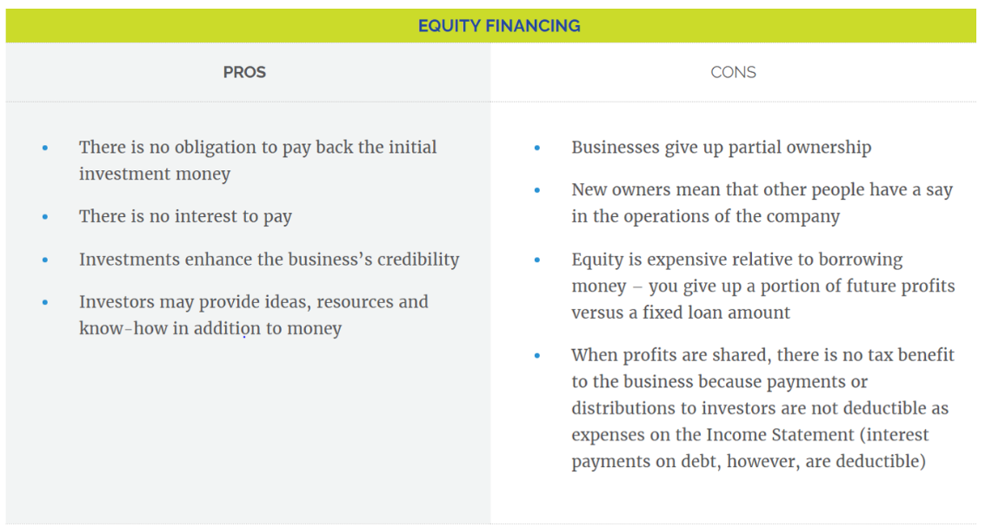
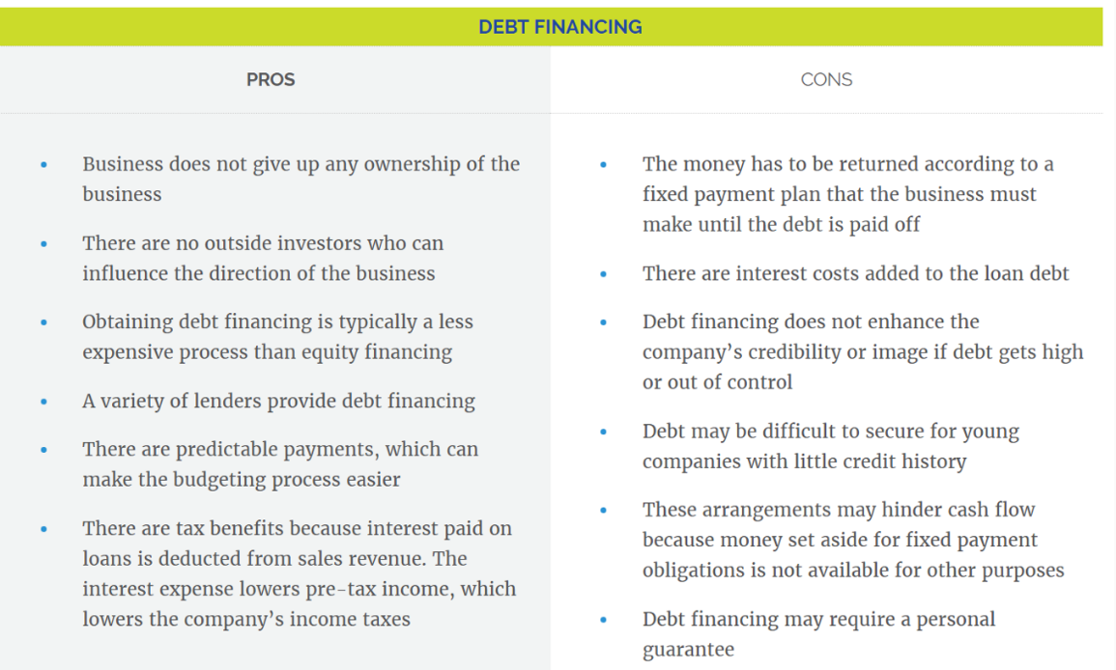
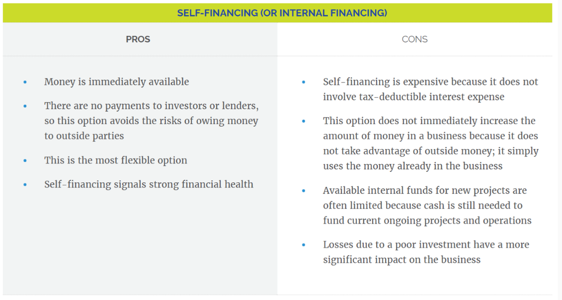

Go to the Assignment #2 Template and complete Question 1.

QUESTION 2: accounting cycle

Background information needed to answer Question #2:
A junior accountant is working to get everything in order for the new financing and has come to you with a question about what to do next in the accounting cycle. Read this email from the junior accountant so you can determine what steps of the accounting cycle she has already completed and what the next step is to complete.

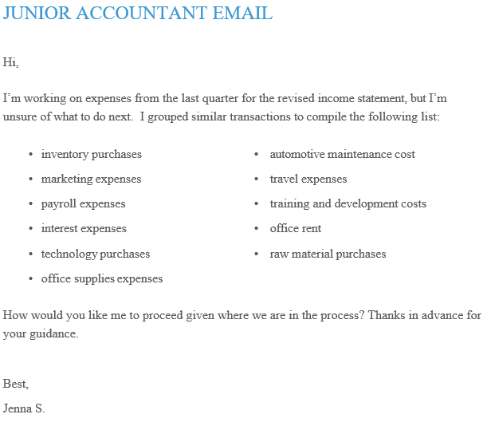
As a refresher, here are the 5 Steps to the Accounting Cycle:
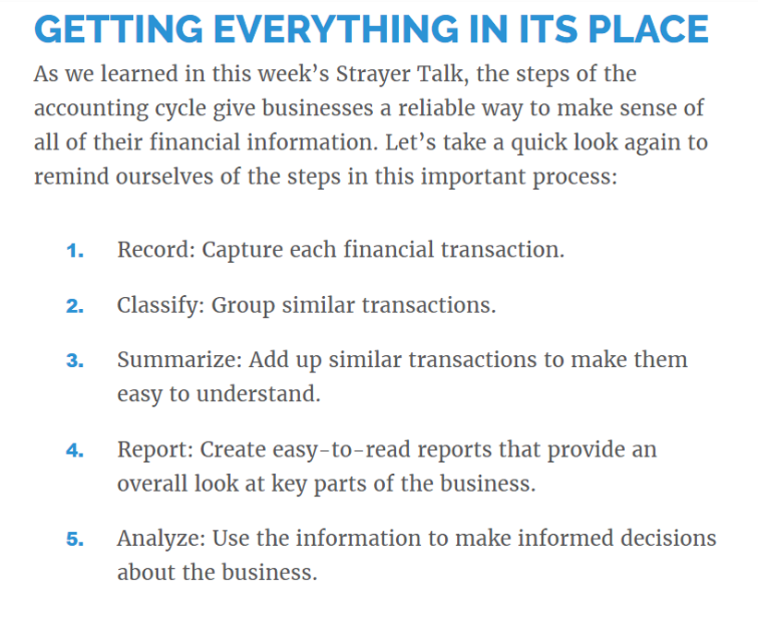

Go to the Assignment #2 Template and complete Question 2.

QUESTION 3: FINANCIAL STATEMENTS

Background information needed to answer Question #3:
A potential investor has been identified, but before they are willing to commit, they have requested information about SunsTruck’s current debt from the junior accountants. You have been charged with reviewing the financial statements (found in the resources) and providing direction to the junior accountant to comply with the request from the potential investor.
Identify the correct financial statement for your junior accountants that will provide the investor with the information it has requested.
As a refresher, here are the types of financial statements.
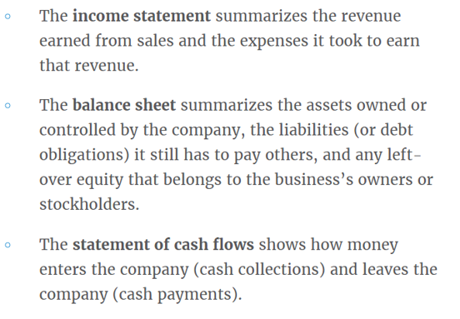

Go to the Assignment #2 Template and complete Question 3.

Next step: submit your work
- Save your completed template (not these instructions) to your desktop.
- Navigation: Select File at the top, then select Save As > Browse > Desktop, select Save.
- Log into your class and select Assignment #2 on the left, scroll down and select Submit Your Work, click Browse My Computer, find your file on the desktop, click Open, then click Submit.
- If you have any issues please email me or call.

I will provide you assignment feedback and you can then make any changes you would like and resubmit for grading.
Congrats on completing assignment #2!

