Assignment Three

Master Narrative
The master narrative that is at work in popular conversation or culture is homelessness. Unfortunately, many people in the United States are homeless due to reasons such as lack of employment, low wages and salaries, poverty, and lack of affordable houses, among other reasons.
Visual Statement:
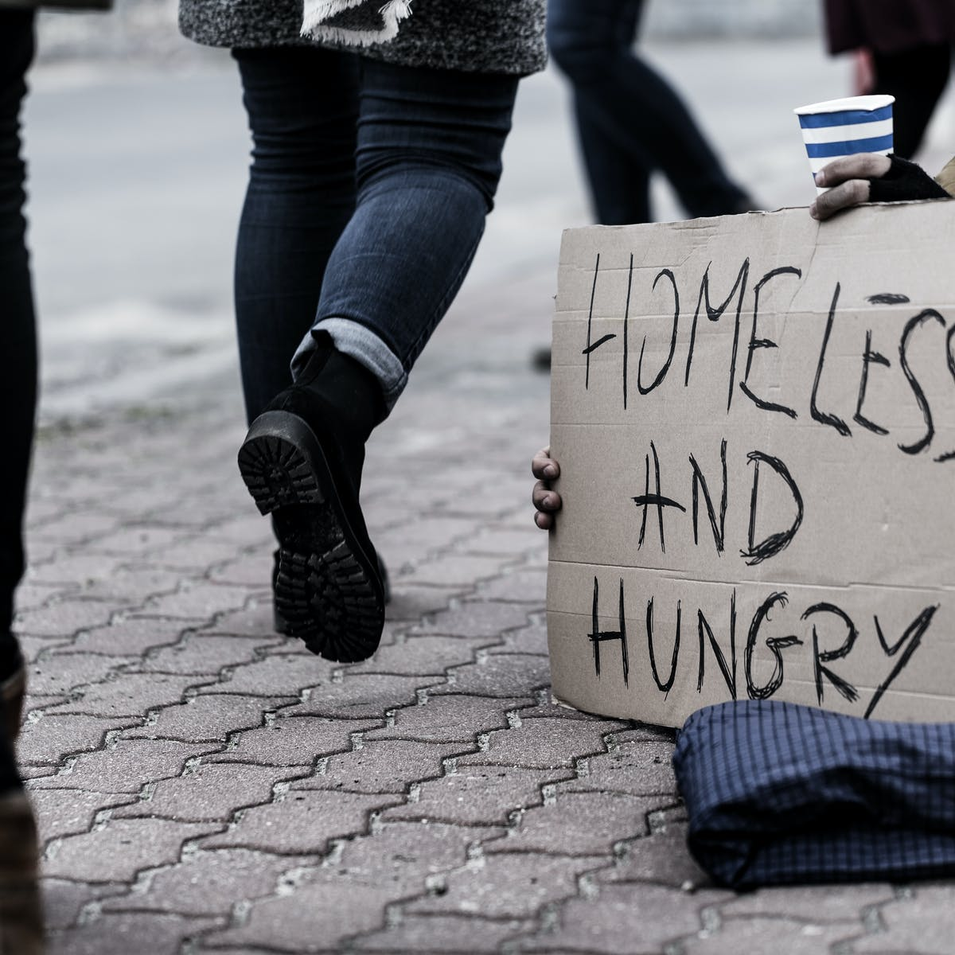

Artist statement
The above photo indicates homelessness as a crisis in the United States. Many people are unable to afford houses. One of the reasons that increase the rates of homelessness in the country is based on immigration. Most people from foreign countries immigrate into the country with the hopes of getting a better life. Unfortunately, things do not turn the same because most of these individuals end up being homeless. These immigrants fail to secure employment opportunities that could sustain them hence ending up on the streets. Based on my opinion, the government, non-governmental organizations, and well-wishers should come in and help these individuals. The government should try and construct cheaper houses that can sustain these individuals. Also, there is a need to strengthen the economy so that most people can have access to jobs. Income inequality should also be addressed since only people with good incomes can afford to pay for house rents and related bills. Therefore, this is an urgent issue that needs urgent measures.

