Part One
A meadow

The source of light in this image is sunlight. Therefore, the color of the light in this picture is orange and yellow. The angle of the light in this image is wide since it was intended to capture a wider view. Lighting in this picture makes it come to life because it makes these flowers, trees, and grass very healthy and lively.
A Party

The source of light in this picture is artificial and is mainly disco lights. The color light in this picture is blue. The lighting also involves a wider beam angle of about 50 to 60 degrees since they are floodlights. The lighting, in this case, makes the picture come to life since it sets a partying mood where people are shown to be enjoying the moment.
A Fast-Moving Object
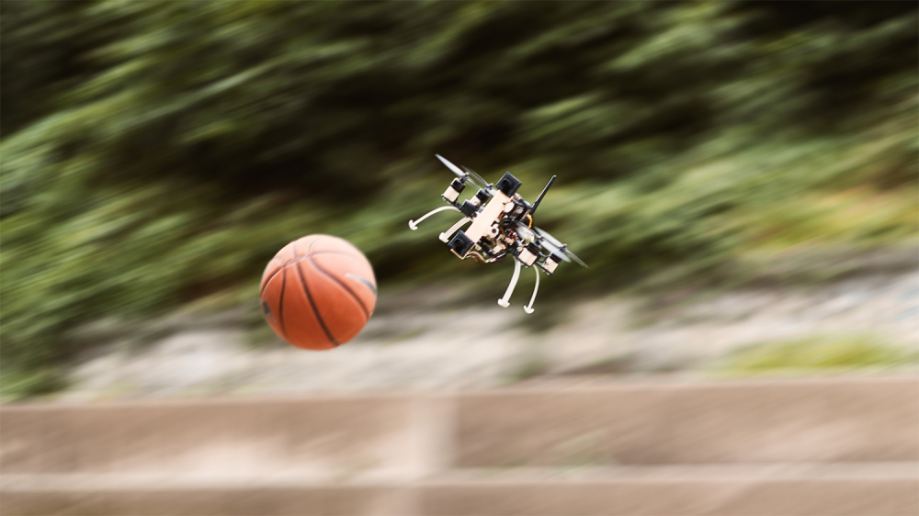
The source of light in this picture is daylight. The color of light is grayish. The angle of light in this context is quite closer to capture the movement. The lighting in the picture makes the image come to life because it portrays an actual event, and it's clear that this object is in motion.
Two People in Love
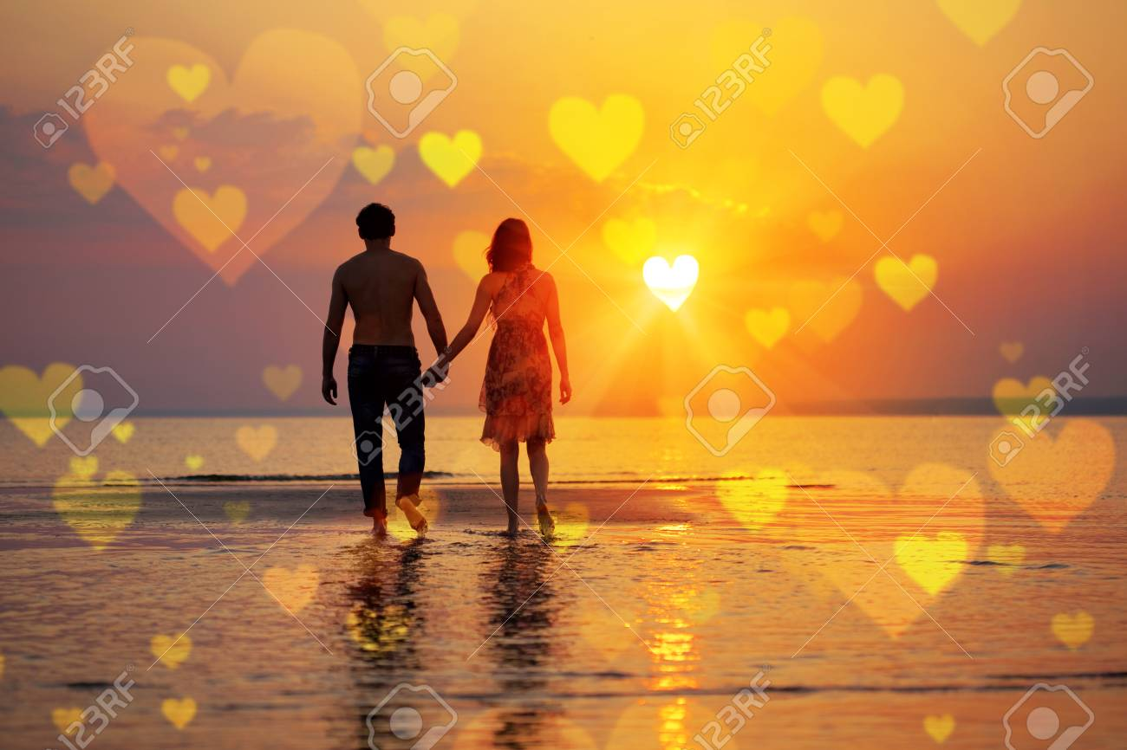
The source of light in this image is daylight or natural lighting. The color of the light is orange. The angle of the light is also wider. The lighting in this picture makes it come to life because it is established to show signs of love and brighter rays from one end that hits these two individuals. The sign of the heart is also created through this lighting hence revealing the context of love.
Part Two
A meadow
https://www.soundsnap.com/node/58674
The sound above reinforces the picture because it captures the sounds of varied elements. All elements in this ecosystem are represented in this sound. For instance, the sound of birds reveals that the context is lively. Also, the sound of chirping insects and bees also makes the picture come to life.
A Party
https://www.soundsnap.com/node/107136
the sound reinforces the information from the picture since it’s all about partying. The sound also reveals that these people are enjoying the party. People are singing and chanting here and there. Therefore, the sound makes it come to life because it incorporates human expectations like movement and conversations.
A Fast-Moving Object
https://www.youtube.com/watch?v=QhIFPi19GfQ
The above sound indicates an object in motion. It aids in making the picture lively since it captures the attention of the audience. For instance, the great collision of the object with the air leads to the production of a sound. This unique sound makes the picture come into life since it reflects the usual events in a human environment.
Two People in Love
https://www.youtube.com/watch?v=2Vv-BfVoq4g
This sound reveals the presence of a strong bond. It promotes a calm mood that characterizes love. The sound also shows that there is an action going on. Therefore, the sound brings the picture to life since it connotes happiness.

