Analysis of Old New England Mill by William W. Stetson
Student’s Name
Institution
Course
Professor’s Name
Date

Analysis of Old New England Mill by William W. Stetson
This art piece, printed in blank ink on tissue, shows the growth of industrial technology and American enterprises in the 19th century. First, the image portrays the beginning of the industrial revolution in America, which was characterized by many things, including establishing factories. The industrial revolution period started in the north, which is portrayed by the image of a mill of New England. Secondly, this image further depicts the development of American enterprises in the 19th century. Cotton production created opportunities for the establishment of cotton mill factories. Thousands of such cotton mill factories were established in different parts of America. It is estimated that by the 1840s, there were more than 700 cotton mills in New England alone (Dublin, 1983). The image of Old New England Mill of 19th century was William W. Stetson’s work that portrayed the beginning of industrial technologies in America in the 19th century. The image is unclear probably because it is old, but the mill is still visible. Printed in black ink, the mill appears to be very old and in the middle of what looks like a cotton plantation. This image marks a significant history of enterprise and industrial development in America.
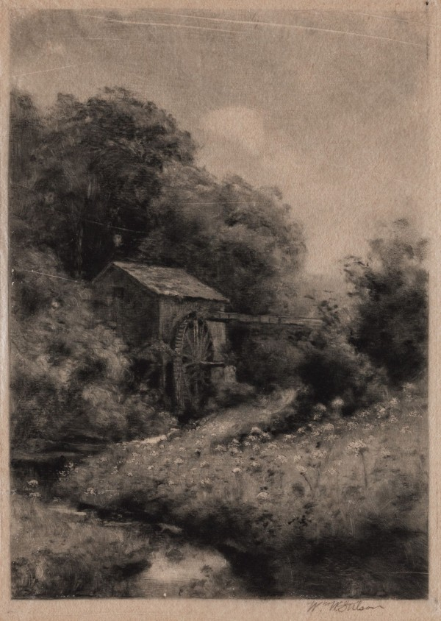
Old New England Mill, 19th Century (Source: detroit institute of art)
Reference
Dublin, T. (1983). The New England Mill Village: 1790–1860. Edited by Gary Kulik, Roger Parks, and Theodore Z. Penn. Cambridge, MIT Press, 1982. Pp. xxxv+ 520. $40.00. Business History Review, 57(3), 421-422.

