
Build an Atom Lab
Download this document to your computer. Type your answers below each question. The links are reviews of the material in the module reading. Save this lab as a Microsoft document or pdf (if not Microsoft document) and submit. This lab is worth 30 points. If you need help, contact your instructor through the Inbox.
Hint: To access the links in this document once downloaded, hold the Control key down while clicking the link.

Part 1: Practice.
There are no points to earn in Part 1.
From your reading, 2.1 Atoms, recall that Atomic Number is the number of protons in an atom.
The Atomic Mass is the number of protons + neutrons.
Let’s look at one element together – Helium. The symbol for Helium is in the upper right of the Periodic Table (image below). Find it now.
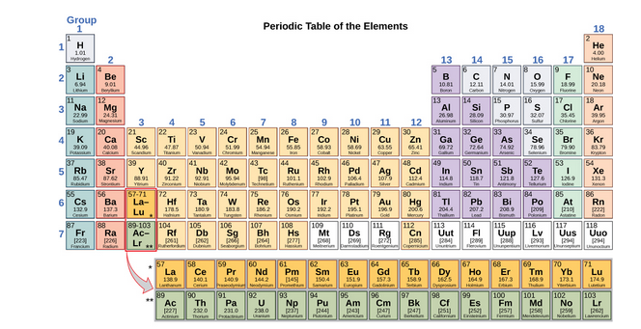
Try to answer the following questions about Helium before looking at the answers below.
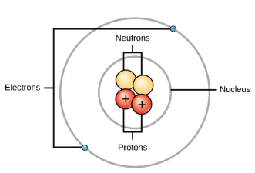
What is the atomic number?
What does that tell you?
What is the atomic mass?
What does that tell you?

Answers to Helium atom: 
What is the atomic number? 2
What does that tell you? The number of protons.
What is the atomic mass? 4
What does that tell you? The number of protons + neutrons.
Recall from your reading that in uncharged, neutral atoms, the number of electrons orbiting the nucleus is equal to the number of protons inside the nucleus.

2. If you need more explanation or review on electrons, protons, and neutrons, see this interactive tutorial Atomic Structure Tutorial
3. You can practice building atoms at Build an Atom
Hint: The protons and neutrons are in the center of the atom – the nucleus. The electrons orbit the nucleus.
Review the octet rule from your reading: Under standard conditions, atoms fill the inner shells first, often resulting in a variable number of electrons in the outermost shell. The innermost shell has a maximum of two electrons but the next two electron shells can each have a maximum of eight electrons. This is known as the octet rule, which states, with the exception of the innermost shell, that atoms are more stable energetically when they have eight electrons in their valence shell, the outermost electron shell.
Watch the Octet Rule video. Octet Rule

Part 2: Draw an Atom
The four elements common to all living organisms are
oxygen (O), carbon (C), hydrogen (H), and nitrogen (N).
Choose one of these 4 atoms to draw and label.
Do not choose an isotope (one or more forms of an element that have different numbers of neutrons) of the element.
You may use Build an Atom, but you must draw your own atom using the drawing tools in your computer. Or you may draw by hand. Take a picture of your drawing and insert below.
You may not copy/paste an image of an atom you find on the Internet or from Build an Atom.
18 Points are as follows:
2 points for identifying your atom
2 points each (6 points total) for the correct number of protons, neutrons, electrons
2 points each (8 points total) for labeling protons, neutrons, electrons, and nucleus
2 points for placing the subatomic particles in the correct location within the nucleus and the inner/outer valences.
Your atom drawing:

Part III. Chemical Bonds
Key terms in reading:
Ionic bonds -- Covalent bonds -- Hydrogen bonds
8 points – 2 points per question
Atoms can form molecules by donating, accepting, or sharing electrons to fill their outer shells.
A.
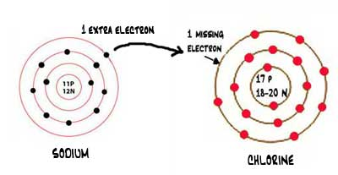
This image is a sodium atom and a chlorine atom.
The sodium “gives” an electron from its outer valence to the chlorine atom, which only has 7 electrons in its outer valence.
1. What type of chemical bond is this?
2. The new molecule (a group of 2 or more elements) is common table __________, known as sodium _______________.
B.
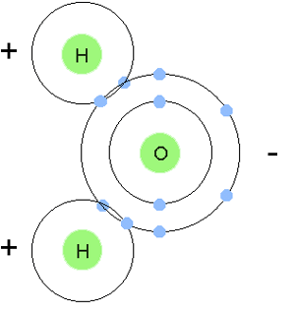
1. This image shows 2 hydrogen atoms bonding to an oxygen atom. This bond forms a single molecule of __________________. Hint: H₂O is the chemical symbol.
2. This type of chemical bond is known as what?

Part IV Isotopes and Carbon Dating
Isotopes are different forms of an element that have the same number of protons but a different number of neutrons.
Read more about Carbon Dating.
4 points
1. Give an example of how scientists can use carbon dating. (List your source if other than the one given above or your textbook.)
2. a. Explain (using and defining terms such as half-life and radioactive) why carbon dating is only useful on once-living organisms that have not been dead for more than approximately 50,000 years.
b. What is the half-life of C14?
c. Define half-life.

End of Lab
Attribution:
This lesson was compiled for BIOL 160, Pierce College at JBLM. It is licensed under a Creative Commons Attribution 4.0 license and contains content from:

Biology by OpenStax College is licensed under a Creative Commons License 4.0 International

Image Attributions:
"Atomic Structure" by Phillip Martin for educational use and licensed under CC BY-NC-ND 3.0
“Problem Solving” by Phillip Martin for educational use and licensed under CC BY-NC-ND 3.0
“Sodium & Chlorine Atoms” by Carr, K.E. from What is a bond? Used for educational purposes.
“Hydrogen & Oxygen” by Carr, K.E. from What is a bond? Used for educational purposes.

