Avatar

Student’s Name
Institutional Affiliation
Date

‘’
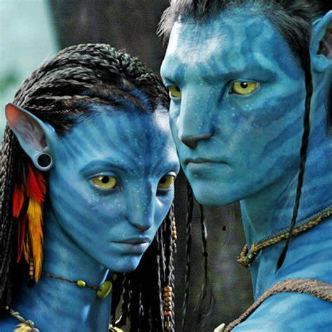
The frame used in the Avatar 2 is modified about different camera techniques and the editor's choice. The portrait was made to address a certain theme to the audience and pass a particular message as well. Some of the camera techniques employed in the portrait include shot size. The portrait shows two individuals whose image is taken very close to make it appealing and clear to the audience. The gentleman is the main character and the shot is taken alongside his wife (Malrooney, 2011).
The camera is positioned at eye level. This has been done to enhance realism and show the audience that it is how it sees the world. The characters face the camera standing and facing each other. This explains the close relationship between them and is meant to entice the audience and create curiosity about who they are. The image is presented in beautiful scenery and is depicted as one that was taken at nighttime. By doing so, it creates a terrific perception in the mind of the viewer. The two beings are presented in form of cartoons explaining the reason why the film is named Avatar (Winerta & Hamzah, 2012).
These techniques and choices are used in the film to achieve various objectives. One of the objectives is to create suspense for the audience. When the image features on the YouTube wall, the audience will have the desire to know what the series contains from its appealing outlook. The animation used on the portrait serves to address the audience that it is set in Asian culture and involves actors who use some powers during the action (Malrooney, 2011).
In conclusion, the use of a portrait is one way of communicating to the potential audience what to expect. Avatar is not an exclusion and the features on the portrait give a clear image to the audience. It is from the portrait that they can judge whether the series is an exciting one or not.

References
Malrooney, J. (2011). The Sadness of" Avatar". The Wordsworth Circle, 42(3), 201-204.
Winerta, V., & Hamzah, R. A. S. (2012). An Analysis of Politeness Strategies in Requesting Used in Real Human and Non-Human Conversation on “Avatar” Movie. E-Journal English Language and Literature, 1(1).

