Title: B2B
Name:
Course Number:
Course name:
School affiliations:
Professor’s name:
Date:

Introduction
Ingram Micro is a Chinese-owned company, which deals with information technology products such as television sets. The company headquarters are situated in California. The company is devoted to ensure that the customer gets the IT products through a shorter sales cycle, which has a greater success. This is done by the ability of the company to provide real business outcomes as well as remarkable customer experiences.
2 By 2 SWOT Analysis
Strengths
The B2B solutions set by Ingram to meet its customer expectations involves replenished solutions that save money and time for the company. The B2B solutions set by the company enable it to leverage internal operations of the company as well as the technological capabilities to meet its objectives as well of the customer needs (Business). It has a strong employee base (20,000) hence production is well taken care of. Improved profitability enables it to remain competitive in the market (CEV Inc., & Insight Media, 2016).
Weaknesses
The company has financial challenges. The company has the quest to spread across the word but it does this bit by bit continent to continent because of financial challenges. Overdependence on third party services is also a challenge. Ingram Micro has many lawsuits and pending actions against the company (CEV Inc., & Insight Media, 2016).
Opportunity
The business is able to attain connectivity and integration, which provided a point-to-point EDI connection through Shipwire Platform. The Shipwire platform is used by Ingram Micro to set up quickly and connect to the business, which need supply as well as retailers. Another opportunity that the company uses is the integration to a merchant ERP, which is set up in the Shipwire Platform (Mannings, 2012). This enables the business to transact quickly. The company also uses reverse logistics to initiate more returns because it is cost effective and ensures that the returned products are managed efficiently. The company has experienced growth in strategic acquisition, distribution channels, and service to its customers (CEV Inc., & Insight Media, 2016).
Threats
The company faces intense competition from its rivals. It has to compete for products, service, and price in the market. Rival companies such as Synnex Technology are also thriving for the same market share with Ingram (CEV Inc., & Insight Media, 2016).

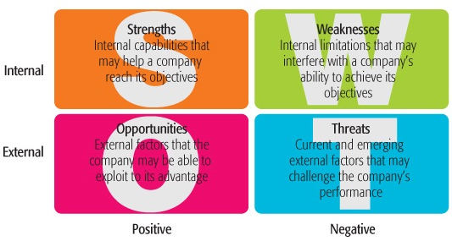
Assessment and Analysis
The company has set up competitive marketing strategies that enhance its business to thrive in the market of consumer electronics. Ingram Micro has segmented its market and serves both the retailer market and the wholesale market as well the ultimate consumer. This enables it to meet the needs of the business it is transacting with. The target market that Ingram looks at is the electronic consumer market. The company is a very strong industry player serving over 185000 B2B customers. In order to raise its sales revenue, the company overs discounts on bulk sales. It also offers its customers competitive prices for its products. The company has also invested in market positioning in that it has created a good market rapport and its products are perceived the best in the industry. It has well established distribution channels that ensures the products value is maintained until it reaches the final consumer (B2B Marketing Magazine).
Industry or product flow chart or chain (with description.)
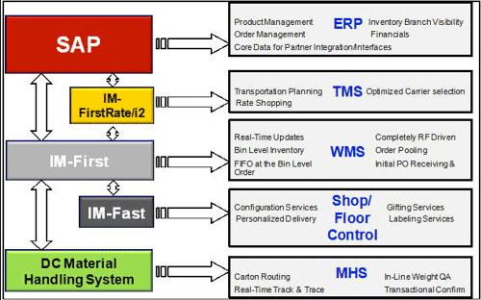
The first stage of the product flow that Ingram Micro uses is the Enterprise resource Planning (ERP). The company uses its integrated systems to source raw materials from the supplier and manufacture them to something more tangible and useful to the consumer (Harwood, 2013). The system also gives the company the power to manage other activities involved such as marketing and advertising, financials required as well as order management of the product. E.g., TV set (Hutt, & Speh, 2013). The second level of the supply chain that Ingram uses is the transport management system (TMS) to enhance delivery of the products to the customer/consumer. Optimization of the carrier selection is also important and the logistics involved.
The third level of the product supply chain includes the Warehouse management system (WMS) and this offers time solutions for managing inventories. Bin level inventory is key in this stage to ensure that the products’ information real time is available throughout the supply chain.
The forth level of the Ingram’s supply chain include personalized delivery of the product to the customer. Other services in this stage include labeling services, and gifting.
After the product is delivered, the final transaction can be made (Friedman, 2011).

References
B2B Marketing Magazine. (n.d.). United Kingdom: Silver Bullet Publishing Limited.
Creative Educational Video, Inc., & Insight Media (Firm). (2016). SWOT analysis. Lubbock, Tex.: CEV Multimedia.
Datamonitor (Firm). (2011). Ingram Micro Inc. New York, NY: Datamonitor.
Friedman, M. (2011). Understanding B2B. Chicago, IL: Dearborn Trade.
Harwood, S. (2013). ERP: The implementation cycle. Oxford (UK: Butterworth-Heinemann.
Hutt, M. D., & Speh, T. W. (2013). Business marketing management: B2B. Australia: South-Western, Cengage Learning.
Mannings, R. (2012). Ubiquitous positioning. Boston: Artech House.

