Boston Consulting Group
Student’s Name
Institutional Affiliation
Course
Professor’s Name
Date

Boston Consulting Group Matrix
This refers to a planning strategy for businesses whose purpose is for measuring a business's brand's strategic position. According to Chiu & Lin (2019), it is used to classify different products into different matrices, with each of them being classified as either high or low performance. This depends with the product’s share in the market and the market’s growth rate.
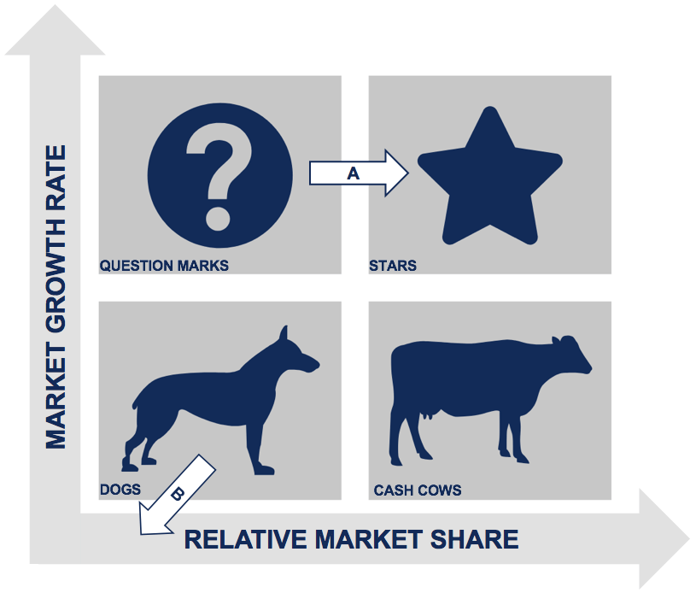
The BCG Matrix's Y-axis represents the product’s relative share of the market and how strong this product is in this market. A business can measure its competitiveness in the market by use of market share. The growth rate of a product is represented by the X-axis.
BCG matrix has four quadrants with question marks being the first one. Products in this section are in a market with rapid growth, but the market share of the products is meager. As stated by Fadrian & Arifin (2018), to increase their market share, question marks require heavy resources and investment. Investments from this quadrant get their funding from the cash cow quadrant cash flows. All firms would want to turn question marks into stars. Question marks that do not become market leaders become dogs when the market trend declines (Fadrian & Arifin, 2018).
The second matrix is Dogs. These products are in a slow-growing market, and the market share is also low. These products provide their own cashflows through self-sustenance. The issue is products in this quadrant have no potential to reach the stars quadrant (Maha, Cahyandito, & Purnomo, 2020). The majority of firms terminate most products in this quadrant unless such products are used for competition or are used to compliment the other existing products.
Besides the dog matrix, the next is the star matrix. According to Chiu & Lin (2019), this represents products that are in a market section which is growing really fast with very high shares in the market. Even though these are already established market products, input is still required to keep them in the competition and to increase their worth. Even though stars generate substantial cash flows, they also require a lot of money for investment. Products in this quadrant eventually grow into cash cows as a result of products remaining successful due to maturity in the market. Stars are every firm's gold possession (Chiu & Lin, 2019).
The last matrix is the cash cows. Products in this quadrant have a slow growth market, but with products whose, market share is very high. Cash cows are products that are market leaders in markets. Being already at the top of the market, these products do not need any further investments ((Fadrian & Arifin, 2018). Question marks and stars are financed by cash flows generated from cash cows. Products from this quadrant give firms the highest levels of profits as firms invest the least with them.
In summary, the BCG matrix is designed to help firms consider growth opportunities and think about long-term strategic planning by closely reviewing its products and deciding where to invest or which products to terminate their production.
References
Chiu, C. C., & Lin, K. S. (2019, July). Rule-based BCG matrix for product portfolio analysis. In International Conference on Software Engineering, Artificial Intelligence, Networking and Parallel/Distributed Computing (pp. 17-32). Springer, Cham.
Fadrian, A., & Arifin, A. S. (2018, September). Study on 2G Termination in Indonesia using BCG Matrix. In 2018 5th International Conference on Information Technology, Computer, and Electrical Engineering (ICITACEE) (pp. 1-5). IEEE.
Maha, K. A., Cahyandito, M. F., & Purnomo, D. (2020, February). Mapping of business potentials of Maha orange plantation using the Business Model Canvas and BCG matrix. In IOP Conference Series: Earth and Environmental Science (Vol. 443, No. 1, p. 012045). IOP Publishing.

