Student’s Name
Professor’s Name
ECON 4150
Due Date
Assignment 1
1. Define Behavioral Economics. Explain two reasons why individual behavior may deviate from the predictions of traditional economic theory.
Behavioral Economics can be defined as the study of how the emotional, cognitive, psychological, social and cultural factors affect the making of economic decisions by institutions and individuals. One reason why individual behavior may deviate from the predictions of traditional economic theory is that it ignores the rationality of individuals in making economic decisions and stresses on observed behavior. The traditional economic theory provides that rationality has the most application in the market and not observed behavior. The second reason for deviation is that behavioral economics rely on stated preferences from their behavioral surveys yet the traditional economic theory emphasizes that revealed preferences are the key determinants of economic value.

2. Explain the following two concepts: decision utility and experienced utility. Discuss why experienced utility and decision utility may fail to coincide. List at least two ways to measure experienced utility.
Decision utility refers to the weight given to the desirability of a specific economic outcome within the decision-making context. Experienced utility refers to the economic state that is attained after successfully achieving a certain outcome. Experienced utility and decision utility may fail to coincide because decision utility is based on future prospects and is thus tend to be less considerate of the potential risks decision contexts. On the other hand, experienced utility is based on past experiences and is thus more risk averse as it tends to favor the best past experiences over future unknown outcomes. Two ways that can be used to measure experienced utility include the day reconstruction method and contingent valuation method.

3. Briefly explain the DRM (Day Reconstruction Method) discussed in class. What are the advantages of this method compared to other methods used in the previous studies?
DRM is a method used to measure experienced utility by assessing how individuals spend their time and the experiences they gain from the various settings and activities of their lives. For this reason, DRM combines the samples of experience and time-budget measures to allow individuals to reconstruct their experiences and activities of the previous day with highly minimized bias. The advantages of DRM compared to other methods used in the previous studies include but are not limited to: lower vulnerability to retrospective reporting biases, joint evaluation of subjective experiences and activities, high flexibility in adapting the needs of a specific study, more complete coverage of the day, lower respondent burden, and allows for duration-weighted analyses of experiences.

4. The efficient market hypothesis predicts that “the future returns on the two portfolios, the Winners and the Losers, should be the same since you are not supposed to be able to predict changes in stock prices from past returns.” Thaler (2018) mentioned that he and his coauthors had a different prediction. What was their prediction? Explain the rationale behind their prediction.
Thaler (2018) and his coauthors predicted that “the losers would do better than the market and the winners would do worse than the market.” The rationale behind their prediction was that people would overreact to the stories surrounding losers and avoid them like the plague, which is what caused them to be losers in the first place. But then, going forward, if the company merely performed a bit better than it had in the past, investors would be pleasantly surprised, and prices would go up. They expected the reverse for winners, who would be unable to live up to the high expectations that went with being a long-term winner. This result was strongly confirmed using a test on five-year formation periods where the loser portfolio had subsequently outperformed the market by a cumulative 46 percent over the following five years, while the winners had underperformed by 19 percent, the results of which held for other tests.
5. Use a graph to show the utility function for a risk-loving individual. Is the expected utility smaller than the utility of expected value for this individual? Justify your answer using a graph.
Fig.1: Utility Function for a Risk-Loving Individual
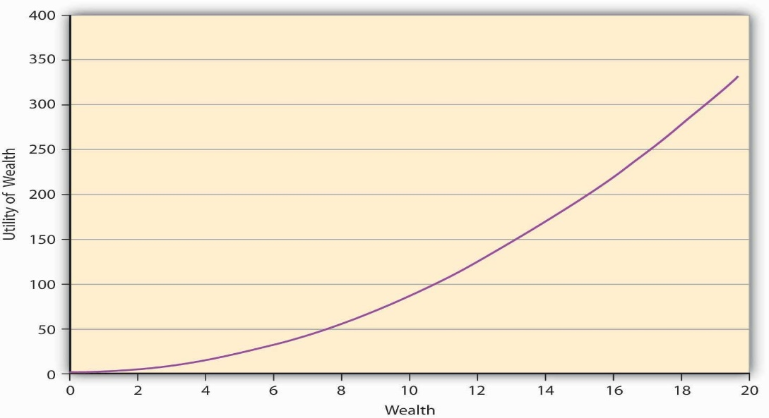
The expected utility is not smaller than the utility of expected value for this individual. For example, a simple gamble based on a coin toss pays $10 for heads and $20 for tails. A risk-loving individual has a utility function that takes the form u(w) = w² as shown in the following graph.

Fig.2: Utility Function for a Risk-Loving Individual
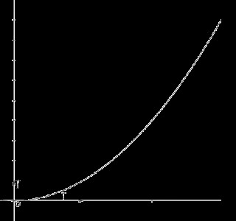
u(w) = w²
u(w)
w
The expected utility over this gamble will be (0.5×10²⁾ + (0.5×20²⁾ = 250
On the other hand, the utility of the expected value of the gamble is 15² = 225.
250 > 225, and therefore the expected utility is greater than the utility of expected value for a risk-loving individual.
6. Explain prospect theory. Use an example to illustrate one implication of the theory. Some claims that people can be extremely risk averse so that they value a risky prospect less than the prospect’s worst possible outcome based on prospect theory. Is that right? Justify your answer.
Prospect theory is a description of how individuals make choices between different prospects and how they estimate, most frequently in an incorrect or biased way, the perceived likelihood of each these prospects. For example, if I am presented with two options: to get $700 or take a 90% chance of winning $900 (and a 10% chance of winning nothing), I would avoid the risk and take the $700 event though the expected outcome is the same in both options. Yes, it is a true claim that people can be extremely risk averse so that they value a risky prospect less than the prospect’s worst possible outcome based on prospect theory. For example, if I was asked to choose between losing the $700 and take a 90% chance of losing $900, I would take the take the second option (with a 90% chance of losing $900). By doing this, I would be engaging in a risk-seeking behavior in the hope to avoid the loss.

7. Define the uncertainty effect (UE). What are the three possible reasons for the UE? Simonsohn (2009) examined the rationale behind the UE using experiments. Summarize the findings from the experiments.
UE refers to the inability to predict the nature of the effect of a future state of the environment on the organization. The results from experiment 1 established that the UE is obtaining when using physical lottery descriptions. Experiment 2 established that the UE is not observed when valuations are obtained using the multiple-price-list method. Experiment 3 suggested that the multiple-price-list elicitation reduces risk aversion to the point that it eliminates an otherwise robust UE finding. The last experiment 4 suggested that the multiple-price-list reduces people’s reliance on intuitive processing of information and their propensity to choose dominated alternatives.

