Cellular Metabolism Lab
We will walk through the steps of Cellular Respiration in this activity. Please do not skip ahead or leave out steps. Fully taking the time to cut out and arrange the shapes and answer attached questions will help you to gain a deeper understanding of cellular respiration (the process of making energy, ATP, the major contributor to our overall metabolism).
Grading Notes: You can either 1) Print out this document, add your answers and shapes to it, then scan the entire document for grading, or 2) Answer the questions on this template and upload images from your camera to the specified locations below.
- Glycolysis
  - Cut out the six carbon circles and connect them to form Glucose.
  - Glycolysis occurs where? in the cytosol of cell’s cytoplasm
  - In this step, we began with a six carbon glucose molecule, and after it encounters ten enzymes, it results in three carbon sugar pyruvate molecules.
  - Now cut your glucose molecule into two pyruvate molecules.
  - Insert an image of your two pyruvate molecules below.
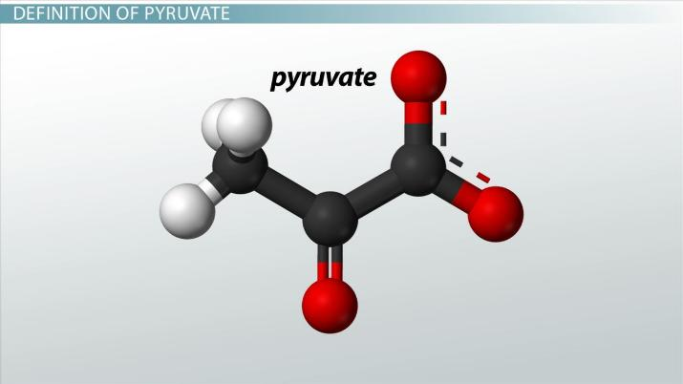

  - Along with Pyruvate, there are two other products of this step. They are one molecule of CO2, and the remaining two carbons are used to form the compound acetyl CoA.
  - The 2 NADH molecules are sent to the mitochondria.

Write out the final products of Glycolysis.

Glucose two pyruvate + two NADH + two ATP

  - Cut out 2 NADH molecules from your shapes sheet and “take them” to the Electron Transport Chain (ETC) on page 6. (Don’t glue them organize them)

2A. In the absence of Oxygen
In the absence of Oxygen (O₂), Pyruvate goes through anaerobic cellular respiration.
- Here Pyruvate yields two ATPs + carbon dioxide (in human) or Ethanol (alcohol). When other organism goes through this metabolic process and produces alcohol instead of the human by the product you named above, it is commonly called fermentation.
Add the correct pieces from your shape sheet to diagram Glycolysis + Anaerobic cellular Respiration due to an absence of Oxygen below.
- (Only use one of your premade pyruvates for this step. You can draw the other if you need too).
- Add brackets { to group 1) Glycolysis vs. 2) Anaerobic Cellular Respiration
- Note: There is no one correct way to configure the shapes, make sure that it shows you can fully document the process of Glycolysis and anaerobic cellular respiration.
  - I should be able to see how Glucose ends as either lactic acid or ethanol (depending on the organism).

2B. In the presence of Oxygen
In the presence of Oxygen (O₂), Pyruvate would instead go through aerobic cellular respiration.
- Here pyruvate bonds with fatty acids to form acetyl coenzyme A. Acetyl Co-Enzyme A can now enter into Krebs cycle also known as the citric acid cycle.
- Besides acetyl CoA, the other two products of this reaction are NADH and FADH2
    - Move the NADHs from the shape sheet to the appropriate location on page 6.
Using your other pyruvate molecule and different shapes Add the shapes (plus your other pyruvate molecule) below to show the equation with reactants and products of this step based on the information above.
Acetyl-CoA + 3 NAD+ + Q + GDP + Pi + 2 H2O →
CoA-SH + 3 NADH + 3 H+ + QH2 + GTP + 2 CO2

3. Krebs Cycle (Citric Acid Cycle)
- Krebs Cycle occurs in the mitochondrial matrix.
- Locate the location of this place in the mitochondria below
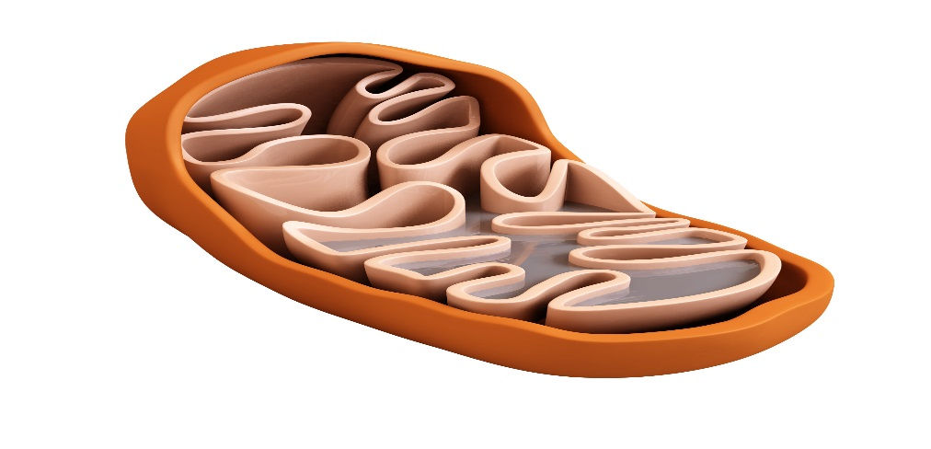
C. Complete the reactants and Products of this step (Words on Shape sheet)
Reactants | Products
Two molecules of pyruvic acid  Acetyl-coenzyme A | NADH, FADH  Oxaelotic
- The 6 NADH and 2 FADH₂ molecules also go to the _electron transport system_________________________.
    - NADH and FADH₂ are temporary receptors that hold hydrogen ions with the energy trapped in that bond.

4. Electron Transport Chain (Oxidative Phosphorylation)
Place the NADH a FADHs (if any) that have come here from the previous aerobic steps (don’t glue them)
Glycolysis | Intermediate Step | Krebs Cycle
How many NADH and FADHs came to the electron transport chain from Glycolysis? | How many NADH and FADHs came to the electron transport chain from the intermediate step? | How many NADH and FADHs came to the electron transport chain from the Krebs Cycle?

- The Electron transport chains are located within the _inner membrane of the mitochondria.
- Label this additional region on the mitochondria pictured on page 3.
- Here hydrogen_ ions are removed from NADH and FADH2.
  - Cleave the H+ ions from each of your temporary receptors you’ve been collecting so far (from above) and placed them in the appropriate location of the image on the next page.
  - Cut out and place the integral proteins on the inner membrane of the mitochondria.
    - Number the intermembrane proteins I-IV (the textbook only highlights 4, so you’ll have a shape left over)
    - Label ATP Synthase
  - Cut out and place the ADP and Phosphate group molecules within the matrix near ATP Synthase (You do not have to use all of these, just enough to show understanding)
ETC Summary
- Where is the H+ that were removed from the temporary receptors pumped to? Back into the matrix.
- H+ can only leave this area of high concentration by traveling along with intermembrane space, which “dumps” them back into the matrix area.
- ATP Synthase uses the energy created by the traveling H+ to turn ADP and Phosphate groups into ATP.
- As the H+ was removed from the temporary receptors (NADH and FADH₂), _NAD+ and FAD+ (hint: energy holding atomic particles) are also released. They are then pulled along the five intermembrane proteins as the H+ are pumped.
  - Cut out the e- and draw arrows to show how they move along the proteins
- Both the electron and the H+ that are now back in the matrix (slide down ATP Synthase) are “captured” when they are bonded to ___NADH+ H+_ forming NADH.
