BIO101

- The smallest unit of all matter; living and non-living is the _atom_

- An atom can be changed into an ion by removing Electrons An atom can be changed into an isotope by adding or removing _Neutrons

- There are three types of chemical bonds:
- Bonds where one charged atom gives one or more electrons to another is an __Ionic _ bond.
- Bonds where atoms share one or more electrons are called __Covalent _ bonds.
- Weak bonds between water molecules and DNA are called ___Hydrogen_ bonds.

4. Water molecules “stick to” other water molecules in a process called _Cohesion__.
Water molecules are attracted to other surfaces in a process called __Adhesion_.

5. A nitrogen atom has 7 protons, and the most common isotope of nitrogen has 7 neutrons. A radioactive isotope of nitrogen has 9 neutrons. What are the atomic numbers and mass numbers of the stable and radioactive forms of nitrogen?
Stable Radioactive
Atomic # __7___ Atomic # __7___
Mass # ___14___ Mass # __16___

6. Using the periodic table of the elements on page A-3 of the appendix of your book, fill in the following information.
- What element is the most abundant in the human body? __oxygen_(O)___
(give element and symbol)
- What element found in bananas is important for nerve and muscle function? Atomic number 15. __Phosphorous (P_)_
- This element (one of the only liquid at room temperature) used to be used to fill thermometers. It is toxic to the body. Mercury______ , (_Hg_)_
- Pennies are made of this element: __Zinc ____________, _(_Zn__)
- This noble gas is the second lightest gas on Earth. _Neon___ (Ne )
- This element is often known as “Vitamin Z” due to its positive effects in building immunity. __Zinc __________, (_Zn_)_
- Sodium Chloride is made up of these two elements: __Sodium________, _Na___ and
___Chloride_____________, (Cl_)___.
- These two elements are our “precious metals” which are used in making many forms of jewelry. ____Silver__, _(Ag)___ (atomic #47) and __Gold__, __(Au)__ (#79)
- This element is the basis for organic chemistry; it is versatile able to form four bonds ith other atoms. ___Carbon_____________, _(C) ___. Atomic # __6___
Label the atom and its parts:

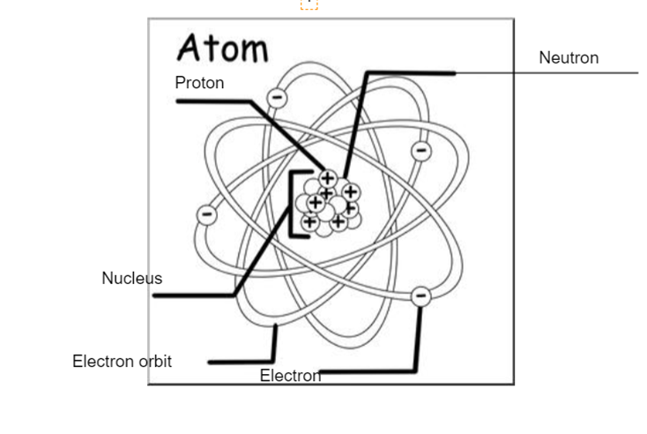

What are the names of the following molecules? (You may have to use other resources)

CO₂ _Carbon dioxide_
O_{2 _____________}Oxygen __gas____
O_{3 ________}Ozone__
H_{2 ______}Hydrogen __
H₂O ___Water_____
NH₃ _____Ammonia_
CH₄ _____Methane_
C₆H₁₂O_{6 ______}Glucose__

