Designing A New Website for Berkshire Hathaway
Student’s Name
Institutional Affiliation

- Project Integration Management:
  - Project Charter:
    - General Project Information
The title of this project is designing a new website. The sponsor of this project is Berkshire Hathaway. The project started on 3 January 2019 and is expected to end on 4 July 2019.
    - Project Objective:
- To establish a design for the proposed website
- To create an infrastructure for the website
- To develop a high quality content for the website
- To roll out a website that is well-organized and user-friendly
    - Assumptions:
- Users have laptops, computers, smartphone or any gadget that can access the internet
- Users want to shop and access other services online
    - Project Scope:
A project scope establishes boundaries of the project. This project will involve gathering requirements of the website including technical specifications, user requirements are reporting requirements. The project will establish a new design for Berkshire Hathaway website, select technical framework, implement technical framework, create a new content, test and roll out a new website.
    - Project Milestones:
- Milestone 1:
Description: Gather website requirements
Date: 17/Jan/2019
- Milestone 2:
Description: Establish website design
Date: 08/Feb/2019
- Milestone 3:
Description: Select technical framework
Date: 11/March/2019
- Milestone 4:
Description: Create infrastructure
Date: 07/May/2019
- Milestone 5:
Description: Create website content
Date: 06/Jun/2019
- Milestone 6:
Description: Load the website with new content
Date: 26/Jun/2019
- Milestone 7:
Description: Test the website
Date: 01/Jul/2019
- Milestone 8:
Description: Roll out the new website
Date: 04/Jul/2019
  - Statement of Work
    - Designing a new website, submitted on 22/Feb/2019 and prepared by Alexander Kerry
    - Business Need and Benefits: There is need to develop the new website because although Berkshire Hathaway technically has a website, the company has never renovated their page since the mid-90s. The company’s current website is www.berkshirehathaway.com. The new website will be more presentable and contain updated information about the company including its products.
    - Strategic Business Information for the Organization:
The vision of Berkshire Hathaway is to be a provider of choice for comprehensive real estate and financial solutions. Its mission is to utilize their world class professionals to guide people in making real estate and financial solutions (Mission and vision statements of top 10 world largest companies 2015).
    - High Level Schedule with Major Deliverable Milestones (Date and Milestone)
- Gather website requirements by 17/Jan/2019
- Establish website design by 08/Feb/2019
- Select technical framework by 11/March/2019
- Create infrastructure by 07/May/2019
- Create website content by 06/Jun/2019
- Load the website with new content by 26/Jun/2019
- Test the website by 01/Jul/2019 and
- Roll out the new website by 04/Jul/2019
  - Business Case:
    - Project Name: Designing a new website
    - Project Purpose: To improve the current website used by Berkshire Hathaway since it is old and does not reflect the company’s current state.
    - Project Description: The project will involve gathering website requirements, establishing website design, selecting technical framework, creating infrastructure, creating website content, loading the website with new content and testing the website.
    - Known Risks:
- Scope of work not properly specified
- Scope creep
- Additional of unnecessary features to the website
- Team change-over
- Poor team cohesion
- It takes time of hire project members with required skills.
- Hiring may take much time
- Disengaged stakeholders
- Application not scalable
- Application not stable
    - Cost-Benefit Analysis
      - Expected cost: $11,200
      - Expected Benefit: -Improved speed of browsing
-More presentable website
    - Summary
The project will deliver a new website for Berkshire Hathaway. Major tasks in the project include gathering website requirements, establishing website design, selecting technical framework, creating infrastructure, creating website content, loading the website with new content and testing the website. The expected cost is $11,200 and expected benefits include improved speed of browsing and more presentable website.
  - Project Management plan
Task | Responsible personnel
Project management | Alexander Kerry
Gathering website requirements | Frederick Brown
Website designing | James Kyle
Evaluation of technical framework | Steve Rodgers
Creation of website infrastructure | Annie Livingstone
Content creation | Tyson Kylan
Website testing | Amos Musk

- Project Scope Management:
  - Project Scope Statement: Designing a new website for Berkshire Hathaway, Managed by Alexander Kerry from 3/Jan/2019 to 4/Jul/2019.
  - Department, Project Manager, Date
    - Prepared by: Alexander Kerry and project manager
    - Version History: 21/Feb/2019, word document, Alexander Kerry
    - Project Description: The project entails designing a new website for Berkshire Hathaway where it can sell its products.
    - Goals of the Project
- To develop a website with an improved speed of browsing than the one currently used by Berkshire Hathaway
- To Berkshire Hathaway’s website more presentable

  - Requirements Traceability Matrix

ID | Associate ID | Requirements Description | Business Needs/ Goals | Project Objectives | WBS Deliverables | Product Design | Product  Development | Test Cases
1.1 | 1.1.1 | Analyze the expected website bandwidth | Better speed of browsing through the website | To establish a design for the proposed website | Task 1.1 | Product design started | Product development started | Testing not started
1.2 | 1.2.1 | Take into account the banners, footers, logo, color scheme and font usage in the new website | Improved presentation and browsing through the website | To develop a high quality content for the website | Task 1.2 | Started | Started | Not started

- Project Time Management:
Project Network Diagram (Precedence Diagramming Method)

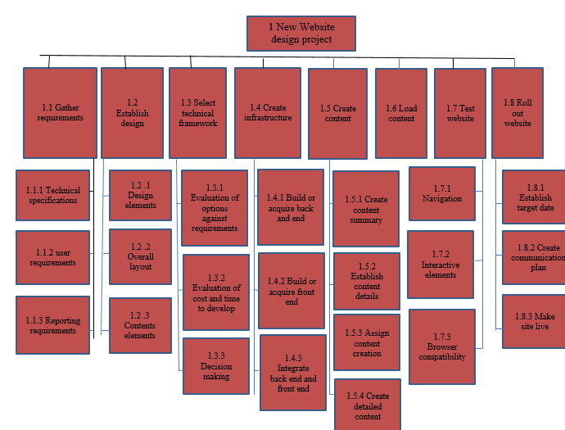

Figure 1: Project work breakdown structure
- Project Cost Management:
  - Budget at Completion:
    - List the money needed to complete the project and the duration of the project
The money needed to complete this project is $11,200 and the project will run for 131 days.
    - Pick a date during the project and a percentage of completion and calculate the following:
As at 8 February 2019, the overall cost performance index of the project is 0% while to complete performance index (TCPI) is 1.14 (see Figure 2). 18% of the project is done (see Figure 3) while the schedule performance index (SPI) is zero. The summary is as follows:
Date: 8 February 2019
Time into Project: 26 days/ 1 Month
Percent Complete: 18%
Expected Completion to Date: 18%
Current Project Cost: $1,550 (see Figure 2 and Figure 3)
Budget at Completion: $11,200
Project Evaluation:
Evaluation | Value
Planned Value | $0
Earned Value | $0
Cost Variance | $1,350
Schedule Variance | $0
Cost Performance Index | $0
Schedule Performance Index | $0
To Complete Index | 1.14
Variance at Completion | $9,650

The project is below what is expected and it is predicted that in the future, the project will end within the budget (not exceeding the budget).

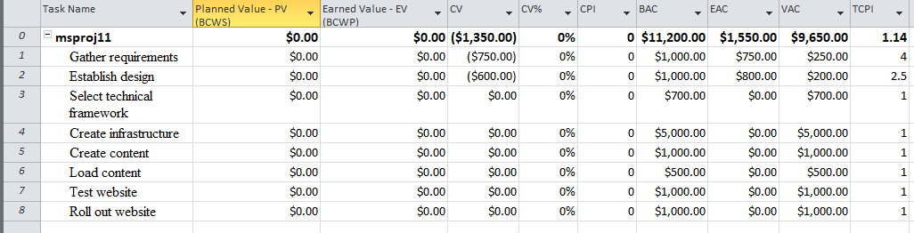

Figure 2: Earned value cost indicators

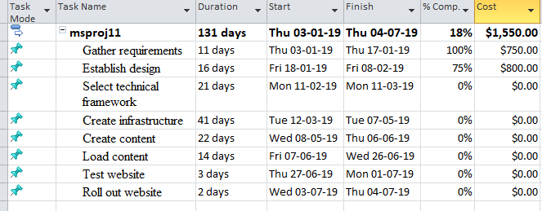

Figure 3: Project summary

- Project Quality Management:
  - Project Quality Management Tool:

Figure 4:
Scope of work:
- Scope of work not properly specified
- Scope creep
- Additional of unnecessary features to the website
Human resources/Team
- Team change-over
- Time to learn
- Poor team cohesion
- It takes time of hire project members with required skills.
- Hiring may take much time
- Disengaged stakeholders
Technical
- Application not scalable
- Application not stable
The above errors may be managed through continual estimation of change during the project, efficient communication within the project members, having more than one developer with the same level of skills who substitute others, and through technical checks such as automated testing.
- Project Human Resource Management:
  - Organizational Management Chart:
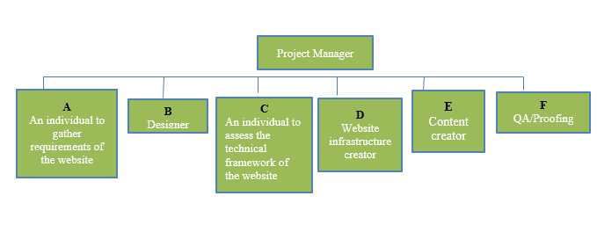
Figure 5: Organizational management chart

  - Job Descriptions:
- The team member A will gather the technical, user and reporting requirements of the website.
- Member B will design the website and this including programming.
- Member C evaluates options against the requirements, cost and time required to develop the website and recommends the course of action.
- Member D will build or acquire back end, front end and integrate back end and front end.
- Member E will create the content and load it the new website.
- Member E will ensure the website is functioning as required. He will also test the website.
- The project manager will oversee the project. He will address emerging issues and ensure the project runs smoothly to completion.
- Project Risk Management:
  - Probability-Impact Matrix:
Risk score= Probability * Impact
- Green- low impact, low probability
- Yellow- moderate impact, moderate probability
- Red- high impact, high probability

Probability
.9 | .05 | .09 | .18 | .36 | .72
.7 | Scope of work not properly specified  (.04) | .07 | Application not scalable  (.14) | .28 | .56
.5 | Scope creep (.03) | .05 | Application not stable  (.1) | .2 | .40
.3 | .02 | .03 | .06 | .12 | .24
.1 | Additional of unnecessary features to the website  (.01) | Project team turn over (.01) | Poor team cohesion  (.02) | Disengaged stakeholders  (.04) | .08
 | .05 | .1 | .2 | .4 | .8
 | Impact

- Project Procurement Management:
    - Project/ Company Description
The project involves designing a new website. The website belongs to Berkshire Hathaway which is an American multinational company headquartered in Omaha.
    - Identify the Need for the purchase (and needs purchase will meet)
There is need to purchase the following hardware and software to design the new website. They are the ingredients for the website and without them, the project will not succeed. For instance, we need the domain name because it is the digital address that people will use to connect to the website. Any missing of the following hardware or software will ruin the project.
    - Specify Hardware and Software Requirements for the purchase
- Domain name
- Business email address
- Website building software
- Website hosting
- Logo design
- High quality images for the website
- Image editors
- Google analytics

- Project Stakeholder Management:
  - Stakeholder Analysis:

  - Stakeholder Register:
Berkshire Hathaway
Stakeholder Group | Power | Influence (+/-) | Information needs | Role | Currencies to be used or provided
Berkshire Hathaway | High | + | Project status | Sponsoring the project | Task-related
Project team | High | + | Project status | Participation | Task-related
Software users | High | + | Features of the new website | Using the new website to purchase products from Berkshire Hathaway | Product features
Competitor (Leucadia National Corporation) | High | -

Reference
Mission and vision statements of top 10 world largest companies 2015. 17 7 2015. Web. 21 Feb 2019. <https://908436031989043030.weebly.com/mission-and-vision-statements-of-top-10-world-largest-companies-2015/mission-and-vision-statements-of-top-10-world-largest-companies-2015>.

