Chapter 2: The Chemical Context of Life
2.1 Describe matter, chemical elements, and chemical compounds.
2.2 Use examples to illustrate how the structure of an element's atoms determines its properties.
2.3 Identify and describe the types of strong and weak chemical bonds, and use examples to show how bonds affect molecular shape.
2.4 Given an example of a chemical reaction, describe its meaning in words.

This chapter covers the basics that you may have learned in your chemistry class. Whether your teacher goes over this chapter or assigns it for you to review on your own, the questions that follow should help you focus on the most important points. It will be assumed that you have this basic material mastered in future topics, so review if necessary!
Study Tip: How much time you spend with this chapter depends on your chemistry background. The Study Tip table on p. 28 is a great idea if you are uneasy with the fundamentals of chemistry. If you have a good chemistry background and can, for example, visualize the electron distribution diagrams of the elements listed in the table, the table will not be necessary. The ideas in this chapter are fundamental to understanding the text, so do the work you need. Everyone should review Figure 2.1 as an introduction to the chapter.
Concept 2.1 Matter consists of chemical elements in pure form and in combinations called compounds
LO 2.1: Describe matter, chemical elements, and chemical compounds.
1. Define and give an example of the following terms:
matter:
element:
compound:
2. What four elements make up 96% of all living matter?
3. What is the difference between an essential element and a trace element?
essential element:
trace element:
Concept 2.2 An element’s properties depend on the structure of its atoms
LO: 2.2: Use examples to illustrate how the structure of an element's atoms determines its properties.
4. Sketch a model of an atom of helium, showing the electrons, protons, neutrons, and atomic nucleus.

5. What is the atomic number of helium? What is the atomic mass?
6. Here are some more terms that you should firmly grasp. Define each term.
neutron
proton
electron
atomic number
atomic mass
isotope
electron shells
energy

7. Consider the entry in the periodic table for carbon, shown below.
What is the atomic mass? What is the atomic number?
How many electrons does carbon have? How many neutrons?
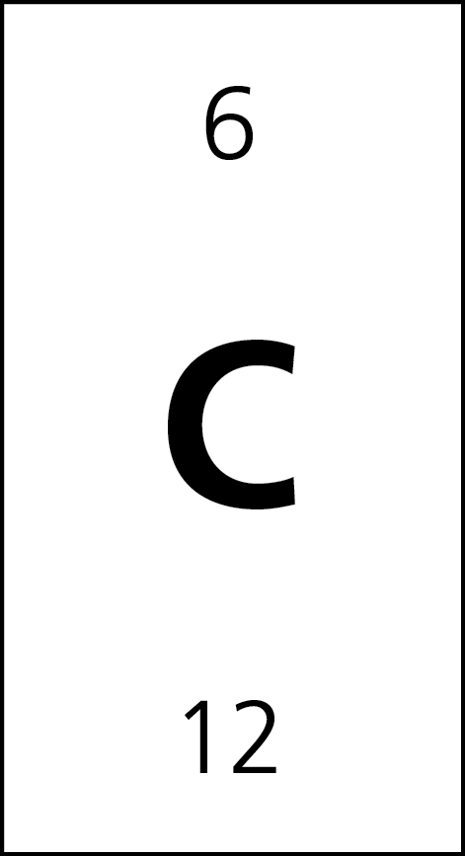
8. What are isotopes? Use carbon as an example in your explanation.

9. What are radioactive isotopes? Give one medical application that uses them.
The radioactive isotopes diversely are useful. In the medicine field, Cobalt-60 is used as radiation source aimed to arrest cancer development. Many other radioactive isotopes are utilized as tracers for diagnostic use.
10. Application: Radiometric dating uses the rate of decay of certain radioactive isotopes, such as carbon-14 to date relics of past life. The Scientific Skills Exercise on p. 33 explains this process. The half-life of carbon 14 is 5730 years. How old would a piece of ancient wood be if only ¼ of this isotope remains? (Hint—how many half-lives have passed? How long is each half-life?) You can check your answer at the end of this chapter.
11. What is the only subatomic particle that is directly involved in the chemical reactions between atoms?
The only subatomic particle that is directly involved in the chemical reactions between atoms is electron.
12. Label the diagram as shown in Figure 2.6. The cellular processes of photosynthesis and cellular respiration center on the movement of electrons. How is the movement of electrons shown in the diagram related to photosynthesis?
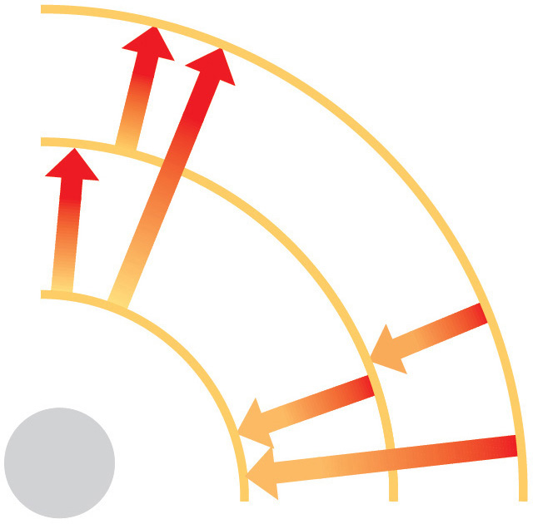

Arrows pointing in= sunlight and carbon dioxide
Arrows pointing out= oxygen
The movement of electrons shown in the diagram related to photosynthesis because the reaction center chlorophyll then transfers its high-energy electron to an acceptor molecule in an electron transport chain as indicted by the arrows. High-energy electrons are then moved through several membrane carriers, coupled to the synthesis of ATP and NADPH.

13. What is potential energy?
This is energy, possessed by matter because of its structure or location.
14. Explain which has more potential energy in each pair:
a. boy at the top of a slide/boy at the bottom: The boy on top of the slide has more potential energy and this is as a result of Its location.
b. electron in the first energy shell/electron in the third energy shell:
Electrons In the third energy shell contains more potential energy due to Its relative distance from the nucleus.
c. water/glucose: Glucose remain to have higher potential energy due to Its structure. Potential energy always is stored in chemical bonds. Comparing water and glucose, there are less chemical bonds in water (H2O) than those in glucose (C6H12O6).
15. What determines the chemical behavior of an atom?
The distribution of the electrons within an atom determines the chemical behavior of an atom.
16. What are valence electrons?
The number of electrons in the outermost shell.
17. Here is an electron distribution diagram for sodium: 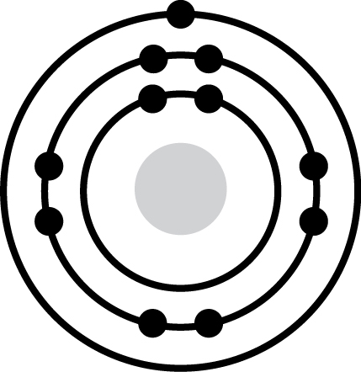
a. How many valence electrons does it have? One Circle the valence electron(s).
b. How many protons does it have? Eleven.
Concept 2.3 The formation and function of molecules and ionic compounds depend on chemical bonding between atoms
LO 2.3: Identify and describe the types of strong and weak chemical bonds, and use examples to show how bonds affect molecular shape.
18. Define molecule.
When two atoms or more held together by the covalent bond, tend to form a molecule.
19. Now, refer to your definition of a compound and fill in the following chart:
 | Molecule? (y/n) | Compound? (y/n) | Molecular Formula | Structural Formula
Water | Yes | Yes | H2O | H-0-H
Carbon dioxide | Yes | Yes | CO2 | O-C-O
Methane | Yes | Yes | CH4 | H  |  H-C-H  |  H
Oxygen | Yes | No | O2 | O=O
20. What is the valence of hydrogen (-1), +1 , oxygen -2 , nitrogen
-3, -2, -1, (+1), +2, +3, +4, +5 , and carbon (+2), +4 ?
21. In the formation of a water molecule why is the ratio two hydrogens to one oxygen?
Two atoms of hydrogen are needed to satisfy the valence of one oxygen atom.
22. What type of bond is seen in O₂? Explain what this means.
In O2, there exist a double covalent bond. The two atoms of oxygen together thus forming a molecule by sharing the two pairs of valence electrons.

23. What is meant by electronegativity?
The electronegativity is referred as an attraction of a certain Atom for the electrons in the covalent bond.
24. Explain the difference between a nonpolar covalent bond and a polar covalent bond.
A nonpolar covalent bond occurs between atoms of the same elements, electrons shared equally and they have neutral polarity.
A polar covalent bond on the other hand occurs when a single atom is bonded to several electronegative atoms and have electrons that are unequally shared.
H2-nonpolar covalent bond, H2O-polar covalent bond
25. Make an electron distribution diagram of water. Which element is most electronegative? Why is water considered a polar molecule? Label the regions that are more positive or more negative. (This is a very important concept. Spend some time with this one!)
Water is considered being a polar molecule since oxygen is more electronegative compared to Hydrogen and thus pulling the shared electrons pulled towards oxygen.
26. Another bond type is the ionic bond. Explain what is happening in the following figure.
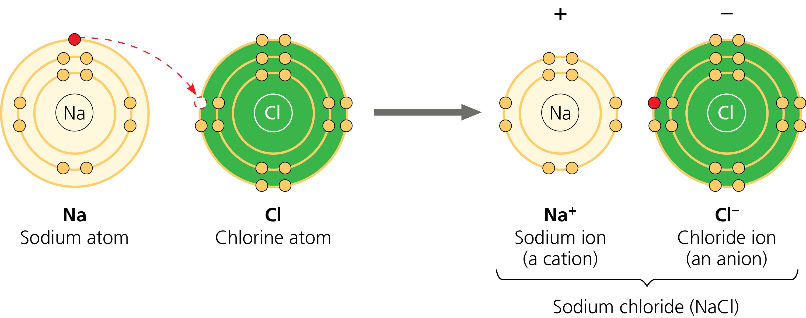
Ionic bonding is the attraction existing between atoms or ions with opposite charges The above figure is a representation of the electron transfer and the ionic bonding process. The one atom of sodium is moved to be able to join other seven valence electrons of chlorine atom as indicated. Every resulting ion has completed valence shell with eight electrons.
27. Define anion and cation. In the preceding example, which is the anion?
An anion is an ion, which is negatively charged while a cation is appositely charged ion. In the above diagram, chloride ions are anion.
28. What is a hydrogen bond? Indicate where the hydrogen bond occurs in the following
figure.
A hydrogen bond is the noncovalent attraction existing between a hydrogen and an
Electronegative Atom. In the figure 2.12, the hydrogen bond occurs between H2O and NH3.
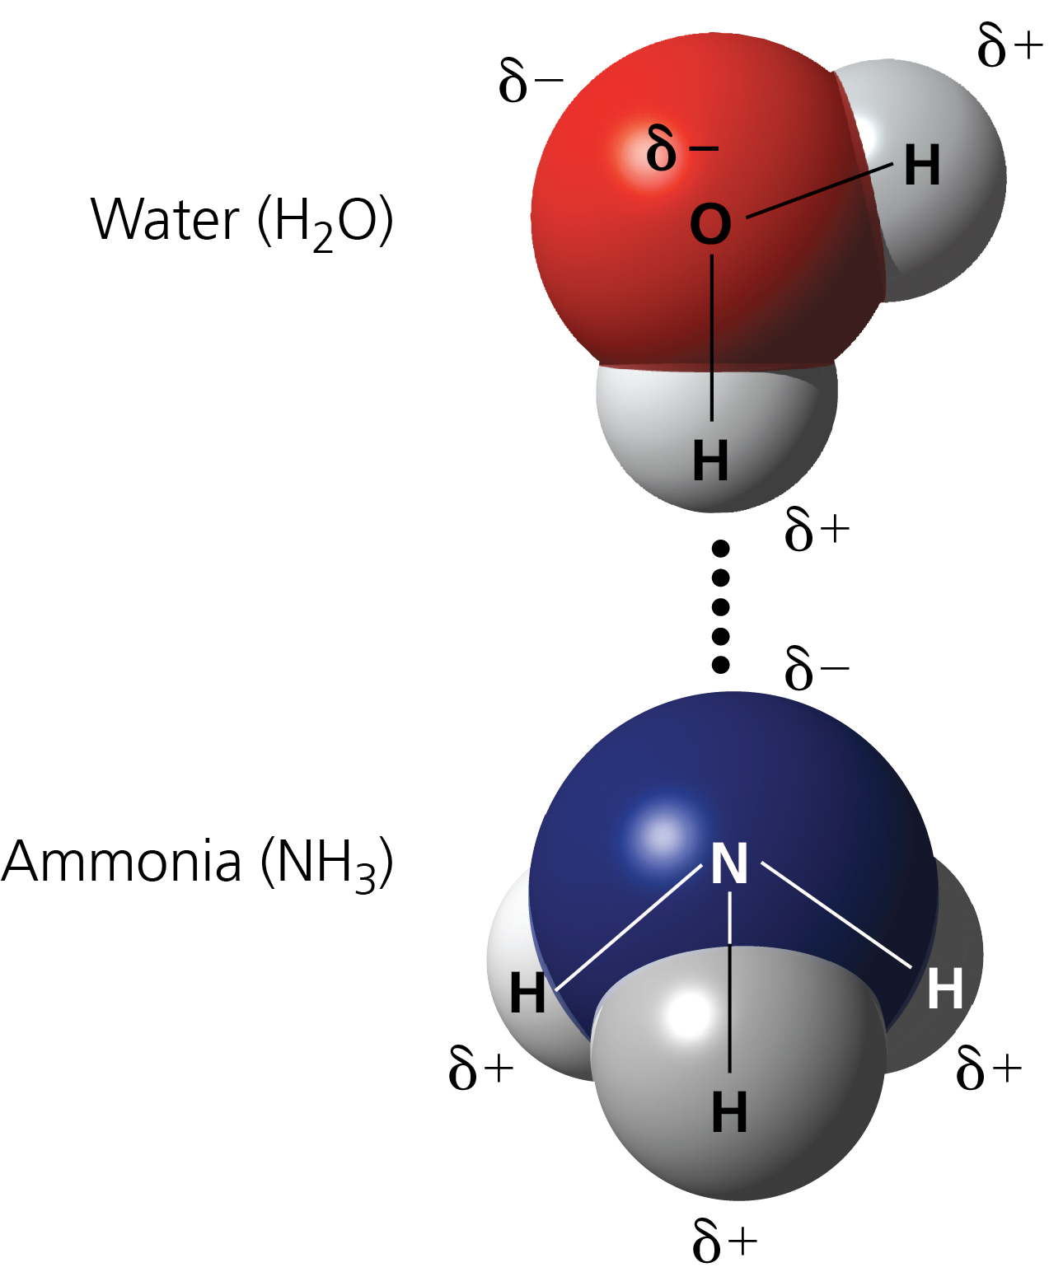
29. Explain van der Waals interactions. Although they represent very weak attractions, when these interactions are numerous they can stick a gecko to the ceiling!
The van der Waals Interactions are weak individually and occurs when molecules and atoms tend to be very close to each other and the interaction can be more powerful when numerous interactions happen simultaneously. Molecules having nonpolar covalent bond may have both negatively and positively charged atoms. In such a molecule, electrons are not symmetrically distributed always. By chance, they may accumulate in one region of the molecule resulting to two different regions having negative and positive charges. The changing regions having opposite charges enable molecules and atoms stick to each other.
30. Here is a list of the types of bonds and interactions discussed in this section. Place them in order from the strongest to the weakest: hydrogen bonds, van der Waals interactions, covalent bonds, ionic bonds.
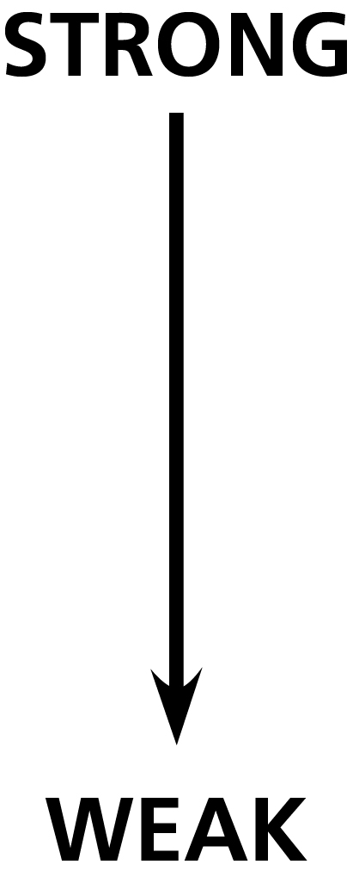 Covalent Bonds, Ionic Bonds, Hydrogen Bonds and Van der Waals interactions
Io

31. Use morphine and endorphins as examples to explain why molecular shape is crucial in biology.
The shape of any molecule remains to be of great importance to its function in the living cell as well as crucial in biology since it helps determine how biological molecules respond and recognize each other with specificity. Morphine together with other opiates possess same shape to endorphins, and thus mimic the pain-relieving effect of endorphin receptors within the brain.
Concept 2.4 Chemical reactions make and break chemical bonds
LO 2.4: Given an example of a chemical reaction, describe its meaning in words.
32. Write the chemical shorthand equation for photosynthesis. Label the reactants and the products.
6CO2+6H2O→C6H12O6+6O2
Reactants Products

33. For the equation you just wrote, how many molecules of carbon dioxide are there? 6
How many molecules of glucose? 1 How many elements in glucose? 3
34. What is meant by dynamic equilibrium? Does this imply equal concentrations of each reactant and product?
Reactions are still continuous but having no effect on the concentration of products and reactions.is the meaning of dynamic equilibrium. Does not mean that, the products and reactants have same or equal concentration, instead they have stabilized concentration at a certain ratio.
Test Your Understanding, p. 42
Now you should be ready to test your knowledge. Place your answers here:
1. 2. 3. 4. 5. 6. 7.
8.
Answer to Question 10: If ½ the of the original C-14 remains after one half-life, ½ of this, or ¼ would remain after 2 half-lives. The half-life for carbon-14 is 5730 years, so 11,460 years have elapsed.

