Chapter 3: Water and Life
3.1 Explain how hydrogen bonding results from polar covalent bonds.
3.2 Identify four properties of water that are important for life and describe how they result from hydrogen bonding.
3.3 Differentiate between an acid and a base; define pH and describe how it affects the processes of life.

Living systems depend on properties of water that result from its polarity and hydrogen bonding. As you work through this chapter, you will come to understand how these properties impact life processes. Be sure you understand the concept of determining pH as well as its biological significance.
Study Tip: Figure 3.1 in your text gets at the core of why water is such a remarkable compound. Read and study the entire figure, and then use the information to help you answer the questions that follow.
Concept 3.1 Polar covalent bonds in water molecules result in hydrogen bonding
LO 3.1: Explain how hydrogen bonding results from polar covalent bonds.
1. Study the water molecules at the right. On the central molecule, label oxygen (O) and hydrogen (H). Now, add + and − signs to indicate the charged regions of each molecule. Then, indicate the hydrogen bonds.
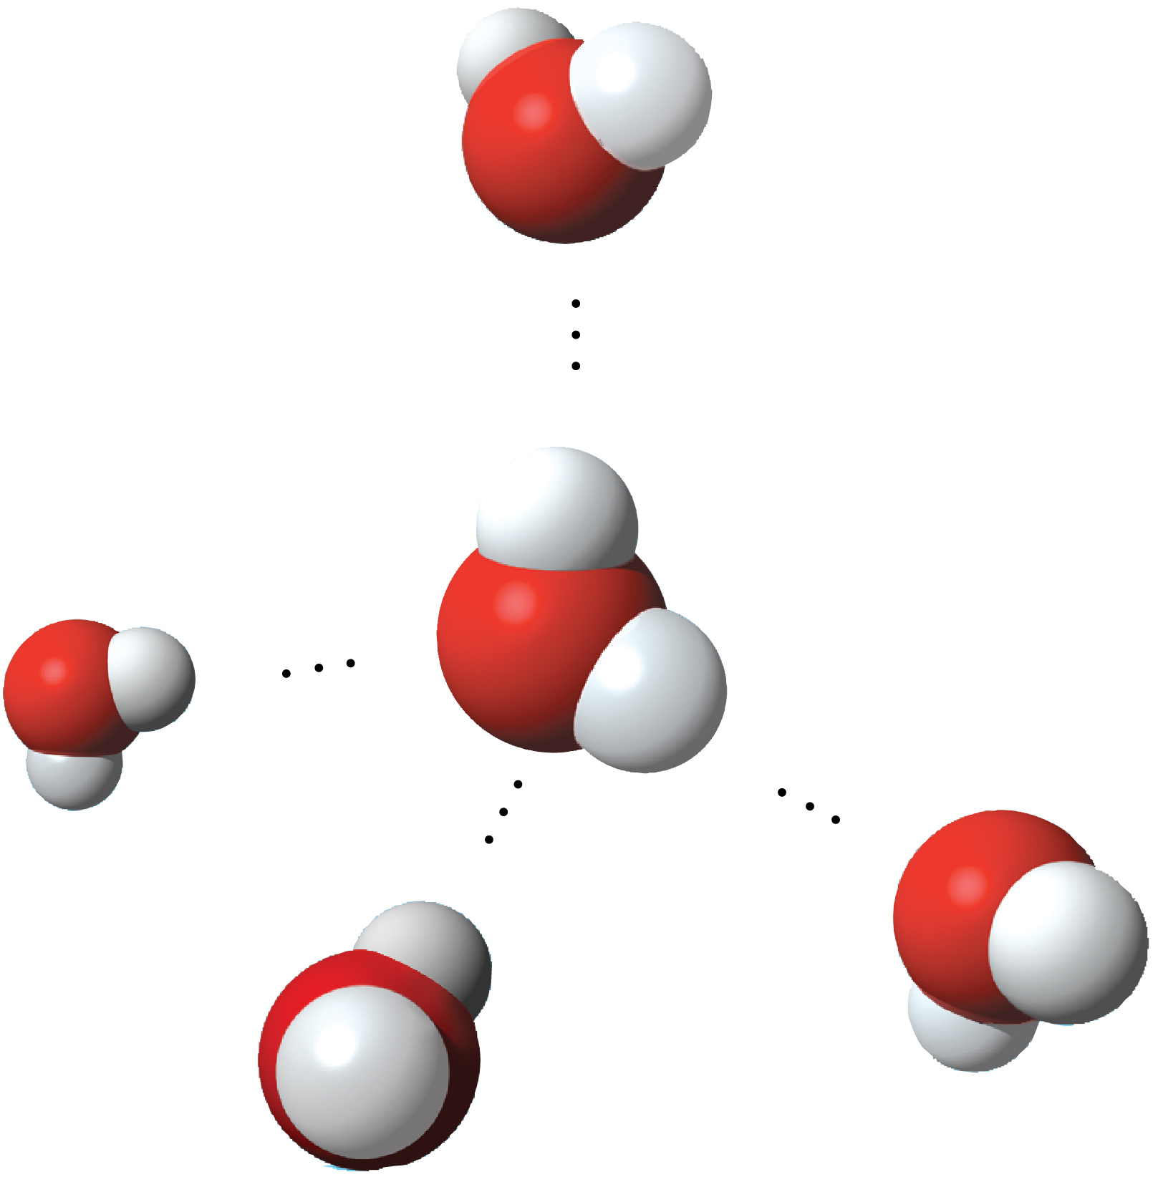

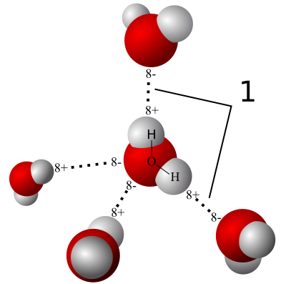The oxygen is in the center (red), with hydrogen on either side (white).

2. Water is considered a polar molecule. What does this mean?
Water is considered a polar molecule to mean, one side of the water molecule is a different charge compared to the other side of the same water molecule.

3. Explain hydrogen bonding. How many hydrogen bonds can a single water molecule form?
Hydrogen bonding tend to occur when the slightly positive hydrogen of one mole is attracted to a slightly negative oxygen of any molecule nearby, thus holding both together. Hydrogen bonds tend to be weak/fragile and thus within any moment a percentage of water molecules are hydrogen-bonded to those nearby. A single water molecule is able to form four hydrogen bonds.
Concept 3.2 Four emergent properties of water contribute to Earth’s suitability for life
LO 3.2: Identify four properties of water that are important for life and describe how they result from hydrogen bonding.
Hydrogen bonding accounts for the unique properties of water. Let’s look at several of these properties.
4. Distinguish between cohesion and adhesion.
Cohesion is defined as a phenomenon of the hydrogen bonds to hold water together.
Adhesion on the other hand is a property of which one substance cling to another.
5. Which property explains the ability of a water strider to walk on water?
The ability of a water strider to walk on water is explained by Surface tension property.
6. Which property is demonstrated when paper towels absorb a water spill?
The adhesion property is demonstrated when paper towel absorbs a water spill
7. The calorie is a unit of heat. Define calorie.
This is the amount of heat energy required to raise the temperatures of 1 gram of water by 1 degrees Celsius
8. Water has high specific heat. What does this mean? How does water’s specific heat compare to alcohol’s specific heat?
The amount of heat that has to be lost or absorbed in order for the 1gram of the substance to change its temperature by 1°C is known as Specific heat. The specific heat of water is not usually high at 1cal/g∙ °c, and alcohol on the other its specific heat stand at 0.6cal/g∙ °c.
9. Explain how hydrogen bonding contributes to water’s high specific heat.
Heat is absorbed then released when there is formation of the hydrogen; this means that, a calorie of heat cause a much small change in water temperature since much of the heat is utilized in disrupting hydrogen bonds prior to water molecules beginning to move faster. However, when there is a slight drop in the temperature of water, more additional hydrogen bonds tend to form, thus releasing energy in the form of heat.
10. Summarize how water’s high specific heat contributes to the moderation of temperature. How is this property important to life?
Having a relatively high specific heat, a large water body is in a position to absorb and store a huge amount of heat originating from the sun during the day as well as summer while warming up just a few degrees. The water usually cools at night and winter season, thus warming the air, leading to the milder climates within the coastal regions.
11. Define evaporation. What is heat of vaporization? Explain at least three effects of this property on living organisms.
Evaporation is the process by which liquid change to gas. Heat of vaporization on the other hand is the quantity of heat that can be absorbed by a liquid in order to convert 1gram of liquid to gaseous form. The three effected of this property include Moderate climate of the earth, Sweat in humans and severity of steam burns on the human skin.
12. Ice floats! So what? Consider what would happen if ponds and other bodies of water
accumulated ice at the bottom. Describe why this property of water is important.
If ice sank, this would mean that, oceans, lakes and ponds would freeze and just a few inches at the top would thaw during the summer. Since ice floats, the upper frozen layer insulates the liquid water under it, keeping it relatively warm thus continuation of life that exist below the water surface. In addition, the layer of water already frozen provides a habitat for some animals like seals and polar bears.
13. Now, explain why ice floats. Why is 4°C the critical temperature?
Due to hydrogen bonding, water always expands while solidifying. At a water temperature of 4°C, it starts to acts like other liquids that tend to expand as it warms and contracts as it cools. At temperatures under 4°C water starts freezing as accumulatively more hydrogen molecules move more slowly to break the hydrogen bonds. The hydrogen bonds do keep the molecules far apart from each other thus resulting to an ice which is about 10% less dense compared to water at a temperature of 4°C; Ice floats due to its lower density.
14. Review and define these terms:
Solvent: Dissolving agent of the solution
Solution: Homogeneous mixture of two or more substances.
Solute: Substance dissolved.
Aqueous solution: A solution whose solvent is water.
15. Consider coffee to which you have added sugar. Which of these is the solvent? Which is the solute?
Coffee is the solvent and the solute is the sugar.
16. Explain why water is such a fine solvent.
Water is such affine solvent due to the polarity of its molecules.
17. Distinguish between hydrophobic and hydrophilic substances. Give an example of each.
Hydrophilic substances are those substances, which has an affinity for water. An example of such substance is cotton.
Hydrophobic substances on the other hand are substances that are nonionic and repeal water. An example to such substances is vegetable oil.
18. You already know that some materials, such as olive oil, will not dissolve in water. In fact, oil will float on top of water. Explain this property in terms of hydrogen bonding.
The oil molecules cannot form hydrogen bonds with water since it is a hydrophobic substance. There exists prevalence of relatively nonpolar covalent bonds- in this case, bonds between hydrogen and carbon sharing electrons almost equally.
19. Now, let’s do a little work that will enable you to prepare solutions. Read the section on solute concentrations carefully and show your calculations here for preparing a 1-molar (1-M) solution of sucrose. Steps to help you do this follow. The first step is done for you. Fill in the steps below.
Steps to Prepare a Solution
a. Write the molecular formula.
(C₁₂H₂₂O₁₁)
b. Use the periodic table (Appendix B in the textbook) to calculate the atomic mass of each element. Multiply by the number of atoms of the element. (For example, oxygen has a mass of 16. Therefore, oxygen has a total mass of 16 × 11 = 176 grams.)
C12=12∙12=144g/mol
H22=22∙1=22g/mol
O11=11∙16=176g/mol
c. Add the masses of each element in the molecule.
144+22+176=342g.
d. Add water to the total molar mass you determined and bring the solution to a volume of
1 L. This makes a liter of a 1-M solution.
342g/mol to make 1 liter of a M

20. Can you prepare 1 L of a 0.5-M solution of glucose? Show your work here. You can check the answer at the end of this chapter.
C6H12O6
C6=6 ∙ 12=72
H12= 12 ∙ 1=12 72+12+96=180=1mole
O6=6 ∙ 16=96 0.5=90g.
Add this mass of the compound to water, bring it to the volume of 1litre. This makes 1litre of 0.5M solution.
21. Define molarity.
Molarity is the number of moles of solute per liter of solution. It is the unit of concentration most utilized by biologists most often for aqueous solution.
Concept 3.3 Acidic and basic conditions affect living organisms
LO 3.3: Differentiate between an acid and a base; define pH and describe how it affects the processes of life.
22. What two ions form when water dissociates?
The two ions that form when water dissociates are hydroxide ions OH- and hydronium ions H3O+.
(You should have answered “hydronium (H₃O⁺) and hydroxide ions (OH⁻)” in the preceding question. However, by convention, we will represent the hydronium ion as H⁺.)
23. Draw and label the chemical reaction that occurs when water dissociates.
24. What is the concentration of H⁺ and OH⁻ in pure water at 25°C?
The concentration of each ion in pure water at 25°C is 10-7
25. Water has a pH of 7. pH is defined as the negative log of the hydrogen ion concentration [H⁺]. Explain why water is assigned a pH of 7.
The concentration of H+ is 10-7
Considering; Log1010-7 =-7log1010=-7.
PH of water is 7.
26. To go a step further, the product of H⁺ and OH⁻ concentrations is constant at 10⁻¹⁴.
[H⁺][OH⁻] = 10⁻¹⁴
Water, which is neutral with a pH of 7, has an equal number of H⁺ and OH⁻ ions. Now,
define
Acid: This is a substance, which increases the hydrogen ion concentration of a solution.
Base: It Is a substance which reduces the hydrogen ion concentration of a solution.
27. Because the pH scale is logarithmic, each numerical change represents a 10× change in ion concentration.
a. How many times more acidic is a pH of 3 compared to a pH of 5?
10²=100
b. How many times more basic is a pH of 12 compared to a pH of 8?
10⁴=10000
c. Explain the difference between a pH of 8 and a pH of 12 in terms of H⁺ concentration.
The H+ concentration of a pH 12 is 104 times greater than that of a pH of 8.
28. On the pH scale, label pH 1–14. Label neutral, acid, and base. Indicate the locations of pure water, urine, gastric juice, and bleach.
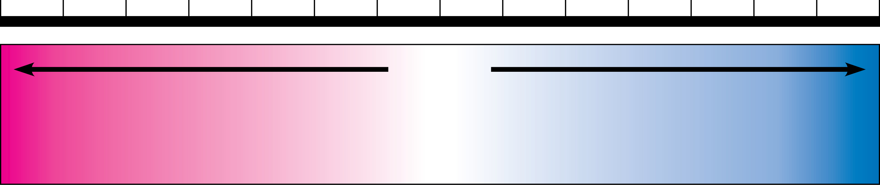
29. Even a slight change in pH can be harmful! How do buffers moderate pH change?
A buffer is that substance which tend to minimize changes in the concentration of H+ ions and OH in a solution. This substance does so by accepting hydronium ions from the solution when they are in excess and donating hydronium ions to the solution when they have depleted. Most buffer solutions contain a weak acid and its corresponding base, which combine reversibly with hydronium ions.
30. Exercise will result in the production of CO₂, which will acidify the blood. Explain the buffering system that minimizes blood pH changes.
When CO2 reacts with H2O in the blood plasma, there is formation of Carbonic acid (H2CO3) which dissociates to yield a bicarbonate ion HCO3 - and hydrogen ion H+ . The chemical equilibrium between bicarbonate and carbonic acid acts as a pH regulator, the reaction shifting from left or right as other processes in the solution add or remove hydrogen ions.
31. Using Figure 3.12 in the text as a starting point, discuss how CO₂ emissions affect marine life and ecosystems.

Test Your Understanding, p. 55
Now you should be ready to test your knowledge. Place your answers here:
1. 2. 3. 4. 5.
Answer to Question 20: The formula for glucose is C₆H₁₂O₆ which gives a molar mass of 180 g. A 0.5M solution would require 90 g of glucose, adding water to bring the total volume to 1 L.

