Introduction:
KOH + FFA H2O + [K+][-FFA](soap)
This reaction above shows the titration process, and how the base (KOH) reacts with free fatty acid in order to produce water and soap. Phenolphthalein is used in titration process as an inductor of the reaction.
Vegetable oil + Methanol Biodiesel + Glycerol (KOH as a catalyst)
This chemical reaction appears when vegetable oil reacts with methanol in order to produce biodiesel and glycerol, that reaction happen with the presence of KOH as a catalyst. Also, that reaction occurs at 60 degrees Celsius.
This experiment intended to change vegetable oil into biodiesel. Be that as it may, utilizing clean vegetable oil costs as much as customary diesel. Consequently, this test intended to utilize squander vegetable oil, since it's more moderate, and endeavor to take shape it to get a biodiesel that can be utilized.
The experiment took 4 days. The first day was to contrast waste vegetable oil to clean vegetable oil, so each group attempted different method, and it was determined that the best outcomes were gotten by including baser. Second, In the following lab time frame on determining the amount of needed base. In the third day, the combination was finished. Oil was added to methanol and the base, and it we left that in the lab for a week so the biodiesel can be. Finally, the biodiesel was purified, and 3 tests were run to a crude sample and purified biodiesel.
Procedure:
Having a couple standers is basic to create anything. therefore, the group had a standard convention to follow in order to create biodiesel. However, running many reactions might take long time. Thus, the class was divided into many groups, each group ran a response with the goal that as well as can be expected be reach effortlessly. The chosen reaction was adding 5 minutes. After running the reaction, it was determined that adding more time was not the most effective way to get the needed result. Whatever is left of the outcome demonstrated that the most ideal outcome can be accomplished by including a greater amount of the base which was KOH..
At the point titrating stage. The goal of this stage is deciding the needed KOH. In this stage, a pellet of KOH was added to 100 mL of water in a volumetric flask for two time the first time 50 ml, so that it can dissolve. Once it dissolved the volumetric flask was filled with another 50 ml of water. Then burette was washed twice with titrating solution, then it was filled with titrating solution. After that the oil was setup by dissolving 1 mL of oil in 10 mL of isopropanol. Add a couple drops of phenolphthalein. Then the volume of the arrangement was recorded. After that the titration solution was added slowly to the mixture until the mixture turned red, and stayed for 30 seconds. Then the final volume was recorded. This stage was done 4 times to get the best results.
After that the synthesis stage. The point of this stage was to separate glycerol and biodiesel. The first step was to heat 100 mL of waste oil until it reaches 60C, then adding 9.324 mL of methanol, and (4.9 plus titrating) KOH g per letter of oil to the oil. Then the mixture was left for an hour to heat and spin in the same time using the hot plate. After that period was done, the mixture was left for a week to allow glycerol and bio diesel to separate.
The last stage was the filtration and testing stage. At the following lab time frame which was two weeks from synthesis stage, the mixture was ready to purification. In the beginning biodiesel was separated from glycerol by pouring it into another jar. Then 10 mL was taking to do the tests to the crude biodiesel, so that the result of the test to the crude and the clean biodiesel can be comparable. The rest of the biodiesel was put into separatory funnel to wash it five times. At that time my group was divided, one did the testing to the crude biodiesel and the others did the washes. Firstly, three tests were done to the crude biodiesel which were 3-27 test, emulsion test, and the point cloud test. 3-27 tests were done by adding 9mL of methanol for 1mL of biodiesel. Emulsion test was adding several milliliters of crude biodiesel with the same amount of water. Point cloud test was done by putting 5 mL of biodiesel in ice bucket until the oil started to be cloudy. On the other hand, the washes were done 5 times, the first one was By water and there was strange thing it was a big bubble between the water and the biodiesel. The second was by adding water as well. however, this time it was clearer than before. The third time was the first time to add aced, and the results were better than before. The fourth time was with water as well and the biodiesel looked almost clear. In the last wash, the biodiesel contained some remaining soap, so it was washed with acetic acid, but nothing changed so Sodium Chloride was added, and it helped purified the biodiesel.
Data and Results:
Day1
The goal of this day was to figure out which conditions would create the most biodiesel. Thus, the class was divided into many groups each tested clean and waste vegetable oil to determine the best result. The results showed that the most possible biodiesel from clean vegetable oil can be produce by doubling NeOH, decreasing the temperature, or adding more time. On the other hand, the most biodiesel was produce by increasing the value of KOH. Also we used 0.124 g of KOH * by 1 L of oil divide that by 4.9 g and we got 0.025L to convert that with ml it come out to 25.306ml. so the result for day one is we got 95% of clean veg oil and it was Very clear, slightly yellow. And for the waste veg oil we got 15% and it was Clear, but darker yellow
picture 1: The results of adding time.
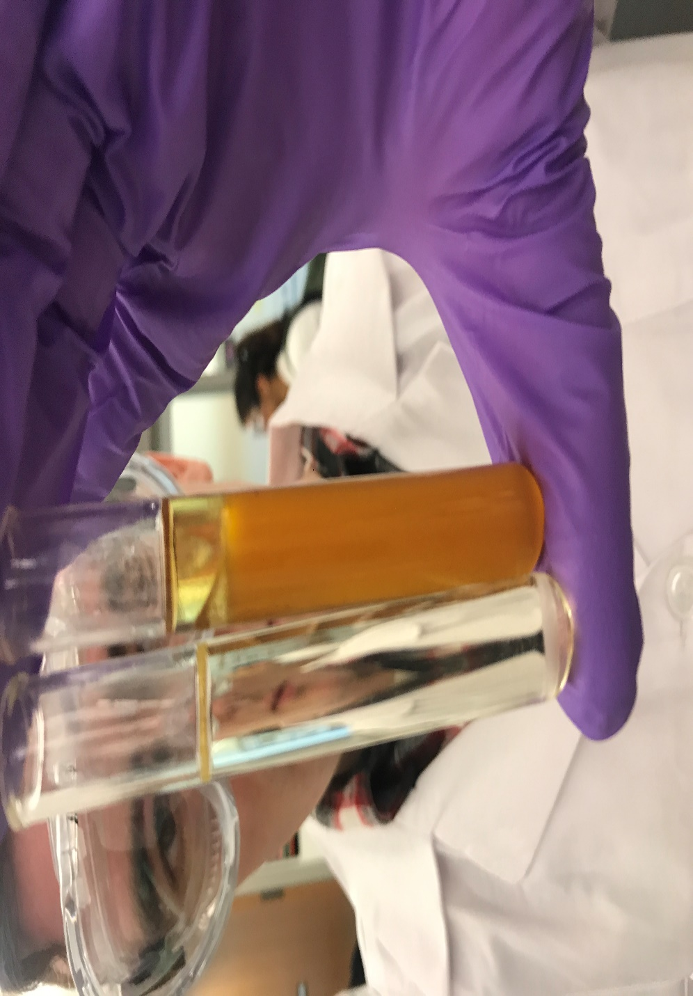

Day two:
The aim in this day was determining how much KOH needed to a free fatty acid solution. The burette was washed with 5.2mL of titrating solution, then the titrating solution was added 100 ml volumetric flask. The group did five attempts, and the results were 11.2mL, 8.6ml, 8ml, 7.5ml and 7.8ml respectively. Because of the gap between the first attempt and the rest, the average was taken considering the last 5 attempts. After that the average, which was 8.62ml. After we used 100 of oil and we used this question:

$\frac{grams of KOH}{100m titrating sol}*\frac{mL titration solution used}{1mL of oil}*\frac{1000mL of oil}{\begin{aligned}\left(L of oil\right) \\ \end{aligned}}=\frac{grams of KOH}{L of oil}$
So we had
$$\frac{0.12 g of KOH}{100m titrating sol}*\frac{7.77 mL }{1mL of oil}*\frac{1000mL of oil}{\begin{aligned}\left(1 L of oil\right) \\ \end{aligned}}=\frac{9.324 KOH}{L of oil}$$

Day 3:
The founded data in the previous lab period was used during this day. The used volumes in this lab were 100mL of oil, 22ml of methanol, which was 22% of the oil, and 1.4261g of KOH, After the mixture was left for an hour to heat, and spin it looked as a two-layered solution, the top layer was biodiesel, and the bottom layer was glycerol.
Day 4:
During this day three tests were run, three for crude biodiesel and three for clean biodiesel. The tests were 3-27, emulsion test, and cloud point. The results of the crude’s tests were: for 3-27 (5 %) of which is veg. oil Emulsion – presence of soup at bottom of test tube test, and for the cloud point test the biodiesel because cloudy at 7.5C. and for the clean test, 3-27 visible but small increase in oil, maybe 8-9%. Emulsion – very clear and visible separation. Cloud point – 2 c
Picture 2: Emulsion test crude biodiesel.
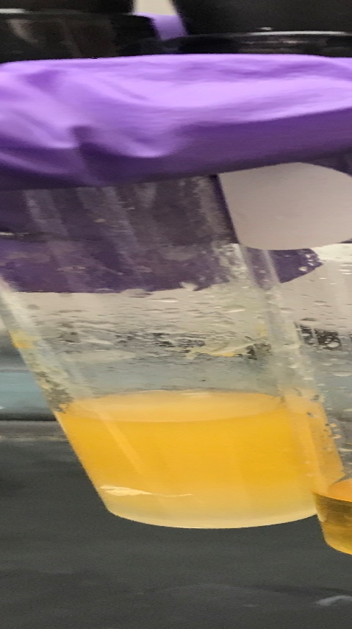

Picture 3: cloud point test crude biodiesel.
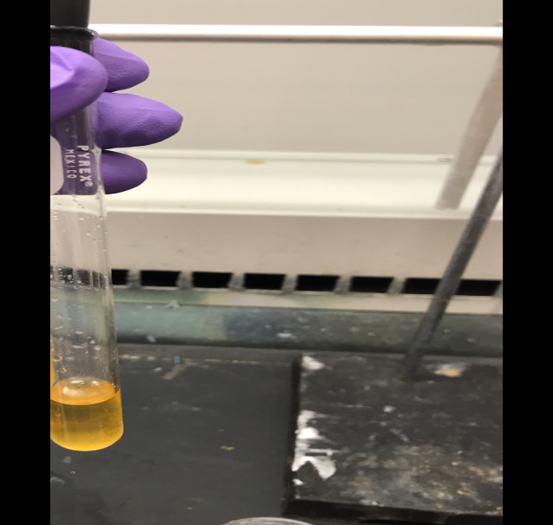
Picture 4 : cloud point test clean biodiesel.

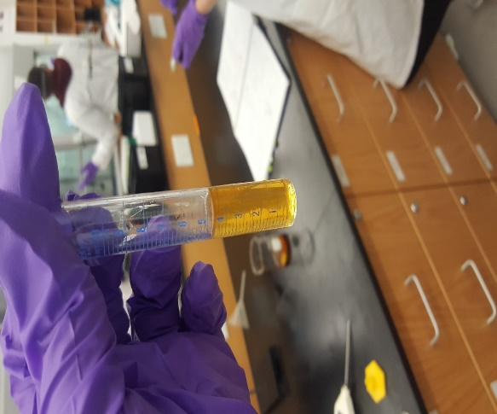

Discussion:
The team successfully made biodiesel out of waste vegetable oil., the final result came as expected. On day one the conditions that the team used did reach the expected goal; however, with the results of the rest of our group wanted we got 95% of biodiesel of clean veg and we got 15% of biodiesel of wasted oil. On the second day, the group did five test, and we wanted to calculate KOH. Then we average. And the percentage of the FFA was 15.108. The third day everything went as arranged aside from that the group turn of the hot plate when the blend was on the hot plate, and it was just turning. however, when the mixture was left for two weeks rather than one the mixture was looking as needed. On the last day when the group did the first was, the solution was good, so the team used acetic acid instead of water for the third washes. In general, the team successfully achieved the goal.
On the second day after the team calculated the excess KOH, the percentage of the free fatty acids (FFA) was calculated, and it came out to be 15.108%. This result was shown when the team did the emulsion test on the fourth day. When the test was done on the crude biodiesel, the result was little soapy, which represent free fatty acid. However, After the five washes the biodiesel was very clear.
On the fourth day 3:27 test was done twice, once with crude biodiesel, and one with clean. The result of that showed that the crude biodiesel had 5% of which is veg oil. On the other hand, the result of the clean biodiesel showed that the solution contained 9-8% . Although the two solutions had the same starting amount of biodiesel.
The results of the could point tests showed that the biodiesel is ready to be used in cold weather. Both biodiesels clean and crude started to be foggy at very low temperatures, 2 C for clean biodiesel and 7.5 C for crude biodiesel. From that it could be determined that the biodiesel is ready to be used in cold weather.

Sources:
1-Chakrabarty, M. “Chemistry and Technology of Oils & Fats.” Google Books, books.google.com/books?id=6ZOsAwAAQBAJ&pg=PA66&lpg=PA66&dq=KOH%2B%2B%2BFFA%2BH2O%2B%2B%2B%5BK%2B%5D%5B-FFA%5D%28soap%29&source=bl&ots=yt6QAr-aDq&sig=sI571I5WTvTyT-2FFgyHmHRZSKo&hl=en&sa=X&ved=0ahUKEwjsqdHrgfTXAhXlYt8KHeK5DzgQ6AEINjAE#v=onepage&q=KOH%20%2B%20FFA%20H2O%20%2B%20%5BK%2B%5D%5B-FFA%5D(soap)&f=false.2-
2- http://www.make-biodiesel.org/Winter-Biodiesel/biodiesel-in-winter.html.
Tech, Rick. “The Biodiesel Economy and Biodiesel Policy.” Biodiesel, pp. 195–204., doi:10.1007/978-1-84628-995-8_10.
3- http://www.instructables.com/id/Titrating-Waste-Vegetable-Oil-for-Biodiesel-Produc/

