Assignment 9 - Biodiversity of Microscopic Organisms

- Explain why bacteria have a cell wall?
The cell wall of bacteria has multiple functions like maintaining bacterial cell integrity and the shape of the cell. Besides, the cell wall resists internal turgor pressure and thus keeping the bacteria withstand external pressures.

- Compare the bacterial cell wall and capsule. Explain how they are different.
The bacterial cell wall protects the organism against mechanical damage while the capsule is critical in protecting a bacterial cell from ingesting and destruction by white blood cells. The capsule makes the bacterial surface component more slippery and thus preventing phagocytosis as opposed to the bacterial cell wall. The capsule offers protection to the organisms against infections while the bacteria cell wall helps in spreading diseases. The make-up of both the bacterial call wall and the capsule contains basic protein compounds.

- Explain how bacterial move about their environment.
The movement of bacteria in the environment is aided by tail-like flagellum or a cluster of flagella which rotate progressively to propel the organisms forward. The flagella can rotate as first as 1,500 times every second and help the bacteria to move 10 times its length per second.

- Some species of bacteria form endospores. Explain the function of an endospore.
The endospores enable the bacteria to lie dormant for extended periods and thus survive unfavorable conditions.

- Compare & contrast binary fission with mitosis by completing the chart below.

Types of Cell Division
Mitosis | Binary Fission
- Type of cell division done by  Eukaryotes | - Type of cell division done by  Prokaryotic cells
- Produces identical daughter cells  - Cells must go through prophase, metaphase, anaphase ,  telophase and then  cytokinesis | - Produces two daughter cells  - Cells simply replicate their  DNA and form a new cell wall between each copy
- This process occurs about once ever 24 hours, on average, in humans | - This process occurs very quickly under ideal conditions

- Compare various bacterial shapes by drawing an illustration of each of the listed shapes below.

Bacterial Shapes
Coccus | Bacillus | Spirillum
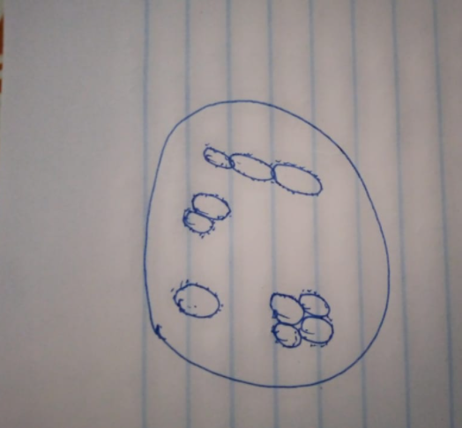 | 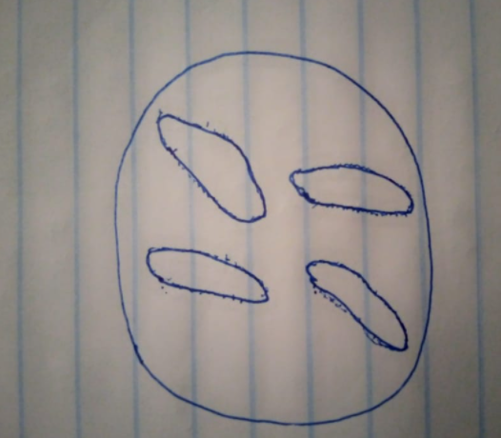 | 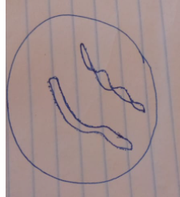

- Compare protists and bacteria by explaining how they are different.
Bacteria and protists are different in their cellular organization. The bacteria are single-celled organisms lacking specialized organelles, while the protists are mostly single-cell eukaryotic organisms that are neither plant nor fungi. In the converse, both bacteria and protists have cell membranes made of chemicals known as phospholipids that is a bilayer.

- Analyze virus structure by creating a diagram of a single viral particle. Label ALL of the following in your diagram: capsid, spike protein, nucleic acid genome, and capsid.
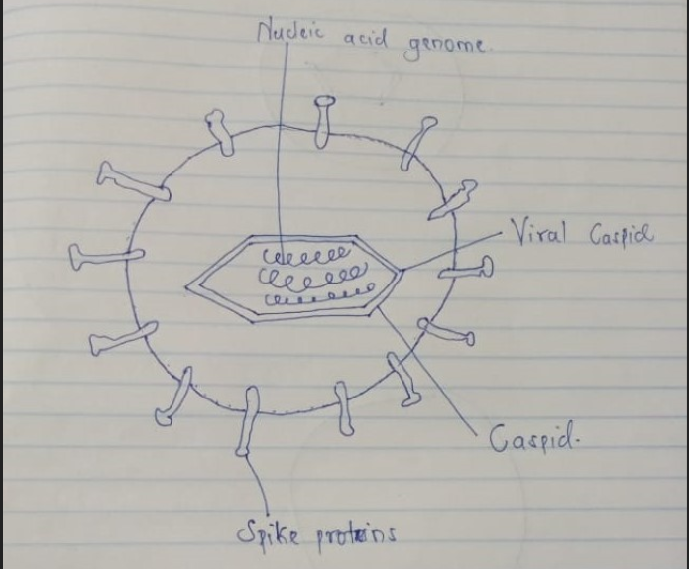

- A prion is not made of cells, nor is it a virus. Prions are simply an infectious
protein . For example, in humans, Creutzfeldt-Jakob disease is caused by a prion and may be transmitted by eating
infected brain or nervous tissues . This disease is incurable.
- Like prions, viroids are also not composed of cells. Viroids are made of small circular single -stranded RNA molecules . This virus typically infects
plants .

