Animals on Treadmills: A Walk Through the Scientific Method

Part I – Creative Research
In your group, discuss what makes a good hypothesis. Come up with an inclusive definition and write it down below. Then, discuss the two different types of hypotheses and come up with a definition for each as well.
- Hypothesis: (1 point)

- Two Types: (2 points)

Now, discuss with your group about what kind of information can come from studying animals on treadmills. Once you think you have some ideas, develop a basic research and an applied research question and accompanying hypotheses that this kind of data from SHRIMP or PUMAS (highlight your groups assigned topic) on treadmills could test. Indicate whether your questions address proximate or ultimate explanations (by circling one). (6 points)
Basic Research Question: Circle One: Proximate Ultimate

Basic Research Hypothesis:

Applied Research Question: Circle One: Proximate Ultimate

Applied Research Hypothesis:

Part II – Evaluating Media Response (Shrimp)
Group Members:
In your group, find an online media response to the video you have been assigned: <https://youtu.be/oX2Ief4kjrI>. The response could be a video or an article. Do not use an article written by the principal author of the research (Dr. David Scholnick). Then answer the following questions.

Which search terms did you use to find your media response to the video? What is the title of the response chosen? Who is the author of the response? (2 points)

Is the media response well stated, clear and unbiased? Why or why not? Does the media response do justice to the complexity of the matter at issue? Why or why not? (2 point)

Does the media response cite relevant evidence, experiences, and/or information essential to the issue? Explain. (2 point)

Does the media response develop a definite line of reasoning, explaining well how he or she arrives at his or her conclusions? What information does the media response assume or take for granted? (2 point)

Part II – Evaluating Media Response (Puma)
Group Members:
In your group, find an online media response to the video you have been assigned: <https://youtu.be/G3c1SpV6jvE>. Remember that pumas are also commonly called cougars or mountain lions, so you may want to use these terms in your search. The response could be a video or an article. Do not use an article written by the principal author of the research (Dr. Terrie Williams). Then answer the following questions.
Which search terms did you use to find your media response to the video? What is the title of the response chosen? Who is the author of the response? (2 points)

Is the media response well stated, clear and unbiased? Why or why not? Does the media response do justice to the complexity of the matter at issue? Why or why not? (2 point)

Does the media response cite relevant evidence, experiences, and/or information essential to the issue? Explain. (2 point)

Does the media response develop a definite line of reasoning, explaining well how he or she arrives at his or her conclusions? What information does the media response assume or take for granted? (2 point)

Part III – Analyzing the Data (Shrimp)
After evaluating various methods to collect respiration data (e.g., runnning shrimp on a treadmill), Dr. Scholnick and his co-authors decided to instead publish a paper based on respiration data collected from resting shrimp in respiration chambers. In their experiment, they injected shrimp (Litopenaeus vannamei) with one of two solutions: a saline solution or a bacteria (Vibrio campbellii) solution. Afterwards, they measured shrimp respiration. Below are the data collected and published.
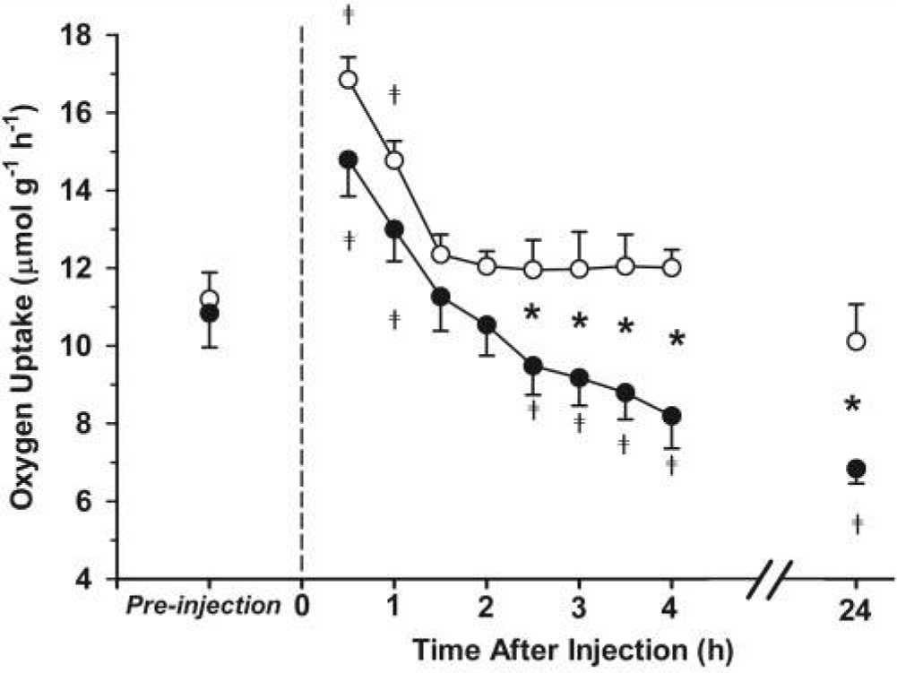
Figure 1. The rate of oxygen uptake (mmol g−1 h−1) of Litopenaeus vannamei following injection with Vibrio campbellii (closed circles) compared to saline injection (open circles). Oxygen uptake was measured in a flow-through respirometry chamber thermostat to 25 °C. Pre-injection values represent average oxygen uptake for 30 min prior to injection. The dashed line represents the injection time. Values post-injection represent averages over 30-min intervals for 6 to 9 shrimp ± standard error. Significant differences between saline (control) and Vibrio injection occurred after 2.5 h (*; P < 0.05 repeated-measures ANOVA). Differences in oxygen uptake from pre-injection values at different times are indicated by crosses. Source: Scholnick, D.A., et al. Impact of exposure to bacteria on metabolism in the penaeid shrimp Litopenaeus vannamei. Biological Bulletin 211: 44–49. © 2006 Marine Biological Laboratory. Used with permission of the publisher, University of Chicago Press.
Answer the following questions about Figure 1. For questions 1 and 2, indicate whether the variable in question is independent or dependent, and whether it is continuous or categorical.
- (1 point) What variable is on the x-axis? ______________________________________________
Highlight one for each: Independent or Dependent Continuous or Categorical/Discrete

- (1 point) What variable is on the y-axis? ______________________________________________
Highlight one for each: Independent or Dependent Continuous or Categorical/Discrete

- (1 point) What do the open and filled dots represent?
Open:
Filled:
- (2 point) Why is it important that the pre-injection oxygen uptake values are not significantly different than each other?

- (2 point) What happens to oxygen uptake after the shrimp are injected with their assigned solutions?

Part III– Analyzing the Data (Puma)
After placing the pumas on a treadmill, Dr. Williams and her co-authors published a paper based on the data collected. In their own words, the authors: “…monitored behavior-specific energetics of a large cryptic felid, the puma, to evaluate the cost of discrete physiological states involved with ambush hunting. Using a laboratory-to-field approach, we developed and calibrated a new SMART (species movement, acceleration, and radio tracking) wildlife collar on captive, adult pumas (n = 3), with subsequent deployment on wild pumas (n = 4 pumas with SMART collars, 1 puma with GPS only). We created a library of behavior-specific collar acceleration signatures by filming instrumented, trained pumas as they traversed a 20-m level course at different speeds, performed routine activities (resting, eating, grooming, etc.), and ran on a motorized treadmill.”
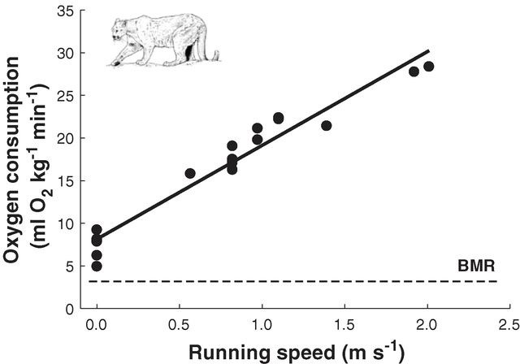
Figure 1: Oxygen consumption in relation to speed for pumas on a treadmill. Points represent individual steady-state measurements. The least-squares regression (solid line) is compared to basal metabolic rate [BMR (basal metabolic rate), dashed line]. Source: Williams, T. M., L. Wolfe, T. Davis, T. Kendall, B. Richter, Y. Wang, C. Bryce, G. H. Elkaim, and C. C. Wilmers. 2014. Instantaneous energetics of puma kills reveal advantage of felid sneak attacks. Science. 346:81-85. Reprinted with permission from AAAS.

Answer the following questions about Figure 1. For questions 1 and 2, indicate whether the variable in question is independent or dependent, and whether it is continuous or categorical.

- (1 point) What variable is on the x-axis? ______________________________________________
Highlight one for each: Independent or Dependent Continuous or Categorical/Discrete

- (1 point) What variable is on the y-axis? ______________________________________________
Highlight one for each: Independent or Dependent Continuous or Categorical/Discrete

- (2 point) What happens when pumas run at a greater speed?

Part IV – Synthesizing the Information (Shrimp)
Dr. Scholnick responded to media attention to his research by writing an article in the Chronicle of Higher Education. Read the response using the link below and respond to the following questions in no more than three sentences.
<https://web.archive.org/web/20191003060315/https://www.chronicle.com/blogs/conversation/2014/11/13/how-a-47-shrimp-treadmill-became-a-3-million-political-plaything/>

Did the media get the science right? Justify your answer. (2 point)

Why are the findings of the study important? (2 point)

Would you defend this research against the media response? Why or why not? (1 point)

After reading both the media response and author’s response, do you believe there is a media bias against basic research? Why or why not? (2 point)

Part IV – Synthesizing the Information (Puma)
Dr. Williams responded to media attention to her research by writing an article for the LA Times. Read the response using the link below and respond to the following questions in no more than three sentences.
http://www.latimes.com/opinion/op-ed/la-oe-williams-wildlife-coburn-wastebook-20141107-story.html

Did the media get the science right? Justify your answer. (2 point)

Why are the findings of the study important? (2 point)

Would you defend this research against the media response? Why or why not? (1 point)

After reading both the media response and author’s response, do you believe there is a media bias against basic research? Why or why not? (2 point)

