Social Responsibility of Educators as they Guide young Learners
Student’s Name
Institution
Course
Professor’s Name
Date

Social Responsibility of Educators as they Guide young Learners
Human existence depends largely upon the ability of people to coexist and learn to socially relate with others (Sihem, 2013). These are skills that are learned at a young age and one gets to practice them as they grow up. Educators have a responsibility to teach more than technical skills on specific subjects. They have to teach learners social responsibility. Students can learn how to interpret their emotions and those of others they relate with. Educators can impart these skills by:
First, letting students participate in the problem they are studying. This strategy, according to Shapiro (2011), allows learners to learn the things they cannot learn in the classroom (theory).
Secondly, open a dialogue with the learners by speaking frankly about the experiences and feelings about a certain phenomenon in the public. Educators can integrate their personal experiences as part of learning by frankly letting students understand how they felt about the event or issue. This may include an incident where the educator participated in community development.
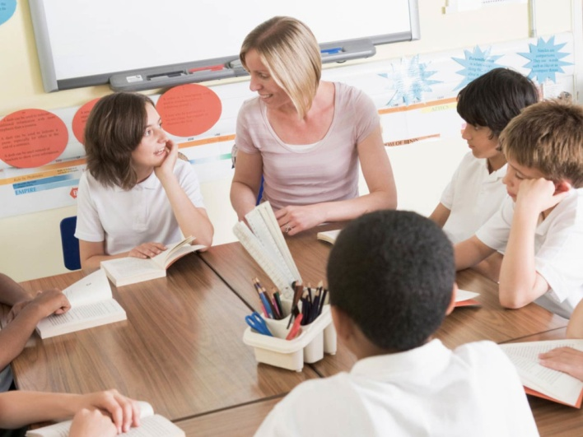
Participating in a dialogue with learners (Source: Google.com)

Lastly, planning a project where the learners can get the opportunity to ask questions. Engaging learners in a project activity can help them learn how to offer their perspectives and also appreciate the diverse views of others.

References
Shapiro, A. (2011, July 23). “Teaching Social Responsibility.” Morning Center. https://www.morningsidecenter.org/teachable-moment/lessons/teaching-social-responsibility
Sihem, B. (2013). Social responsibility of educators. International Journal of Educational Research and Technology, 4(1), 46-51.

