Institutional Affiliation
Professor’s Name
Student’s Name
Date

SEPHORA COMPANY
Introduction
Branding is one of the crucial elements of an institution/firm business program. Branding includes logo, business name, and design of the package. In trade marketing, branding also has taken as an advertising symbol of the company. However, many of the trade owners are the business directors have the view that the nature of branding is concerned with the management of the image of the commodity, which another way that is different from the control of trade products. Branding can be valuable, destroyable, expensive, and containable. Therefore, it is simple to destroy your brand compared to raising one, Volkswagen is one of the examples of damaging their brand through dishonest. On this assignment, it will demonstrate the various weakness and strengths of branding in the stores of Sephora, which includes perceptions illustration on branding.
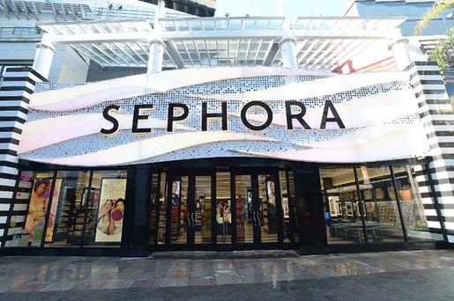

Branding is a strategy way applied by Sephora stores to show their commodities in the sector of the market. This Store also used branding as a center point of attracting customers’ value to their products, which is not a concern of demonstrating the images of their goods. On top of the other strengths, branding is the primary tool that forms and controls its competitive benefits in the arcade. Generally, labeling is like a commercial culture that goes around the majority of trade companies and organizations. For example, when I step into the Sephora supplies, their display is mostly similar, in which you are aware of the place to obtain the good that you need. Regardless of more fortes, there are other known weaknesses related to naming, especially to Sephora suppliers. To give a few, it is expensive and consumes most of the time.
In the occasion, it needs a considerable and extensive advertisement, attractive packages as well as operative sales and advancements, which is a jiff brink to the Sephora suppliers. This is due to developing brand loyalty and recognition to its clients very lavish, mainly with Sephora stores. For example, when I got into the Sephora supply, they have a lot of features that included a wide range of beauty goods exceeding three hundred different brands of products, which gave me a perfect experience shopping within due to its arranged and a variety of choice. These goods included the female make-up, first aid beauty, urban decay, and the benefits of cosmetics, among others. Besides, Sephora stores provide their manufactured make-ups like beauty items, skincare services, and accessories. All this naming and labeling needs incurrence of expenses and the cost to the Sephora suppliers. But this labeling strategy decreases the risks in the commodity decisions for clients, since there are plenty of counterfeit commodities in the market. Sephora's name does not cover clients from getting fake goods, which makes worth and population; this is the that I picked Sephora.
Strengths of Sephora Store Branding
The competitive advantage is one of the strengths of Sephora, which is a cosmetic and beauty stores that they get from branding. Sephora suppliers have a robust naming method for cosmetic and beauty goods. Which provides them with comprehensive competitive benefits to their complements. The advantages they get as the outcome of their labeling techniques do not only depend on clients but also gives a means for negotiation with their respective groups. It has an influential naming habit that provides them with essential control informing laws, hence, providing them with powers to control and talk with their consumers. The diversity of brands related to Sephora suppliers across the globe is the idea behind its brilliant achievements in the sale of cosmetic and beauty goods.
In sales, it is thought that clients have low or lack interest in the tangible nature of the commodities or brilliant services. Still, there are many interested in other mechanisms like the appearance of the good they have to use, which is appropriately an outlook that is attractive and impressive to them when they use the brand commodity. Therefore, Sephora possessing a wide range of items brands; they have an outstanding opportunity to entice more clients who will have the chance to choose the brand they prefer in consuming. This gives an improvement to Sephora stores by receiving high revenue from the consumers they entice from a variety of brands that are not produced or sold by their competitors. To the case of Sephora supplies, the advantages in which the branding procedure form comes from the identified commodities from one of their opponents in a different way, which is crucial for their customers and suppliers. The branding assists in boosting the worthiness and perception of their cosmetic and beauty commodities. A competitive benefit originates where they have more significant opportunities to produce new goods to the market more efficient and accessible.
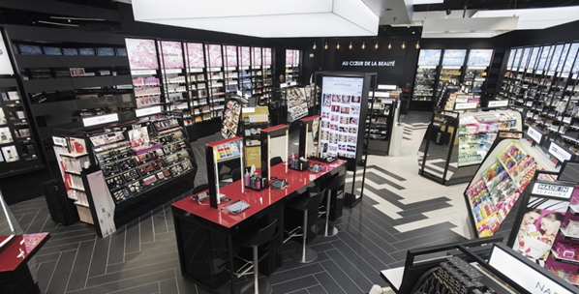
For example, the diagram above displays the personal appearance of the Sephora mall in the United States. It has a variability of brands, mostly the once of cosmetics and beauty and the beauty studio.
When I see the Sephora stores physically am in a position to feel the strength of branding. First, it is very systematized with black and white, which goes hand in hand with the name. White is linked to goodness, virginity, purity, light, and innocence. It is also believed to be the color of precision while black is connected to evil, mystery, power, and elegance. When assembling these colors, it brings a remarkable hallucination for clients to remember it. When I step into UTC mall, I didn't need to search for the name of Sephora stores; I just needed to look for the black and white color on the entrance, which is taken as brand vision. They also have perfect packaging, that is another important symbol of branding, they mainly apply black and white lane in their wrapping, but we can identify it to be Sephora. The moment I spotted people hiking in the mall with a white and black lane carrier, I noted that there was Sephora around in the mall. Thirdly, the stores it resembles other Sephora supply, which h I had visited before that give a great familiarity on finding commodities I needed. Sephora suppliers offer brilliant services to their clients that are far the usual facilities, including hi-touch motivations such as makeovers and demos, as well as incentivizing their buyers by overwhelming fidelity originality like Beauty Insiders Rewards, which is a strategy that provides their clients to get more scores and be rewarded freebies. This is a perfect combination of services and retailers in the Store. One of the ideal knowledge I got mainly promotions where I got more entries, and I was gifted freebies.
Sephora's Supplies gives standard sensory fleshly involvement with new music, samples, and qualified services supplies. It makes use of its availability to provide hands-on activities to their clients. Their variety of workshops all over the globe gives their customers tremendous and amazing resolutions from their qualified methods. They have touchscreens where their clients can test their partialities. In the mortar-and-brick locations such as the one found in UTC, that possess enough area where the customers can view the tutorial on greasepaint and chose commodities they prefer in buying.
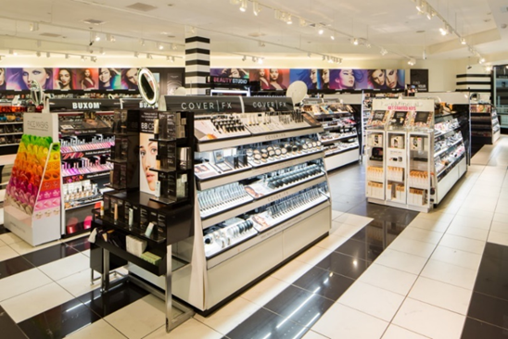
The image above indicates Sephora's supply which is situated at the Middle East that is an internationally good store which has fabulous cosmetic and beauty commodities like Clinique, Estee Lauder, and other variation of brands. The Huda beauty business was founded by one of the business female known as Huda Kattan, that is a classic branch of the United States Sephora mall. There was a moment when it was the most exceptional selling of cosmetic and beauty brands in the entire Sephora Middle East.
Still, on viable advantage as the capability of Sephora store labeling, their branding method gives more value to their commodities since the time of initiating the new products in the market. On my point is that labeling is a method in commercial and trading that needs step by step progress for it to be influential and beneficial. It is linked with the operating branding mechanism, and their skills of initiating them via market mean they investigate response based trade and communications concerning the brand from clients while taking into action the necessities of the market. Therefore, it is very relevant that the brand process and procedures should act as the main goals and objectives of the commercial institution or a firm like Sephora stores both in the long and short term marking technique.
Branding acts as an element for conveying the identification and worthiness of the good. In the past, human being used to relay on their material cultures like religious icons, clothes, and natural ornaments that resemble the material makes of fabrication values and for identity. The construction of Sephora stores has introduced the emergence and establishment of cosmetic and beauty in the current arcade field in the world. They give a variety of types of consumer products that dominate in many regions of the world that act mostly function to female beautification. Branding has many of authority to the current community. It is applied to demonstrate the lifestyle of people, aspirations, social status, among other social identities that Sephora stores maintain its focus. This indicates that Sephora possesses an apparent target shop and positioning.
Hence these stores have become the larger manufacturers, sellers, and supplies of cosmetic and beauty goods in America; that was its great perseverance and achievements. They are also the most significant founders, creative and rebellious by producing a variety of brands of their commodities, which gives values that are linked to the movement of the global economy. For this reason, this Store shows symbolic values in their specialties, which make them possess conventions in their products culture that have substantial effects, mainly on the other goods value from other firms.
The weakness of Sephora stores branding
Regardless of the many fortes that Sephora provisions possess the market field, some flaws hinder and discourage their clients and affecting the operation of the Store. One of the shortcomings is the policy of pricing. Because of the variety of specialized services and goods they give their customers, it has enabled them to set high prices to their activities and assets that make them unfordable to some consumers. Their method of setting price, mainly to the majority of the products and services provided to the public, mostly possess side implications for the economy. At the moment I was in the stores, I kept seeing people relate pricing online and in-store, that I will do too, and usually, the online price is affordable and cheaper. This leads to buyers purchasing the products directly from the stores since they can acquire it immediately, unlike the online purchase.
Despite them aiming to provide commodities of high quality, their method of setting price also has a strong labeling effect. For example, the pricing regulations can be directly focused on profit maximization from their goods and services. This discourages many of the clients, mainly those who are having the challenges of finances., therefore making them choose commodities and services from the supplies. In accordance, there are various pricing regulations that customers recognize to be gouging. This is discrimination on the price that is mainly after taking advantage of their consumers, and it develops into narratives of a self-centered and uncaring organization that could, in return, bring to an end the values of the relationship with their main clients. On the other side, the chances to apply in promotions technique that can make consumers feel the price are reducing and its worth to purchase.
High and effective competition is among the weakness that is faced by this Store. Sephora is at the brink of competing against other firms like Marcy and Ultra, who are among the largest sellers of cosmetic and beauty goods. This might push Sephora to change its channel of marketing techniques and hire more incentives such as trade discounts since the market environment is under stiff competition. This is due to increased supply and demand, which have brought a competitive field making it more extensive. When I got to Sephora most of the time, I see a lot of discounted, similar to their online supplies. As a result of demand, clients have decreased due to a hike in the quantity of the product and services, hence forming a weak market environment. Sephora can only get a small increase in the sales of its commodities by taking away the shop share of the competitors.
Insufficient capitalization is among the other weakness that has been faced by Sephora stores. This is directly related to the short sales they obtain, mainly when they are referring to their competitors such as Marcy and Ultra, and firms that make huge sales yearly. For example, Marcy has a vast amount of funds availability that causes it to be more operationally and active in its operations, hence expanding and proliferating than other organizations. It also provides the Paris cosmetic and beauty firm a more substantial advertisement to America as the second leading area on sales, which comes after Asia.
Conclusion
Branding methods and techniques that are more strong in the cosmetics and beauty shopping fields frequently change over time. Many firms are developing internet platforms to advertise and market their goods and services regularly, which attract the attention of persons from various regions of the world. However, organizations have set their focus on media that possess a significant mobilization on the people, and they are attractive and appealing, for instance, WebMD. Although Sephora is doing great work about branding their name, which meets the scenario that is protectable, likable, meaningful, and memorable. Customers are the drivers, and many of them are shifting in preferences and tests concerning how it is shown on the website platform. So, organizations, inclusive of Sephora, must improve their labeling efforts and focus on the customers through massive publicity. Publicity can assist them in getting more struggles and strengths, eliminating or lowering their weakness, hike their sales and promote people's thoughts of power of Sephora, which will give way for them to emerge as the best of beauty and cosmetics globally.

References
Picture 1: Source: https://thumbor.forbes.com/thumbor/960x0/https%3A%2F%2Fspecials images.forbesimg.com%2Fdam%2Fimageserve%2F948753524%2F960x0.jpg%3Ffit%3Dscale
Picture 2: Source: https://www.criteo.com/wp-content/uploads/2018/12/sephora.png
Picture 3: Source: https://markteskeyarchitecture.com/wp content/uploads/2015/10/A2008_Sephora_MOA 13-1024x683.jpg

