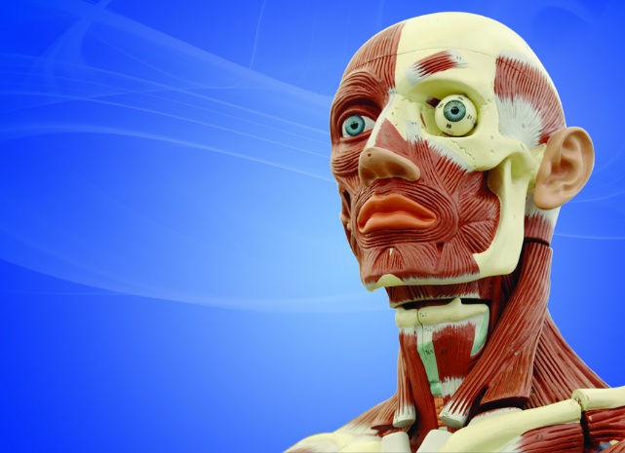
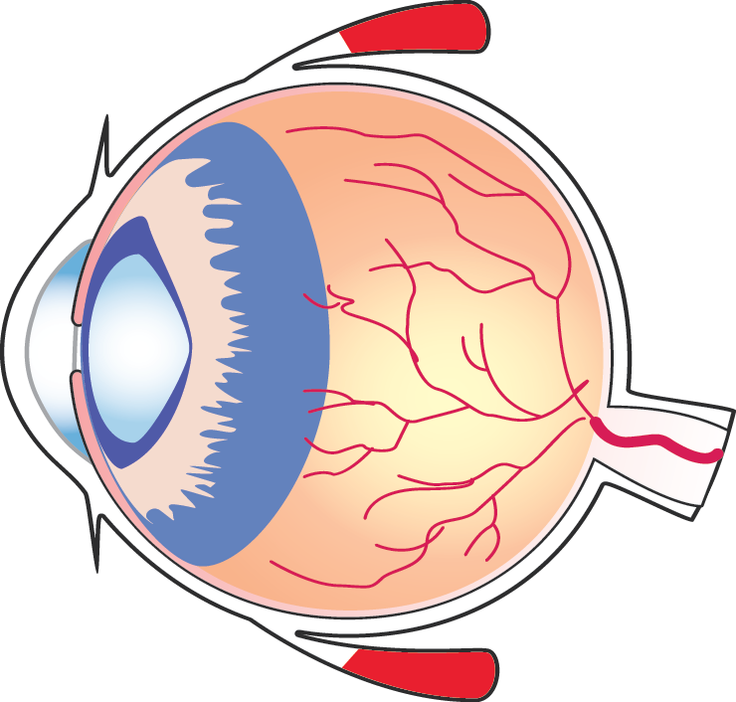



c
The most common cause of cataracts is aging. Cataracts are very common among the elderly. This is because of some normal vision changes that happen after one turns 40. The proteins in the lenses start breaking down causing lenses to become cloudy. On turning 60, the lenses may cloud some more causing vision problems later.

Cataracts are usually accompanied by several vision changes including; seeing double (ghost images), blurry vision, increased sensitivity to light, bright colours appearing faded and trouble with night vision
Cataracts are dense cloudy patches in the eye lens that form due to accumulation of proteins in the eye. Our eyes usually have natural lens which help use see by refract light rays that come into our eyes. The clear part of the eye is what is known as the lens. However, when proteins accumulate to form cataracts, the lens become foggy just like a windshield would when dust accumulates
Vision Eye Center

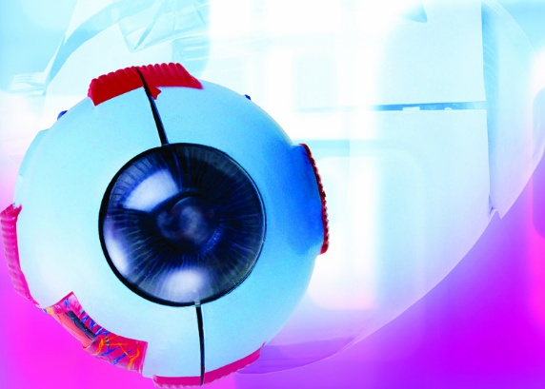
If cataracts are detected in the early stages, antiglare sunglasses, eyeglasses, ambient lighting or magnifying lens may improve them but if these do not work, cataract surgery is the only option.
Cataract Surgery
Cataract surgery involves replacement of cloudy lens with artificial lenses. It is a safe and effective type of surgery and is a very common operation. We offer cataract surgery at our insurance and accept all major insurance providers
Contact us
4423 Knoxfox Street
WestTownsville
Florida 45367 USA
www.visioneye.com
Living with Cataracts

