Intro to life science Cancer Prevention  Lifestyle choices and environmental factors that can lead to cancer.  According to (Sankpal et.al, Pg. 1265, 2012) the dietary and environmental factors have an essential role in the spread of cancer. The environmental risk factors of Cancers has 80 percent implication of various cancers. The various potential players in relation to various types of cancers are; heavy metals, radiation, chemicals as well as smoking. Although environmental disposition is linked to  Life style choices causing cancer include: Alcohol consumption excessively, Smoking of Tobacco, Exposure to various, chemicals, Consumption of unhealthy diet, Lack of physical exercise, Exposure to the sun, environmental pollutants, having stress, infections as well as obesity.    Work cited  Sankpal, Umesh T., et al. "Environmental factors in causing human cancers: emphasis on tumorigenesis." Tumor Biology 33.5 (2012): 1265-1274. |  |  | Process of cancer mutations leading to metastasis  Metastasis is the process which cancer cells spread to various parts of the body, from the initial place it was formed. The cells break from the initial tumor through lymph system or blood as it forms new tumor in other tissues within the body. Metastasis happens through various sequential steps which include the following: Invasion as well as infiltration of the surrounding tissues of the host, Releasing of the neoplastic cells, Circulation survival, Arrest within the capillary beds of the distant organ and finally the penetration of the blood or lymphatic vessels walls (Mehlen et.al Pg. 452, 2006).  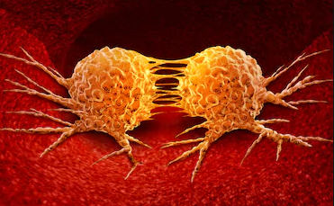  Mehlen, Patrick, and Alain Puisieux. "Metastasis: a question of life or death." Nature reviews cancer 6.6 (2006): 449-458. |  |  | Early detection of cancer  Breast cancer;  Early detection of this type of cancer includes the experience of the following various signs, Loss of appetite, Unending coughing, Chest pain, Hoarseness, Breath shortness, Feeling weak, Loss of weight, Various infections which include pneumonia and bronchitis which keep on coming, Experiencing new onset of wheezing.  Lung cancer;  Early detection of this type of cancer includes the experience of the following various signs, Loss of appetite, Unending coughing, Chest pain, Hoarseness, Breath shortness, Feeling weak, Loss of weight, Various infections which include pneumonia and bronchitis which keep on coming, Experiencing new onset of wheezing.    Ahmad, Aamir. "Breast cancer statistics: recent trends." Breast Cancer Metastasis and Drug Resistance. Springer, Cham, 2019. 1-7.  The American Cancer Society medical and editorial content team: Signs and symptoms of lung cancer. Retrieved on 7th January 2021: https://www.cancer.org/cancer/lung-cancer/detection-diagnosis-staging/signs-symptoms.html#written_by

