While you have a section called research questions I am not seeing in this section the answers to the questions. Which are:

How is this supercomputer an example of a multicomputer configuration (question 1). What are the specs of each node (question 2) and how do these specs compare to the specs of a midrange/mainframe computer (question 3).

How is this supercomputer an example of a multicomputer configuration (questions 1)? While you give specifications for the computer, you should define what a multicomputer configuration is and then explain, this super computer is made up of many nodes and each node has the power of a high powered computer.

How many nodes does this supercomputer have and what are the specs of each node (question 2)? I did not see this. Again, you mention node (I believe you do but, spelled it “code”) but, do not have the specifics for the answer. You are to research how many nodes are on one of the computers and give the specs for this. For the Titan the total computer nodes are18,688 with each holding a 16-core AMD Opteron 6274 processor and an NVIDIA Tesla K20 GPU accelerator (a GPU is a Graphics Processing Unit) and memory per node is 32GB + 6 GB

The last question then wanted you to compare the specs of the nodes (of the one computer) to a midrange or mainframe computer. Below is a picture from our textbook on these computers. As you can see from the specs from the nodes and that of the midrange/mainframe computers, the nodes (32GB RAM) are comparable to these computers.

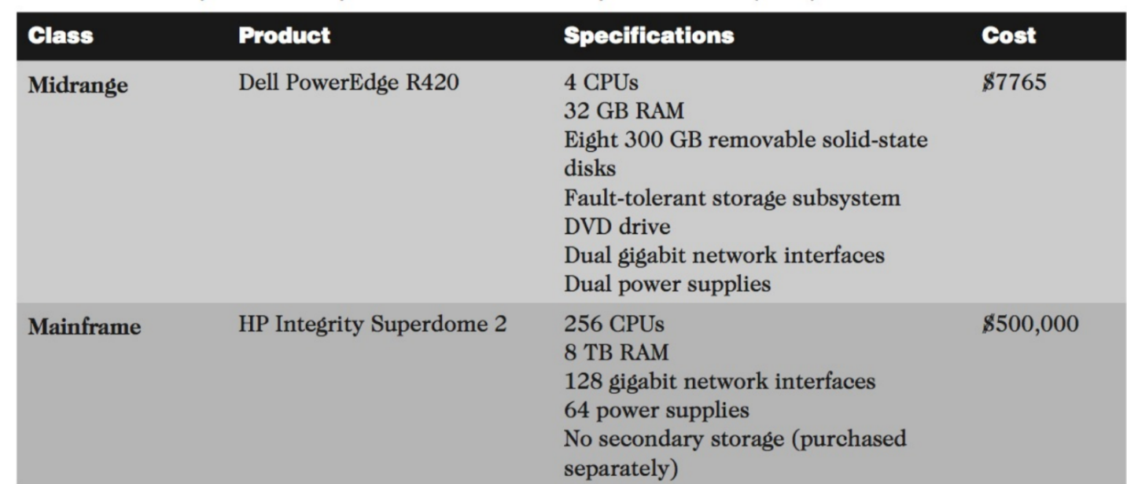

Summary
Oak Ridge Computing facility is the home to Titan-Cray XK7 which is America’s best supercomputer. The supercomputer has a hypothetical pinnacle execution which surpasses 27,000 trillion counts in every second. Titan-Cray XK7 has NVIDIA Kepler preparing units (GPUs) and propelled 16 center AMD Opteron focal handling units. The Titan-Cray XK7 GPU’s are super productive and they were initially created for gaming frameworks. This led to innovations of CPU’s and GPU’s to accomplish high speed of up to 10 times and 5 times vitality proficiency of the initial super computer. The original supercomputer was the Jaguar computer which almost possesses the same physical impressions. Titan-Cray XK7 has 18,688 process hubs and aggregated memory frameworks of up to 710 terabytes. The 299, 008 CPU is able to deal with multiple estimations and conduct prominent authenticity (Segall, et al, 2017).
Titan-Cray XK7 empowers companies/businesses as well as analysts to gain unparalleled precision and accomplish their goals quickly. For example, OLCF company uses Titan-Cray XK7 to execute atomic power plants, flying machines and turbo machinery. Through the use of Titan-Cray XK7, OLCF has been able to conduct environmental change initiatives, improvements in new and modern medications and propelled materials. On the other hand, specialists in different businesses uses the OLCF frameworks to cover different aspects such as demonstrating supernovas, neurodegenerative illness as well as clean ignition of power (Segall, et al, 2017).
Research questions
Titan-Cray XK7 clients approach information perception as well as examination through the incorporation of Rhea frameworks, EoS and Exploratory Visualization environment. The clients are bale to approach document frameworks for a quicker information stockpiling at a speed of 1,000 gigabytes each second of the transmission and a 30 petabytes of capacity limit (Buyya, Vecchiola, & Selvi, 2017). Titan-Cray XK7 high performance storage system (HPSS) is important for chronicled information stockpiling and it is able to deal surges of information. Computer researchers are able to Titan-Cray XK7 for a large number of designated processor hours. Titan-Cray XK7 has an innovative Novel computational impact on experiment programs with vast scale of underpins which affect the utilization of no more than 20% of the Titan’s centers. The Advanced Scientific Computing Research Leadership or the ALCC program is one of the beneficiaries of Titan-Cray XK7 which helps the organization to perform Energy and high-hazard tries. While using Titan-Cray XK7 it is important for researchers to rethink their problems in order to come up with new innovations as well as application developments. For example, the development of CAAR applications such as LSMS, LAMMPS, Dynamics applications and many more apps that are able to explore climatic change (Segall, et al, 2017).
The codes are able to run at 20 petaflops. E.g. S3D code is able to move beyond the modeling of simple fuels to more complex larger-molecule hydrocarbon fuels as well as biofuels such as the butanol and ethanol. Titan-Cray XK7 is helping America to get greater energy efficiency as well as attain improved combustion engines for locomotives in the country.
Titan-Cray XK7 through the CAM-SE has helped the nation to increase its simulation speed of
between 1-5 years per computing day. It has brought in competitive ultra-high resolution as well as chemistry simulations which ensure researchers can run a number of multiple simulations (Buyya, Vecchiola, & Selvi, 2017).
Conclusion
Titan-Cray XK7 is made up of a combination of GPUs and CPUs that enables the user to perform high performance processes as well as overcome space limitations. It is able to perform millions of calculations in a second, while drawing modest electricity. It relies on 299,008 CPU cores that enable sit to guide simulations and architectural processes. Titan-Cray XK7 is ten times more powerful in speed and processing than its predecessor Jaguar. Titan-Cray XK7 supercomputer has achieved greater parallelism through the addition of thousands of computing cores, which are super-fast and power hungry.

References
Buyya, R., Vecchiola, C., & Selvi, S. T. (2017). Mastering cloud computing: Foundations and applications programming.
Segall, Richard, Jeffrey S. Cook, and Qingyu Zhang (2017). Research and Applications in Global Supercomputing. , Internet resource.

