Title: Essay
Name:
Course Code:
Course Name:
Professor:
Date:

Question 1- Experience curve consulting framework
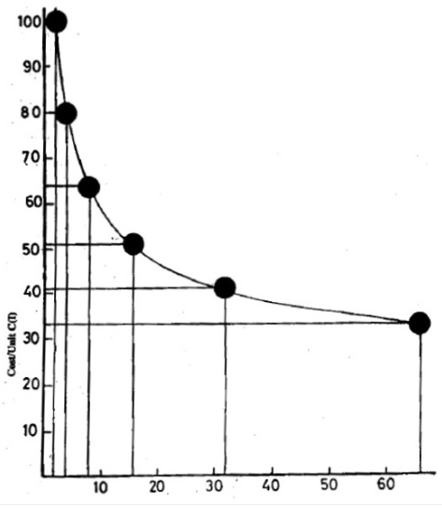
The underlying principle of the experience curve is that the total quantity of production of an item increases while it’s the manufacturing cost decreases systematically. The cost of the value added declines by 25%-30% every time the total accumulated experience is doubled. This means that the time quantum of direct labor in manufacturing of each item declines. This enables the manufacture to predict the cost of the good/product as per the man-hours needed and materials used. This ultimately affects the marked price of the product in the market. For example, production of 2 units cost $100. Then the accumulated product manufactured rises to four units, the cost will be reduced for about 20%. This strategy can be used in design thinking approach to increase on specialization. When the product volume increases, the individual components of production become variable towards the profit margin. Decision thinking approach will direct the manufacturer to innovate in production, cut cost through balancing of the production line, and eventually remain competitive in the market in matters of cost of product. The limitations of the experience curve-consulting framework is that the decline in cost of the manufactured product goes on and have no time limit.
Question 2
Dropbox’s strategy and identify alternate strategic options
Box excels in the web-based interface offers intensive file sharing capabilities with its adorable feature of one click sharing option and the ability to upload files faster no matter the size. One is also able to edit the files and view them while on the Box storage. The service also supports features such as the telephone support to video tutorials as well as the live chat and an individual can interact with the recipient user.
Box is an alternate strategic option of Dropbox though both are from the same company. In this option, the user has the opportunity to store in different environment or geographic regions. It is the best for organizations, which are working under strict policies as well as data protection laws. These are some of the shortcomings that Box has addressed. In this case, the analogy approach is applicable whereby the products similar but they are two completely different things. In this approach, the user can alternatively use the box which enables him/her to store and locate files in alternate locations. Provided by IBM and AWS. The storage is decoupled and one has no worry to understand its broader picture. The Box’s market place has numerous options such as the “Cloud” which has a huge impact on the product. Box gives the user options such as tools, advisories and reports to help him or her customize the storage needs. It boosts the security of data, which is a better alternative to “Dropbox.”
In my recommend the alternate, Box which provides a wider view and user options that the user can rely on to present, store and access data. It is easy to manage files using the box. One does not need to keep on carrying the storage wherever he/she go and still can access the data. It can also use multiple choices of devices as well as platforms. The user is able to synchronize data and share the same easily and efficiently no matter the number of recipients. The storage has a version history that enables the user to retrieve data later.
Question 3A
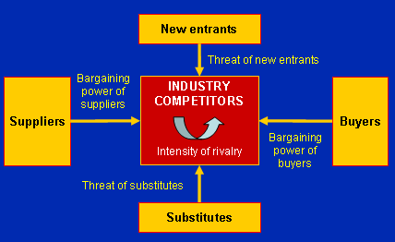
Using the Porters model of strategy above, Colgate has a high competitive advantage in the market, which it has spent many years to build. This means that it has a greater market share as compared to Lamoiyan which is a new entrant in the market system. Colgate Company is able to cut the price of its products comfortably, which is not the case with the new entrant in the market, Lamoiyan. The price war marginalizes Lamoiyan in the market and threatens the company’s existence. In order to capture the Lamoiyan market, Colgate price cut will take time to capture the competitor’s market fully. This will take sometime before it gets out Lamoiyan out of the market. The approach to determine time taken for Colgate to capture Lamoiyan market fully will depend on the existence of other competitors, entry of other new competitors as well as the prices of other competitors offering substitute goods. It is not necessarily necessary for the price war to favor Colgate immediately but the customers might decide to test other products before they settle for Colgate’s product(s).

Question 3B
Coping with price wars
Lamoiyan needs to utilize the Blue Ocean strategy approach in order to create value for its products. Decreasing costs of products and increasing the value of the products can create a better value for its products. It is obvious that in this case when Lamoiyan is experiencing price wars the prices are almost the same as the prices of the competitors. It might be impossible to decrease the prices further. The only option left in this case is to create value for the products. For example, the company can decide to rebrand the product, which will offer a superior value for the same.
Product development is necessary. It will bring in more features, which not present before. Fighting with superior value in this case is accommodative for the business compared to fighting with price, which is inelastic at this point. The business can then re-target the market and open more market doors with new target customers. For example, if the business previously concentrated on products for the adults it can expand to products for the children. This will increase its market size.
NPV Project (Colgate)
Yes, it is a positive NPV project for Colgate if it takes a year to put Lamoiyan out of business. Through a disruptive technology approach, Colgate is able to put Lamoiyan Company out of the market. This means that Colgate will have to disrupt the market for Lamoiyan in order to ensure that it loses its market share. This involves the use of price cuts that will damage the overall market existing for Lamoiyan. For example, Colgate might decide to offer substitute products with better features and better price.
Since the total gross profits of Lamoiyan are too way below the company will not have any other option but to quit. The increase in profits of Lamoiyan will be cut short. Disruptive innovation will enable Colgate Company to remain competitive while its competitor loses her competitiveness. Colgate will also be able to maintain its status quo. Colgate will be able to utilize its market strengths to outdo the weaknesses of Lamoiyan, which is struggling to make it in the market due to the price wars and unfavorable market competition.
Challenges before embarking on a price war (Colgate)
There are a number of scenarios that Colgate have to consider while embarking on price war with Lamoiyan. First, it needs to consider whether it is going to segment its customers in this war. Charging different prices for the same product could segment the customers into undecided market groups. Colgate Company also needs to consider whether it should let the customers know of the price war because they will get concerned and the company will have to respond on what is going on. Colgate should be ready to face the consequences of price wars such as decreased profit margin and gaining of market share, which might take a lot of time to accomplish fully. Price wars will lower its growth strategy, which might have consequences in the company final achievements. For example, it could lead to delayed achievements, which could be very expensive for the company.
Due to status quo, some customers who enjoyed paying more for the company’s product might decide to forego products that are more expensive and leave the ones they used to buy from Colgate. All these is because of the low prices exhibited by the price war. This will force the company to lose its loyal customers, which they might not be able to bring them back on board to continue enjoying the products of the company.

References
Brynjolfsson, E., & McAfee, A. (2014). The second machine age: Work, progress, and prosperity in a time of brilliant technologies.
Bungert, M. (2003). Termination of Price Wars: A Signaling Approach. Wiesbaden: Deutscher Universitätsverlag.
Dutta, A., & Folden, H. W. (2012). Winning strategies: Secrets to clinching multimillion-dollar deals. Singapore: John Wiley & Sons (Asia.
Kim, W. C., & Mauborgne, R. (2015). Blue ocean strategy: How to create uncontested market space and make the competition irrelevant.

