Chemical Connections #8

Note: Chemical Connections #8 Consists of 3 sub-sections. Please be sure to complete all three sections.

  - Part I: Answer the following questions using information from your textbook and the online videos
Introduction
Why is organic chemistry considered the chemistry of Carbon compounds?

Give a few examples of everyday ‘living things’ that contain organic compounds?

What are some other examples of organic compounds that are NOT living?

  - Part II: The Case of the Thalidomide Isomer
Read “The thalidomide tragedy and its lasting effects” and write a short (approximately one paragraph) description of how this demonstrates the importance of isomers and organic chemistry. In your reflection, be sure to include a description of why it is important to develop a system of naming for organic molecules.
The article is linked on Blackboard and can also be accessed at the link below:
https://sqonline.ucsd.edu/2019/07/the-thalidomide-tragedy-and-its-lasting-effects/

  - Part III: Practice Naming & Drawing Alkanes
A Hydrocarbon is a compound containing only hydrogen and carbon atoms.
Remember:
- Carbon will always NEED 4 bonds.
- Hydrogen only needs 1 bond.

Complete the following table and include photos of your drawings (you may also handwrite the entire table and upload photos:
Name | Molecular formula | Number of carbons | Number of Hydrogen’s | Full structure | Condensed formula
Methane | CH₄ | 1 | 4 | 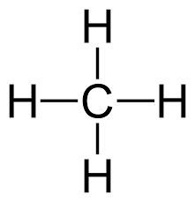 | CH₄
 |  |  | 6
Propane

 |  | 4
 | C₅H₁₂
 |  |  |  |  | CH₃CH₂CH₂CH₂CH₂CH₃

