TARGET PROFILE (Demographic/Psychographic) working class.
PRODUCT/FACT: grinded coffee
Main message / benefit cost saving to consumers who are not willing to purchase ready-made coffee.
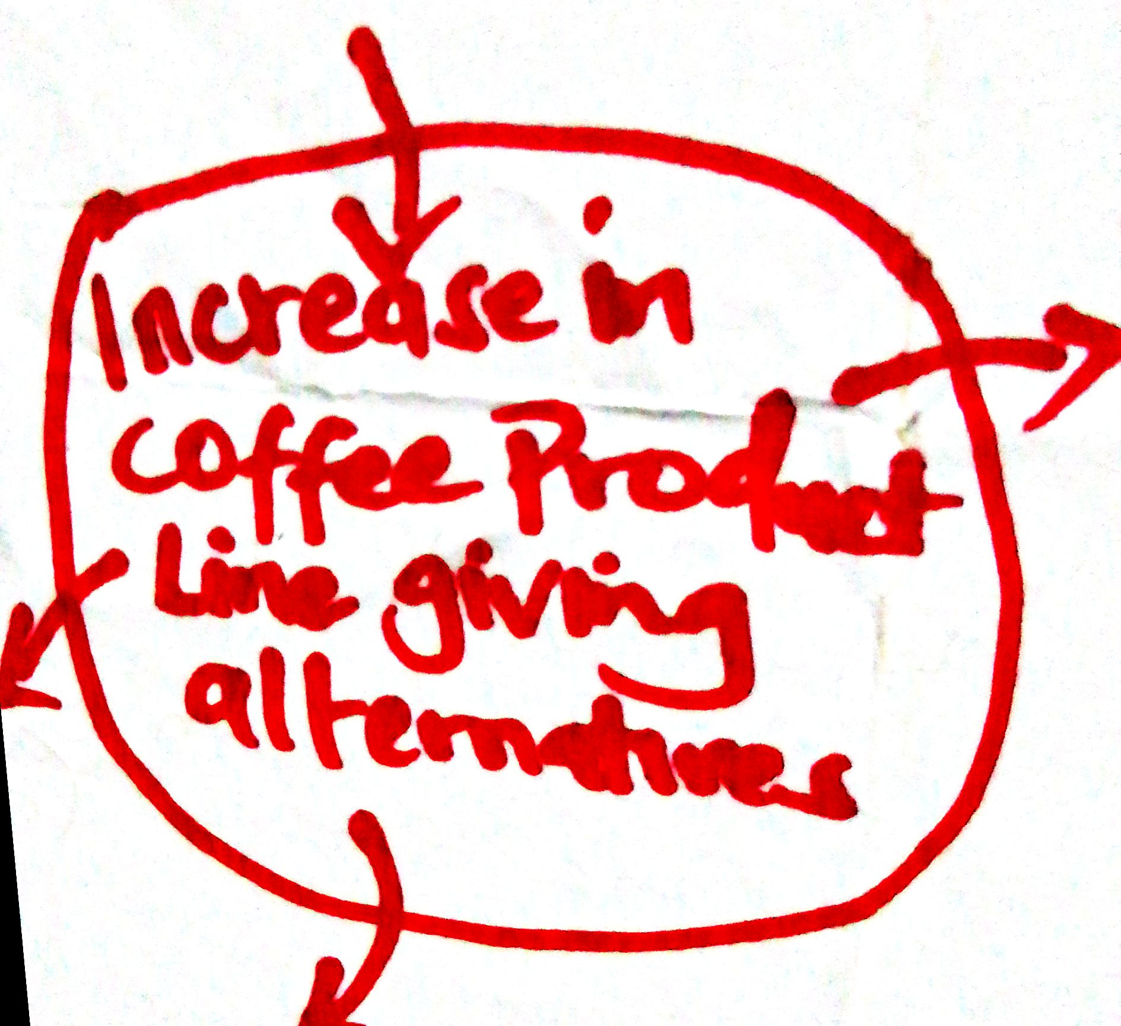
VISUAL EXPLANATION

