5
Elasticity

by Tony Lima, California State University, East Bay, Hayward, CA

brief chapter Outline
Introduction p. 89

Price Elasticity of Demand p. 90
Understand why elasticity is preferable as a measure of responsiveness to slope and how to measure it.

Calculating Elasticities p. 92
Calculate elasticities using several different methods and understand the economic relationship between revenues and elasticity

The Determinants of Demand Elasticity p. 98
Identify the determinants of demand elasticity

Other Important Elasticities p. 100
Define and give examples of income elasticity, cross price elasticity, and supply elasticity

What Happens When We Raise Taxes: Using Elasticity p. 102
Understand the way excise taxes can be shifted to consumers

Looking Ahead p. 104

Visit www.myeconlab.com for current examples, news articles, and teaching tips.
detailed chapter Outline
I. Introduction pages 89–90
A. How Much?
1. Elasticity helps us estimate how much quantity demanded, demand, quantity supplied or supply will change in response to a change in some other variable.
2. Once we understand the relationship between the change in price and the change in quantity demanded, we can estimate the change in total expenditure.
TEACHING TIP: Measurement is important. All the theory in the universe does no good if we still can’t answer the question, “How much?”
B. Elasticity quantifies how sensitive one variable is to a change in a second. The elasticity of A with respect to B is %ΔA/%ΔB.
II. Price Elasticity of Demand pages 90–92
Learning Objectives: Understand why elasticity is preferable as a measure of responsiveness to slope and how to measure it.

TEACHING TIP: Demand curves still slope downward and supply curves still slope upward. While this seems obvious, many students come away from studying price elasticity of demand thinking that inelastic demand means price and quantity move in opposite directions while elastic demand means they move in the same direction. Students confuse quantity with total expenditure. It’s very important to persuade them otherwise.
A. Slope and Elasticity
TEACHING TIP: The data and graphs from Figure 5.1 are in the Excel workbook for this chapter.
1. Slope is not a good measure of responsiveness. One important reason is that slope changes when the units of measurement on either axis change.
2. Price elasticity of demand is the ratio of the percentage of change in quantity demanded to the percentage of change in price; measures the responsiveness of quantity demanded to changes in price.
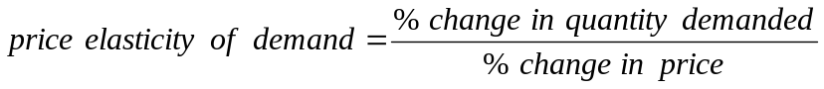
3. Price elasticity of demand is naturally negative. Since we know that, we often omit the minus sign.
B. Types of Elasticity
1. Perfectly inelastic demand is demand in which quantity demanded does not respond at all to a change in price. (The demand curve is vertical.) Example: insulin.
2. Perfectly elastic demand is demand in which quantity drops to zero at the slightest increase in price. (The demand curve is horizontal.)
3. The following descriptive text may help your students remember the difference. (This is from page 91 of the text.)

4. Elastic demand is a demand relationship in which the percentage change in quantity demanded is larger than the percentage change in price in absolute value (a demand elasticity with an absolute value greater than 1.0). Example: bananas (elasticity = |-3| = 3).
TEACHING TIP: Another example of elastic demand is new cars. For a car with a sticker price of $20,000, saving five percent equals $1,000, a nice piece of change. For that reason people spend hours, or even days, shopping for a new car.
5. Inelastic demand is demand that responds somewhat, but not a great deal, to changes in price. Inelastic demand always has a numerical value between zero and -1. Example: gasoline in the U.S. (0.2 in the short run).
TEACHING TIP: Bob Pindyck has estimated the short-run price elasticity of demand for gasoline in the U.S. as about -0.2. Students have an immediate understanding of this example.
6. Unitary elasticity is a demand relationship in which the percentage change in quantity of a product demanded is the same as the percentage change in price in absolute value (a demand elasticity of |-1.0| = 1.0). Example: beef.
7. Warning: economists often omit the minus sign when writing price elasticity of demand.
Tell the class that when they see a price elasticity of demand that is positive they should immediately write a minus sign in front of it. Also emphasize that this only applies to price elasticity of demand.
III. Calculating Elasticities pages 92–98
Learning Objectives: Calculate elasticities using several different methods and understand the economic relationship between revenues and elasticity
TEACHING TIP: All of the numerical examples in part III are included in the Excel workbook for this chapter.
A. Calculating Percentage Changes
1. The percentage change in quantity demanded is equal to the change in quantity demanded divided by the first value of quantity. Here's the calculation technique:
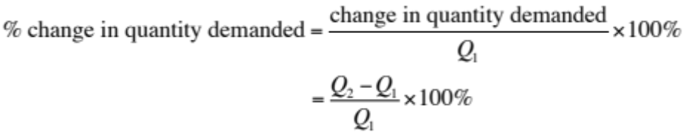
2. The percentage change in price is equal to the change in price divided by the first value of price. Here's the calculation technique:
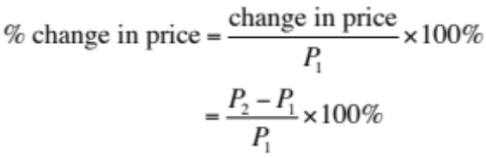
3. Defined this way, the value calculated for the percentage change depends on which of the two values is used in the denominator.
TEACHING TIP: The text includes extensive numerical examples that illustrate this problem. Unless your class is mathematically adept you will probably want to spend some time in class doing examples of your own.
B. Elasticity Is a Ratio of Percentages
1. 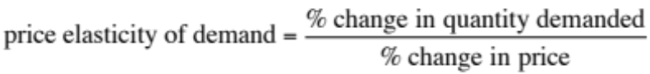
2. Calculating price elasticity of demand from Figure 5.1:
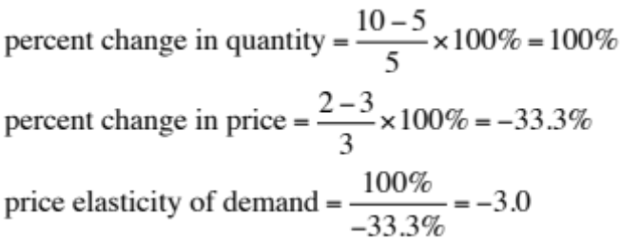
TEACHING TIP: It is impossible to give too many numerical examples in class.
C. The Midpoint Formula
1. For large changes in Q and/or P, the direction of the change makes a difference. Reversing the direction of movement from the previous example,
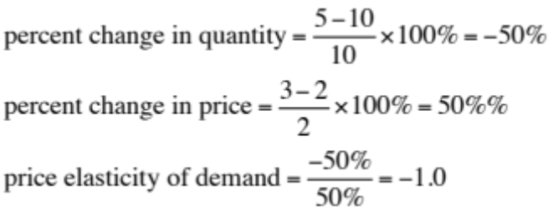
One reason we use elasticity is because it does not change when the units of measurement change. However, a variable whose value changes when the direction of movement changes is almost as bad. We have a solution: the midpoint formula.
2. Instead of having to select one or the other price - quantity pair for the denominators of the percentage change calculation, why not just use the average?
3. The midpoint formula is a more precise way of calculating percentages using the value halfway between P₁ and P₂ for the base in calculating the percentage change in price and the value halfway between Q₁ and Q₂ as the base for calculating the percentage change in quantity demanded.
4. The midpoint formula is calculated as:
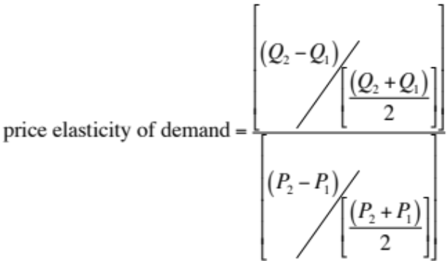
TEACHING TIP: If you have the time and inclination, you can save your students some work by showing them that the midpoint equation can be written as
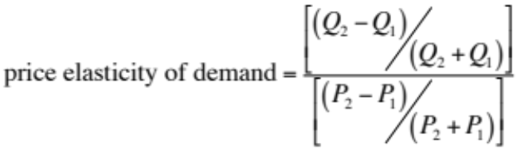

5. Here's how to calculate elasticity using the previous example with the midpoint formula:
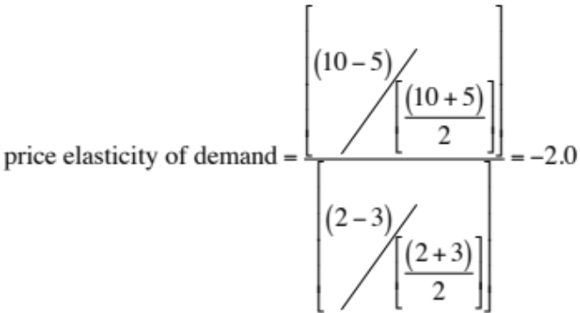
TEACHING TIP: The real issue is the size of the percentage change. If the percentage change is small, it doesn’t make much difference which value you use in the denominator. If your class is rather advanced, you can use calculus at this point and note that price elasticity is
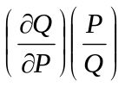
in which case there is no issue at all about what to use in the denominator or numerator. You might mention that this is the true point elasticity.

6. Point elasticity is a measure of elasticity that uses the slope measurement:
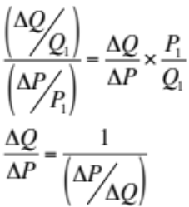
a. Point elasticity uses the reciprocal of the slope.
b. Point elasticity should only be used when the changes in Q and P are small relative to their sizes.
TEACHING TIP: Table 5.1 and the subsequent graph and examples is a very detailed example of how to do the calculations required by the midpoint formula. Consider recommending this in class, particularly for students who are struggling with the arithmetic.
D. Elasticity Changes along a Straight-Line Demand Curve
1. The slope of a straight line is constant.
2. Elasticity is not the same thing as slope.
3. Demand is unit elastic halfway up a linear demand curve (Figure 5.4).
TEACHING TIP: A handy rule of thumb is that elasticity is 1.0 halfway along a linear demand curve. Above that point P is high and Q is low so P/Q is high. Demand is elastic. Below the halfway point P is low and Q is high so P/Q is low. Demand is inelastic.
TEACHING TIP: The material in Table 5.1 and Figure 5.3 is included in the Excel workbook for this chapter. Elasticities are also calculated for each pair of points on the demand curve using both the midpoint formula and point elasticity. Finally, a price of $5.50 has been included so students can verify the claim in the previous Teaching Tip.
TEACHING TIP: Extensive calculations written on the board will help students absorb this material.
E. Elasticity and Total Revenue
1. Total revenue is the total amount sellers receive for their product. This is also the amount consumers spend on the product (total expenditure).
TEACHING TIP: Be prepared for the student who asks about sales taxes.
2. TR = PQ. Total revenue = price x quantity.
3. Any increase in P will cause Q to decrease. TR may rise, fall, or remain the same depending on the comparative magnitudes of the changes in
P and Q.
4. Price elasticity of demand tells us everything we need to know:
Elasticity | Demand is | Price and Total Revenue
between 0 and -1 | inelastic | change in the same direction
less than -1 | elastic | change in opposite directions
equals -1 | unit elastic | small changes in price have no effect on total revenue
TEACHING TIP: The text introduces OBEC, the Organization of Banana Exporting Countries. The point is that OBEC is unlikely to succeed. Why? Because demand for bananas is elastic. OPEC has been a success in large part because demand for oil is inelastic.
IV. The Determinants of Demand Elasticity pages 98–100
Learning Objectives: Identify the determinants of demand elasticity
A. Availability of Substitutes
1. Examples: demand for corn is elastic but demand for oil is inelastic.
2. How many substitutes are available? How close are the substitutes to the product in question?
TEACHING TIP: Here’s an example that will help students understand “close substitutes.” Consider Fuji apples and Macintosh apples. Demand for each is likely to be very elastic because they are pretty close substitutes.
Economics in Practice: Elasticities at a Delicatessen
in the Short Run and Long Run, page 99
Frank runs a corner delicatessen and decides one Monday morning to raise the prices of his sandwiches by 10 percent. Since Frank knows a little economics, he expects that this price increase will cause him to lose some business, since demand curves slope down, but he decides to try it anyway. At the end of the day, Frank discovers that his revenue has, in fact, gone up in the sandwich department. Feeling pleased with himself, Frank hires someone to create signs showing the new prices for the sandwich department. At the end of the month, however, he discovers that sandwich revenue is way down.What is going on?
In this case,Monday’s price increase brings increases in revenue; therefore, this pattern tells us that the demand from Frank’s customers appears to be inelastic. In the longer term, however, demand appears to be more elastic (revenue is down after a month). Another way to pose this puzzle is to ask why the monthly demand curve might have a different elasticity than the daily demand.
Once you are in Frank’s store, planning to buy a sandwich, your demand tends to be relatively inelastic because your ability to substitute by going elsewhere or choosing a different lunch item is relatively limited. You have already come to the part of town where Frank’s Delicatessen is located, and you may already have chosen chips and a beverage to go along with your sandwich. Once you know that Frank’s sandwiches are expensive, you can make different plans, and this broadening of your substitute choices increases your elasticity. In general, longer-term demand curves tend to be more elastic than shorter-term curves because customers have more choices.

B. The Importance of Being Unimportant
1. Products that don’t consume a very large part of our income also don’t command much of our attention.
2. Since we don’t pay much attention to their price, demand for these products tends to be inelastic.
 TOPIC FOR CLASS DISCUSSION
The text's example is buying an occasional box of mints. A common example used by economists is salt. It’s cheap and we don’t buy it very often. When was the last time anyone saw an advertised sale on salt? Ask the class to come up with other examples. Paper clips? Wood pencils?
C. Luxuries versus Necessities
1. Luxury goods tend to have relatively elastic demand. Example: the demand for yachts is likely to be elastic.
2. Necessities tend to have inelastic demand. Example: the demand for food is likely to be inelastic.
3. However, the demand for any individual food (such as bananas) is likely to be elastic.
D. The Time Dimension
1. The longer the time period the more elastic demand becomes.
2. People can find substitutes and change their behavior more over longer time periods.
3. Example: the long-run elasticity of demand for oil is about 0.7 while the short-run elasticity is about 0.2.
Unique Economics in Practice
In 1999, in response to a proposal advanced by actor – director Rob Reiner, California voters passed a measure increasing cigarette taxes by $0.50 per pack. The revenue was stipulated to be used for anti-smoking measures. California also banned smoking in restaurants and bars in 1998.
Proponents of this tax were amazed to discover their tax did not raise the expected revenue. One reason is revenue loss from tax evasion. There are three main sources of evasion:
1. smuggling from neighbor states that impose lower taxes (Nevada),
2. purchases from Native American casinos located in California, and
3. outright fraud by retailers who purchase cigarettes without the state tax stamp.
Joe Fitz, the Chief Economists for the California State Board of Equalization, has studied this issue. He concludes that evasion accounts for about 14.7% of revenue lost and that the amount of lost tax revenue is between $139 and $210 million dollars.
Question: New York City mayor Michael Bloomberg pushed through a tax increase on cigarettes in 2010. The tax in the city is now $5.85 per pack, bringing the retail price to $12.85. Outside New York City, the tax is lower and the retail price is $11.90. In New Jersey (just across the Hudson River from Manhattan), the price is $8.35. What actions would you expect New York City smokers to take in response to this tax increase?
Answer: Interstate (and even intrastate) smuggling has become quite common. According to the source cited below, in 2012 about 57 percent of the cigarettes consumed in New York City were smuggled.
V. Other Important Elasticities pages 100–102
Learning Objectives: Define and give examples of income elasticity, cross price elasticity, and supply elasticity
A. Income Elasticity of Demand
1. Income elasticity of demand is a measure of the responsiveness of demand to changes in income:
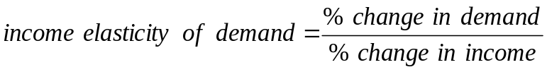
2. China's economic growth has caused income to rise. One item now being demanded is clean air.
3. If the income elasticity of demand for housing is 0.8 then a 10 percent increase in income will cause housing demand to increase by 8 percent.
4. Income elasticity is positive for normal goods but negative for inferior goods.
TOPIC FOR CLASS DISCUSSION
The demand for clean air can lead to a discussion of the economics of the environment. Chinese citizens are demanding cleaner air and (probably) cleaner water. Environmental economists have known for decades that economic development increases the demand for environmental services. It will surprise many of your students to learn that economic development can lead to a cleaner environment, especially in countries with elected governments. Democracies tend to not kill their citizens.
B. Cross-Price Elasticity of Demand
1. Cross-price elasticity of demand is a measure of the response of the quantity of one good demanded to a change in the price of another good. It’s helpful to call these goods Y (percent change in quantity of Y) and X (percent change in price of X):
2. If cross-price elasticity is positive then X and Y are substitutes.
3. If cross-price elasticity is negative then X and Y are complements.
Economics in Practice: Tax Rates and Migration in Europe,
page 102
Countries that are members of the European [Economic] Union agree to labor mobility. However, income tax rates vary among the different countries. What is the labor supply elasticity with respect to tax rates for highly skilled workers?

Denmark's tax rate on incomes over €100,000 was 55 percent. In an attempt to attract highly skilled workers, Denmark offered them a flat 30 percent tax rate for three years. The elasticity of migration was found to be almost 2. After a few years the fraction of foreigners in the top five percent of Denmark's income distribution increased from 4.0 percent to 7.5 percent. Taxes matter.

TOPIC FOR CLASS DISCUSSION
The discussion builds on the Economics in Practice on page 102 ("Tax Rates and Migration in Europe"). There are several questions to throw at the class. First, what will a foreign worker do once the three years are up? Are they likely to stay in Denmark and pay the 55 percent rate? (Note that this is the average tax rate. The marginal tax rate in 2009, the current base year for the program, was 62 percent.)
Second, the program began in 1992. Currently the €100,000 income is based on 2009 incomes and is indexed to average wage growth. The program also applies to Danish citizens who have worked and paid taxes in another country for three years. What are the incentives for a highly-skilled worker in Denmark who is paying the 55 percent rate?
Finally, the authors found that workers who came to Denmark under this program had pretax earnings five to ten percent lower than comparable workers paying the high tax rate. For those workers who stayed after the expiration of their low tax rate, income increased sharply when they moved into the higher tax bracket. Ask the class to speculate on why this might happen.
C. Elasticity of Supply
1. Elasticity of supply is a measure of the response of quantity of a good supplied to a change in price of that good:
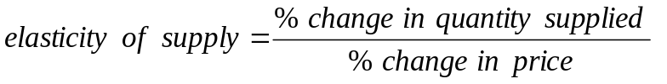
2. Elasticity of supply is likely to be positive in most output markets.
3. The elasticity of labor supply is a measure of the response of labor supplied to a change in the price of labor. If the labor supply curve bends backward the elasticity of supply will be negative along that part of the supply curve. On the backward-bending segment, the worker has chosen to use part of the wage increase to "purchase" more leisure.
VI. What Happens When We Raise Taxes: Using Elasticity pages 102–104
Learning Objectives: Understand the way excise taxes can be shifted to consumers
A. A Tax on Avocados
1. A hypothetical city's residents buy 1,000 avocados per day (365,000 per year). The mayor decides to impose a tax of $1 per avocado, expecting revenue of $365,000 per year.
2. The mayor has imposed an excise tax, a per unit tax on a specific good.
3. After one year the tax has raised $182,500, half what was expected.
4. The reason, of course, is the elasticity of demand.
TEACHING TIP: Make sure your students understand why the supply curve shifts up by $1.00. An easy way to discuss this is by pointing out what would happen if the demand curve was vertical. In that case the equilibrium price would increase by $1.00. The actual price increase is less because the demand curve is not vertical. Using the midpoint formula the implied price elasticity of demand is -1.67.
5. Since the demand curve is not vertical, the equilibrium price rises to $2.50 and the equilibrium quantity falls to 500 avocados per day.
6. The burden of the tax is divided equally between buyers and sellers. The buyers pay $0.50 more and sellers receive $0.50 less.
TEACHING TIP: Don't do it! You'll be tempted to launch into a discussion of what determines the burden of a tax. It's way too soon for that.
TEACHING TIP: The data and calculations for this example are in the Excel workbook for this chapter.
VII. Looking Ahead page 104
A. These five chapters cover basic economic concepts.
B. The rest of the text will go into greater detail about most of these ideas.
Extended Application
Application 1: Inflation Reforming Economies
Microeconomics can often help us understand macroeconomic events. For example, why has economic reform in former Communist bloc countries virtually always resulted in high rates of inflation? Certainly much of the explanation is macroeconomic (faster money supply growth, large and growing budget deficits, depreciating currencies), but microeconomics plays a major role as well.
Consider the market for a typical consumer good in a former Communist country. Under central planning, the quantity produced was fixed by the state, so we can draw the supply curve as the vertical line S₁ in the diagram following. The demand curve, however, looked like demand curves everywhere: The higher the price, the less people would want to buy.

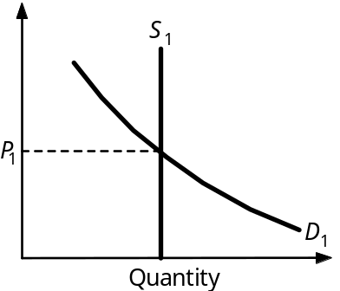
What about price? Under central planning, prices—like quantities—were simply set by the state. To keep things simple, let us assume that initially planners were wise enough to set the price at P₁, where quantity supplied and quantity demanded were equal. (Central planners did indeed try to do this for many consumer goods.) At this price, everyone who wanted to buy the good at the going price could do so.
During the 1980s, for a variety of reasons, production of consumer goods decreased. (The reasons included increased defense production, deteriorating worker attitudes, depletion of natural resources, an aging capital stock, and a decrease in the ability to import goods from the West.) This decrease in production can be shown as a leftward shift of the supply curve from S₁ to S₂ (see the following diagram). To avoid excess demand and shortages, central planners would have had to raise the price to P₂. But throughout the 1980s, Communist governments steadfastly refused to raise consumer prices. There were three reasons for this policy:
- It had long been a source of great pride that “Communism had put an end to inflation.” Rising consumer prices would have been seen as an admission of failure.
- Higher prices would have made consumer goods less affordable to those with lower incomes and little wealth, which was viewed as unfair by the government and intolerable by much of the public.
- Prices were set by a slow-moving bureaucracy that—even if it wanted to—could not have kept up with changing conditions in any meaningful way.
The result of this failure to raise prices was predictable. Consumer goods markets in the 1980s were plagued by excess demand. But there was more. With long lines forming at stores, many consumers found the shelves empty when they got inside. Some could go to the black market to buy goods, but not everyone could do this, and not everyone who went there could find what they needed. Thus, many consumers who had the income to buy goods were unable to do so. In fact, the typical Eastern European family during the 1980s found itself in an ironic situation: It had more income than it could spend! Year after year, this unspendable income was saved—Western economists called it “forced saving”—resulting in a steadily increasing stock of cash and savings deposits—an increase in wealth.
Now, an increase in wealth causes a rightward shift in the demand curve for normal goods (shown as a move from D₁ to D₂).

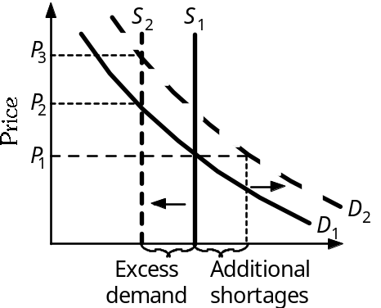

Demand shifts like this—with fixed prices—served only to worsen the shortages, leading to more forced saving, further increases in wealth, further shifts of the demand curve and still worse shortages.
By the time reform-minded leaders took power in these nations (1989 in Eastern Europe, 1991 and 1992 in the former Soviet republics), the shortages had grown intolerable. Something had to be done, and quickly. Because supplies of most goods would remain unchanged for some time (in the short run, production was constrained by the preexisting productive capacity of factories) the only option was to allow prices to rise closer to their equilibrium values. In many cases, this required price increases of hundreds or even thousands of percent.

