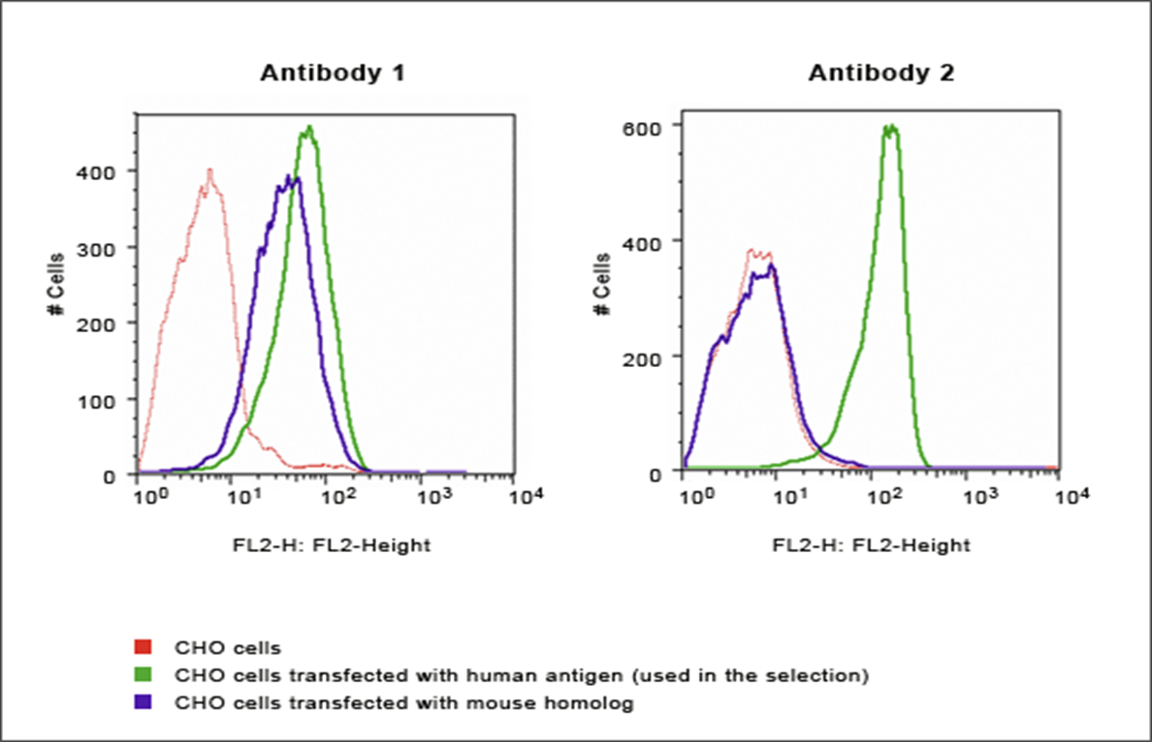
CHO cells transfected with a human antigen and CHO cells transfected with a mouse homolog (of the human antigen) were analyzed for surface antigen expression using two different monoclonal antibodies (1 and 2). Explain the data.
Chinese hamster ovary (CHO) is the mammalian most preferred cells that are used for bio-pharmaceutical production. The main problem experienced in metabolic engineering is the ability to achieve an effective mammalian cellular system response by balancing the tuned heterogonous metabolic pathway flux. This is a schematic illustration of CHO cells transfected with mammals which is a mouse homolog and human antigen. During transfection, the introduced nucleic acid may transiently exist in the cells in that it is expressed for a short period and does not replicate. It also may be stable and go through integration into the recipient genome, replicating when the genome of the host replicates. Human cell lines can produce many similar proteins to those that are naturally created in human bodies, which is an advantage as compared to other mammalian expression systems such as a mouse. In the above experiment, the CHO cells are still having high stability compared to that of a mouse. This expression system is highly tolerant of changes such as temperature, pressure, pH and oxygen level during manufacturing. In antibody two, the human antigen level remains the same because the cell line has been used to the familiarity level. The cell lines of a mouse cannot produce similar proteins to the ones that are naturally produced in their bodies.

