MT. SAN ANTONIO COLLEGE
CISB11
FLOWCHART ASSIGNMENT

PURPOSE:

This assignment will help you understand how to flowchart a programming problem.
You are to use the five standard flowchart symbols to document how to perform the tasks described in step 3 below.

Here is the example in the book:
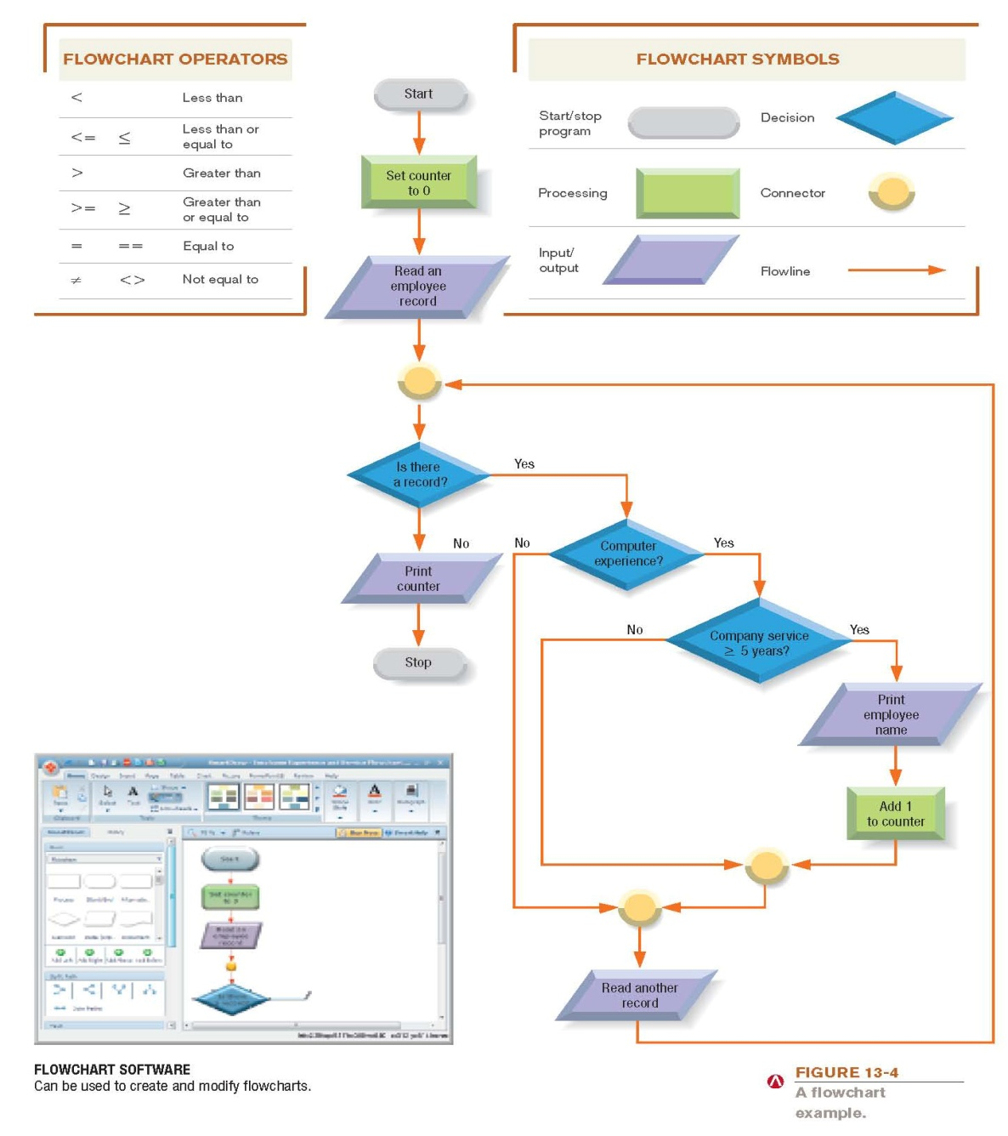
You can use the “Insert” tab in Word to insert the flowchart shapes. Upload your Word document to Moodlerooms.

ASSIGNMENT:

1. Draw a flowchart for each of the problems listed below (items A - F). Try to fit each separate flowchart onto one page.

2. Use the following flowcharting standards for this assignment:

Use a flowchart template.

Use one or more sheets of 8 1/2 by 11-inch paper.

Use only one side of the paper.

The logic flow is from top to bottom and left to right.

Exit the logic flow at the bottom or to the right.

Enter the logic flow at the top or on the left.

Use the On-page connector to transfer logic on the same page.

Use the Off-page connector to transfer logic from one page to another.

The last record in the file contains no data.

3. Flowchart the following programming problems:

A. Calculate the square footage of a house for a carpet company. The width and length of each room will be input from a PC. When 0 is input for the width, all of the footage for the house has been entered and it is time to calculate the total and print it out so the carpet company knows how much carpet will be needed.

B. Calculate the sales tax and total amount owed for a purchase. Los Angeles County charges 8.25% sales tax while San Bernardino charges 7.75% sales tax. The purchase amount and the county will be input from a PC.

C. Read the personnel master file and print out the name and bonus for each employee who has a bonus of over $1,000.00. The bonus is 6% of the employee sales and must be calculated from the sales figure.

D. Read the student master file, calculate the average age of all male students and print this average age after the last record has been read.

E. Read the student master file and print a list of the students who meet ALL THREE of the requirements below:
1. Are carrying 15 or more units,
2. Are seniors,
3. Have a GPA of 3.0 or better.

F. Read the personnel master file and print a list of the employees who meet BOTH of the requirements below:
1. Have been with the company 25 years or more
2. Have 120 days or more of sick leave.

